ACTIVITY: Investigating air pollution

Activity idea
In this activity, students investigate exhaust emissions, car use and air quality.

By the end of this activity, students should be able to:
- recognise some of the sources of air pollution
- understand that only some pollution is visible
- carry out simple scientific observations and interpret results.

Introduction/background
What you need
What to do

Introduction/background

These three activity ideas introduce students to aspects of air pollution that are often not seen, yet are parts of everyday life. As an introduction, read the Science Ideas and Concepts article Air quality.

What you need

- Clean white socks
- Vehicle(s)
- Gloves
- White card
- Scissors
- Vaseline
- Tape, drawing pins
- Microscope

What to do

Exhaust emissions

- Place a white sock over the exhaust pipe of a car and run the car for 5 minutes. Stand back while the engine is running.

- Remove the sock – use gloves as the exhaust pipe will be hot! – and turn it inside out.

- Discuss what you see. Soot particles are produced during the combustion of petrol and diesel. (An average car produces approximately 2 kilograms of pollution for every 35 kilometres it travels. The UK Alliance of British Drivers website provides a short summary of Facts About Car Exhausts.) How dirty would the sock be after longer periods of time?

- If possible, conduct the same experiment to compare different types of car, for example diesel versus petrol, old versus new, big versus small.

Car use

- As a class, conduct a survey about how families of students commute in the morning and create a visual human graph by putting students into categories depending on their answers. For example, you could investigate:
- how many students come to school by car
- how far students travel by car
- how many trips students do by car in a week
- how students’ parents commute by car, for example, alone, car pool and so on
- which types of car are involved and how this relates to exhaust emissions.

Air quality

- Cut out several 50 x 50 mm squares of white card and smear the surface of each lightly with Vaseline.

- Have students fix the squares to as many different areas you can think of, for example, by the bus stop, inside the classroom, under trees, by a car park, on a post by traffic lights, on a back door and so on. Leave for 24 hours. (As an alternative, you could use slightly damp cotton wool to swab different surfaces, such as road signs, leaves on trees, window panes and so on.)

- The squares will now have particles stuck to them. Some will be big enough to see, but most particles will be too small – try looking at them under a microscope.
- Where do you think the particles have come from?

- Have students devise a particle pollution indicator, from low pollution to high pollution, for the cards based on the results you get. It is best to have about five categories.

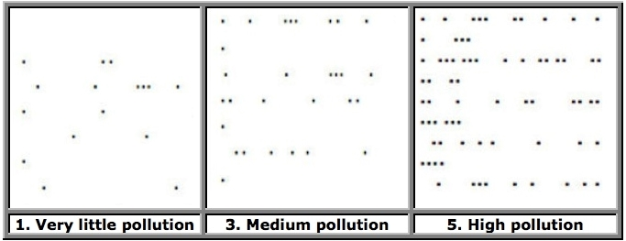

- Score each card on how polluted it is and use this data to draw a graph showing the level of air pollution in the various areas.

- Discuss the graphs. What areas were least polluted? What areas were most polluted? Are there any links between the areas that are most polluted?

