ACTIVITY: Build a marine food web

Activity idea

In this activity, students build their own food web using images of organisms from the marine ecosystem. This activity can be done indoors on paper or outdoors on a tarmac surface using chalk.

By the end of this activity, students should be able to:
- understand the difference between a food chain and a food web
- understand that food webs are made up of producers, consumers and decomposers
- build and revise their own food web to show the interdependence of organisms in an ecosystem
- understand the potential impact of the removal or reduction of one species on the rest of the food web.

Introduction/background notes
What you need
What to do
Discussion questions
Possible variations
Student worksheet
Trophic pyramid diagram
Tuna sandwich diagram (transfer of energy)
Organism cards (small)
Organism cards (large)

Introduction/background

Feeding relationships are often shown as simple ‘food chains’, but in reality, these relationships are much more complex, and the term ‘food web’ more accurately shows the links between producers, consumers and decomposers.

A food web diagram illustrates ‘what eats what’ in a particular habitat. Pictures represent the organisms that make up the food web, and their feeding relationships are typically shown with arrows. The arrows represent the transfer of energy and always point from the organism being eaten to the one that is doing the eating.

What you need

- Student worksheet for each group
- Large piece of paper for each group
- Set of organism cards for each group
- Blu-Tak
- Pencils

What to do

- Have students explore the Marine ecosystem interactive and complete the student worksheet. This could also be explored as a class using an interactive whiteboard or data projector. Additional information can be found in these articles: Plankton, Bryozoans, Cockles, Sea stars and Mussels.

- As a class, discuss what the students know about food webs. The discussion could focus on producers, consumers, decomposers, the trophic pyramid, energy loss in food webs (tuna sandwich) and human impact on food webs. It may be helpful to watch the video clip Understanding food webs.
Common student alternative conceptions about food webs include:
- top consumers eat everything below them
- organisms shown in food webs represent individuals rather than populations of organisms
- an organism that is not directly linked to another by a feeding relationship will not be affected if that organism is removed.

- Give each student or group a set of organism cards (small). You may want to start the food web building activity by asking students to use their organism cards to build simple food chains before they move on to build a web. For example:

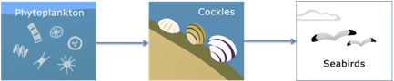

- Working on a large piece of plain paper, ask students to use the organism cards and the information gathered on their worksheet from the Marine ecosystem interactive to build their own food web using Blu-Tak so they can move the cards around.

- Have them use pencils to draw arrows showing connections between the different organisms. (The arrows represent the transfer of energy and always point from the organism being eaten to the one that is doing the eating.)

Discussion questions
- Can you make any connections on your diagram that aren’t a feeding relationship? (For example, bryozoans provide a nursery habitat for young fish.)
- Are some organisms more important than others?
- Why are decomposers important in a food web?
- Do you think anything is missing from your food web?
- Where do humans fit in the marine food web?

Possible variations

Estuary habitat

Before step 4, ask students to draw their own poster diagram of an estuary (without any organisms in it). They can then Blu-Tak the organism cards into the appropriate habitat on their poster before completing the rest of the activity.

Outside version

Run the activity outside (you will need one set of large organism cards and some chalk):
- Divide the class into groups of 2–3 and find a suitable area of tarmac outside (preferably flat with few markings). Give each group one organism card (large) and some chalk.
- Ask students to spread themselves out in the tarmac area. 1 member of the group should stay in the same spot holding the card at all times. The other group member(s) should move around and explore the other cards. (All group members should have the opportunity to move around at some stage.)
- When 2 groups agree that their cards should be linked, they should draw a chalk arrow to illustrate the feeding relationship. (Remind the students that the arrows represent the transfer of energy and always point from the organism being eaten to the one that is doing the eating.)

Scenarios

The effect of removing or reducing a species in a food web varies considerably depending on the particular species and the particular food web. In general, food webs with low biodiversity are more vulnerable to changes than food webs with high biodiversity. In some food webs, the removal of a plant species can negatively affect the entire food web, but the loss of one plant species that makes up only part of the diet of a herbivorous consumer may have little or no effect.

Some species in a food web are described as keystone species. A keystone species is one that has a greater impact on a food web than you would expect in relation to their abundance. The removal of a keystone species characteristically results in a major change, in the same way that removing a keystone from an arch or bridge could cause these structures to collapse. In Fiordland, the New Zealand sea star is a keystone species that controls the numbers of the species it feeds on, for example, mussels. If the sea star is removed, this could cause a large increase in the numbers of mussels and this has flow on effects throughout the food web.

After the students have shown connections between the different organisms (on both the inside and outside version of the activity) introduce one of the scenarios (For the inside version, you could give different groups a different scenario.):
- A large commercial fishing company triples their annual catch of red cod in the area.
- The land on the edge of the estuary is converted to intensive farming. There is a big increase in agricultural run-off and nutrients into the estuary. This increases the risk of phytoplankton blooms.
- Due to increased carbon emissions, the ocean is becoming more acidic. Bryozoans and other shelled animals will no longer be able to make shells.

Ask the students to revise their food web to show what they think might happen to the food web based on the scenario.

Scenario | Possible outcomes
A. Annual catch of red cod increased | Increase in zooplankton, small fish and juvenile sea stars. Decrease in squid, sea birds and dolphins – some top predators may disappear altogether. Damage to the seafloor affecting seaweeds and bryozoans. Increase in the number of bycatch (non-target species), for example, this could reduce populations of crabs, dolphins and squid.
B. Run-off | Additional nutrients in the sea can lead to excessive phytoplankton growth that results in ‘blooms’. When these large numbers of organisms die, the sharp increase in decomposition of the dead organisms by oxygen-using bacteria depletes oxygen levels. In some cases, this can result in the death by oxygen-starvation of large numbers of other organisms such as fish.
C. Ocean acidification | Any animal that produces a calcium carbonate shell will find it much more difficult to do so as CO₂ levels in the atmosphere rise and oceans become more acidic. Organisms could grow more slowly, their shells could become thinner or they might dispense with shells altogether. This may lead to the loss of cockles and other bivalves as well as the important bryozoan habitats for juvenile fish.

Student worksheet

 | Decomposer | Producer | Consumer | Eaten by… | Feeds on… | Other information…
Zooplankton
Seaweed
Red cod
Sea stars
Phytoplankton
Dolphins
Crabs
Cockles
Arrow squid
Bryozoans
Sea birds
Bacteria
The Sun

Trophic pyramid

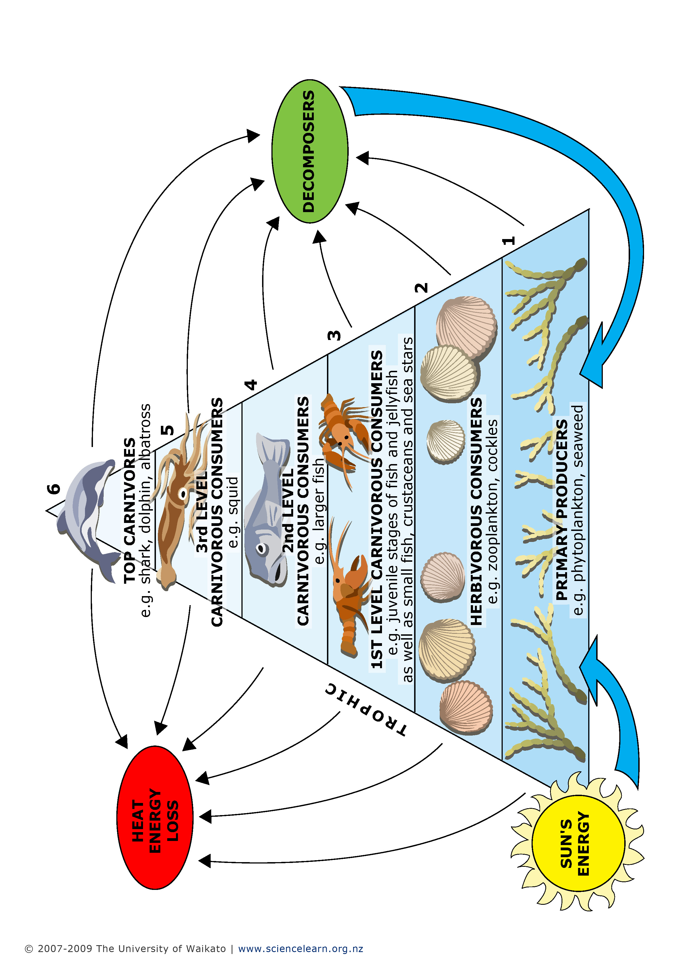
Tuna sandwich
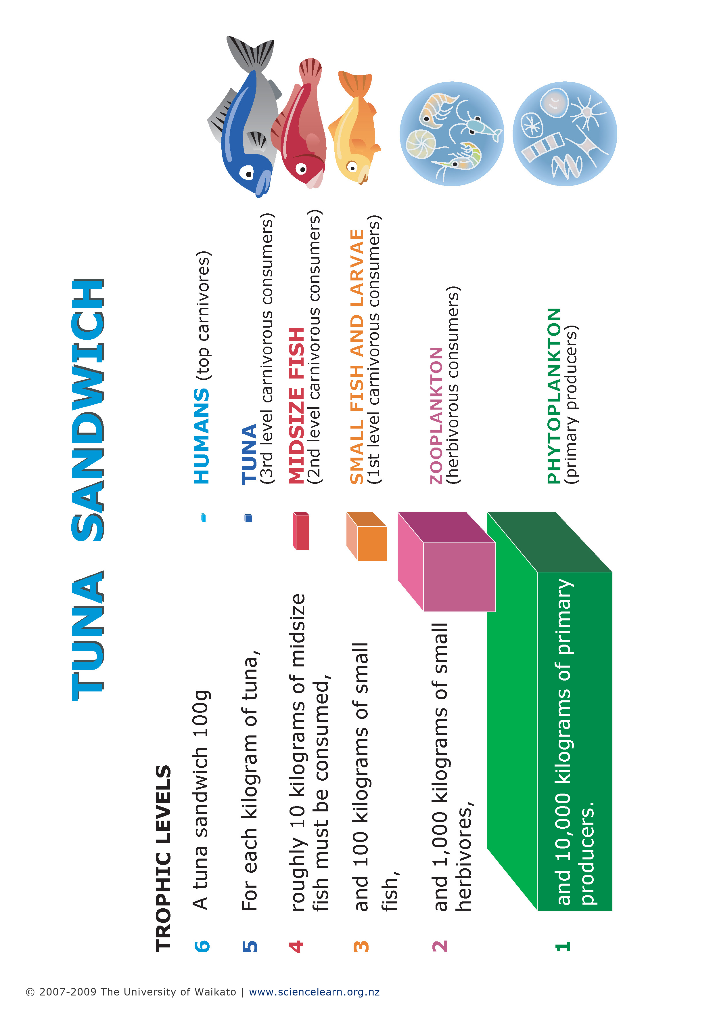
Organism cards (small)

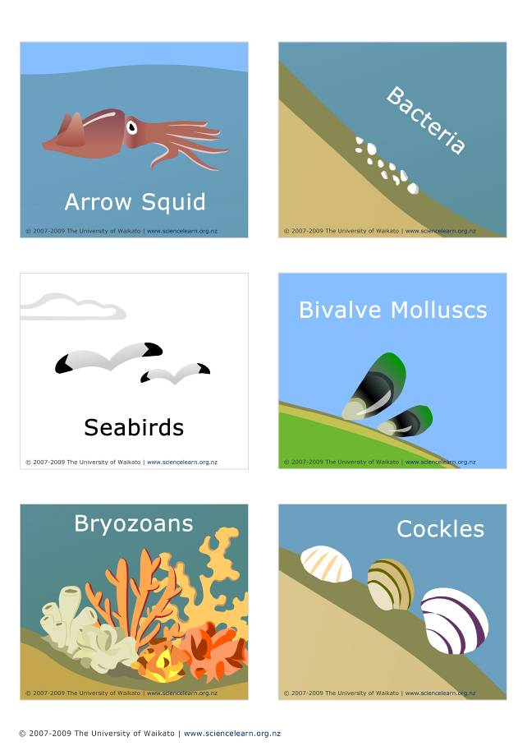

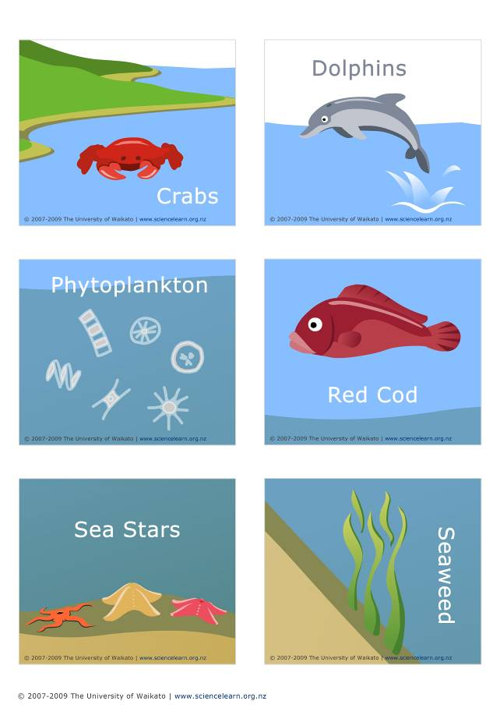

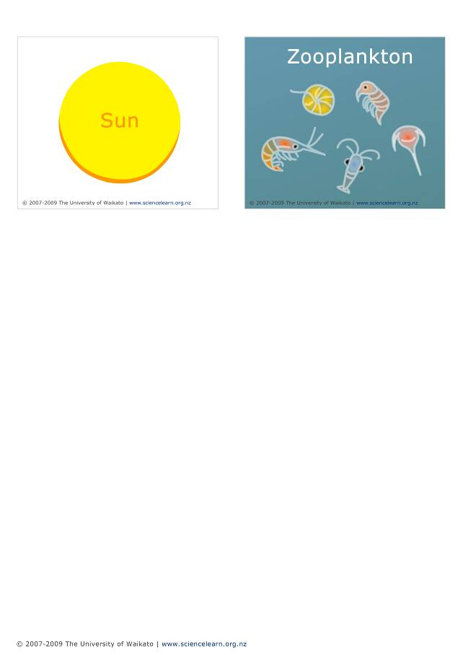
Organism cards (large)
