ACTIVITY: Build a timescale

Activity idea

In this activity, students develop a timescale for a person’s life. The techniques of relative and absolute dating are similar to those used in the construction of a geological timescale.

By the end of this activity, students should be able to:
- understand how a timescale is constructed
- understand the difference between relative and absolute dating
- realise that timescale divisions are not of standard lengths like other scientific units of measurement
- recognise stages of a person’s life.

Introduction/background notes
What you need
What to do
Discussion questions
Extension ideas
Geological timescale for the Earth

Introduction/background

Geologists use an internationally accepted timescale to divide up Earth’s 4.6 billion year history. This timescale is based on two types of dating – relative and absolute. Relative dating places things in sequence from oldest to youngest. Absolute dating provides actual dates.

The length of a geological time division is not a set amount of time – the Jurassic period was 55 million years long, but the Cretaceous period lasted for 80 million years. The boundaries between divisions are mostly defined by the appearance or disappearance of certain fossil species, which have evolved through time.

Geologists have only been able to put actual dates to these time divisions over the last 100 years. A wide range of absolute techniques are now available, especially radiometric ones.

In this activity, students build up a young person’s timescale using similar principles to the construction of a geological timescale. Relative dating places events in a person’s life into a sequence. Absolute dating puts actual dates to some (but not all) of these events.

As an extension activity, it is suggested that students research the life of an older person and construct a timescale based on divisions they decide on themselves.

The instructions below are directed at group work, but there are several different ways you could organise the activity:
- You could build one timescale as a class, based on the life of one older person you invite in.
- You could work in groups – even if all the groups use information from the same person, the resulting timescales will all be different, depending on decisions students make.
- Students could work individually using information from a member of their own family.

Any group or individual work can easily be shared and discussed with the whole class.

What you need

- Access to the article Developing the New Zealand geological timescale and the video clip New Zealand geological timescale
- Copies of Geological timescale for the Earth
- Sticky notes (about 10 per group)
- A3 paper (one sheet per group)

What to do

- As a class, look at Developing the New Zealand geological timescale and the video clip New Zealand geological timescale.

- Hand out copies of Geological timescale for the Earth and look at how it is constructed using eons divided into shorter eras, periods, epochs and ages. (A more detailed example can be found at www.stratigraphy.org/index.php/ics-chart-timescale.)

- Get each student or group to write a sticky note for each of these words:  - INFANT  - YOUNG ADULT  - CHILD  - Attach these notes in a column on the left side of an A3 piece of paper. The words should be in time order, with the earliest event at the bottom. Write the word ‘Eras’ at the top as a label for column.  - Now write a sticky note for each of these words/phrases:  - BABY  - PRESCHOOL/KINDY  - PRE-TEEN  - PRIMARY SCHOOL  - TEEN  - TODDLER  - Students use these as subdivisions of the eras, again in time order with the earliest at the bottom. Label this new column ‘Periods’. There is more than one way of doing this, but one might look like the image on the right. | 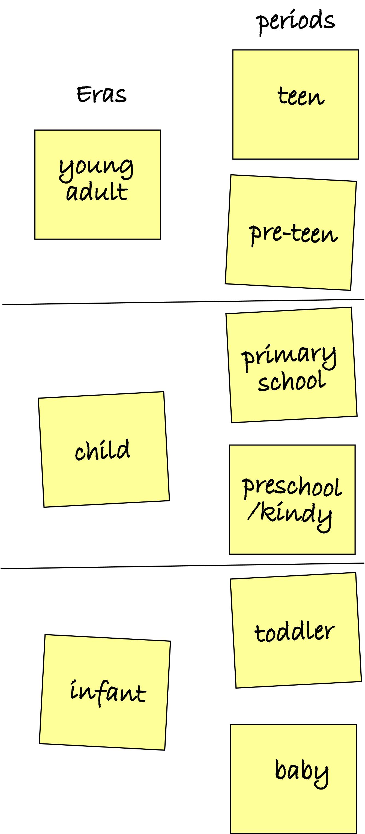
- Students should then choose some events that might mark the change from one period to another. These might include learning to walk, starting kindy, starting secondary school and so on. Write these next to the appropriate part of the ‘Periods’ column.  - The timescale so far is only a relative one – there are no actual dates. Students should now decide where they are on the timescale at the moment (assuming they’re all about the same age). For example, they might be just above the ‘start secondary school’ point. That is time ‘0’, so write that in the correct place on the timescale. How long ago was the first event below ‘0’? For example, the students might have started secondary school 2 years ago – write ‘2 years ago’ next to the event. Continue to write dates for all the events.  - Students should now have a completed timescale, with a relative sequence of events, some of which have actual years associated with them. | 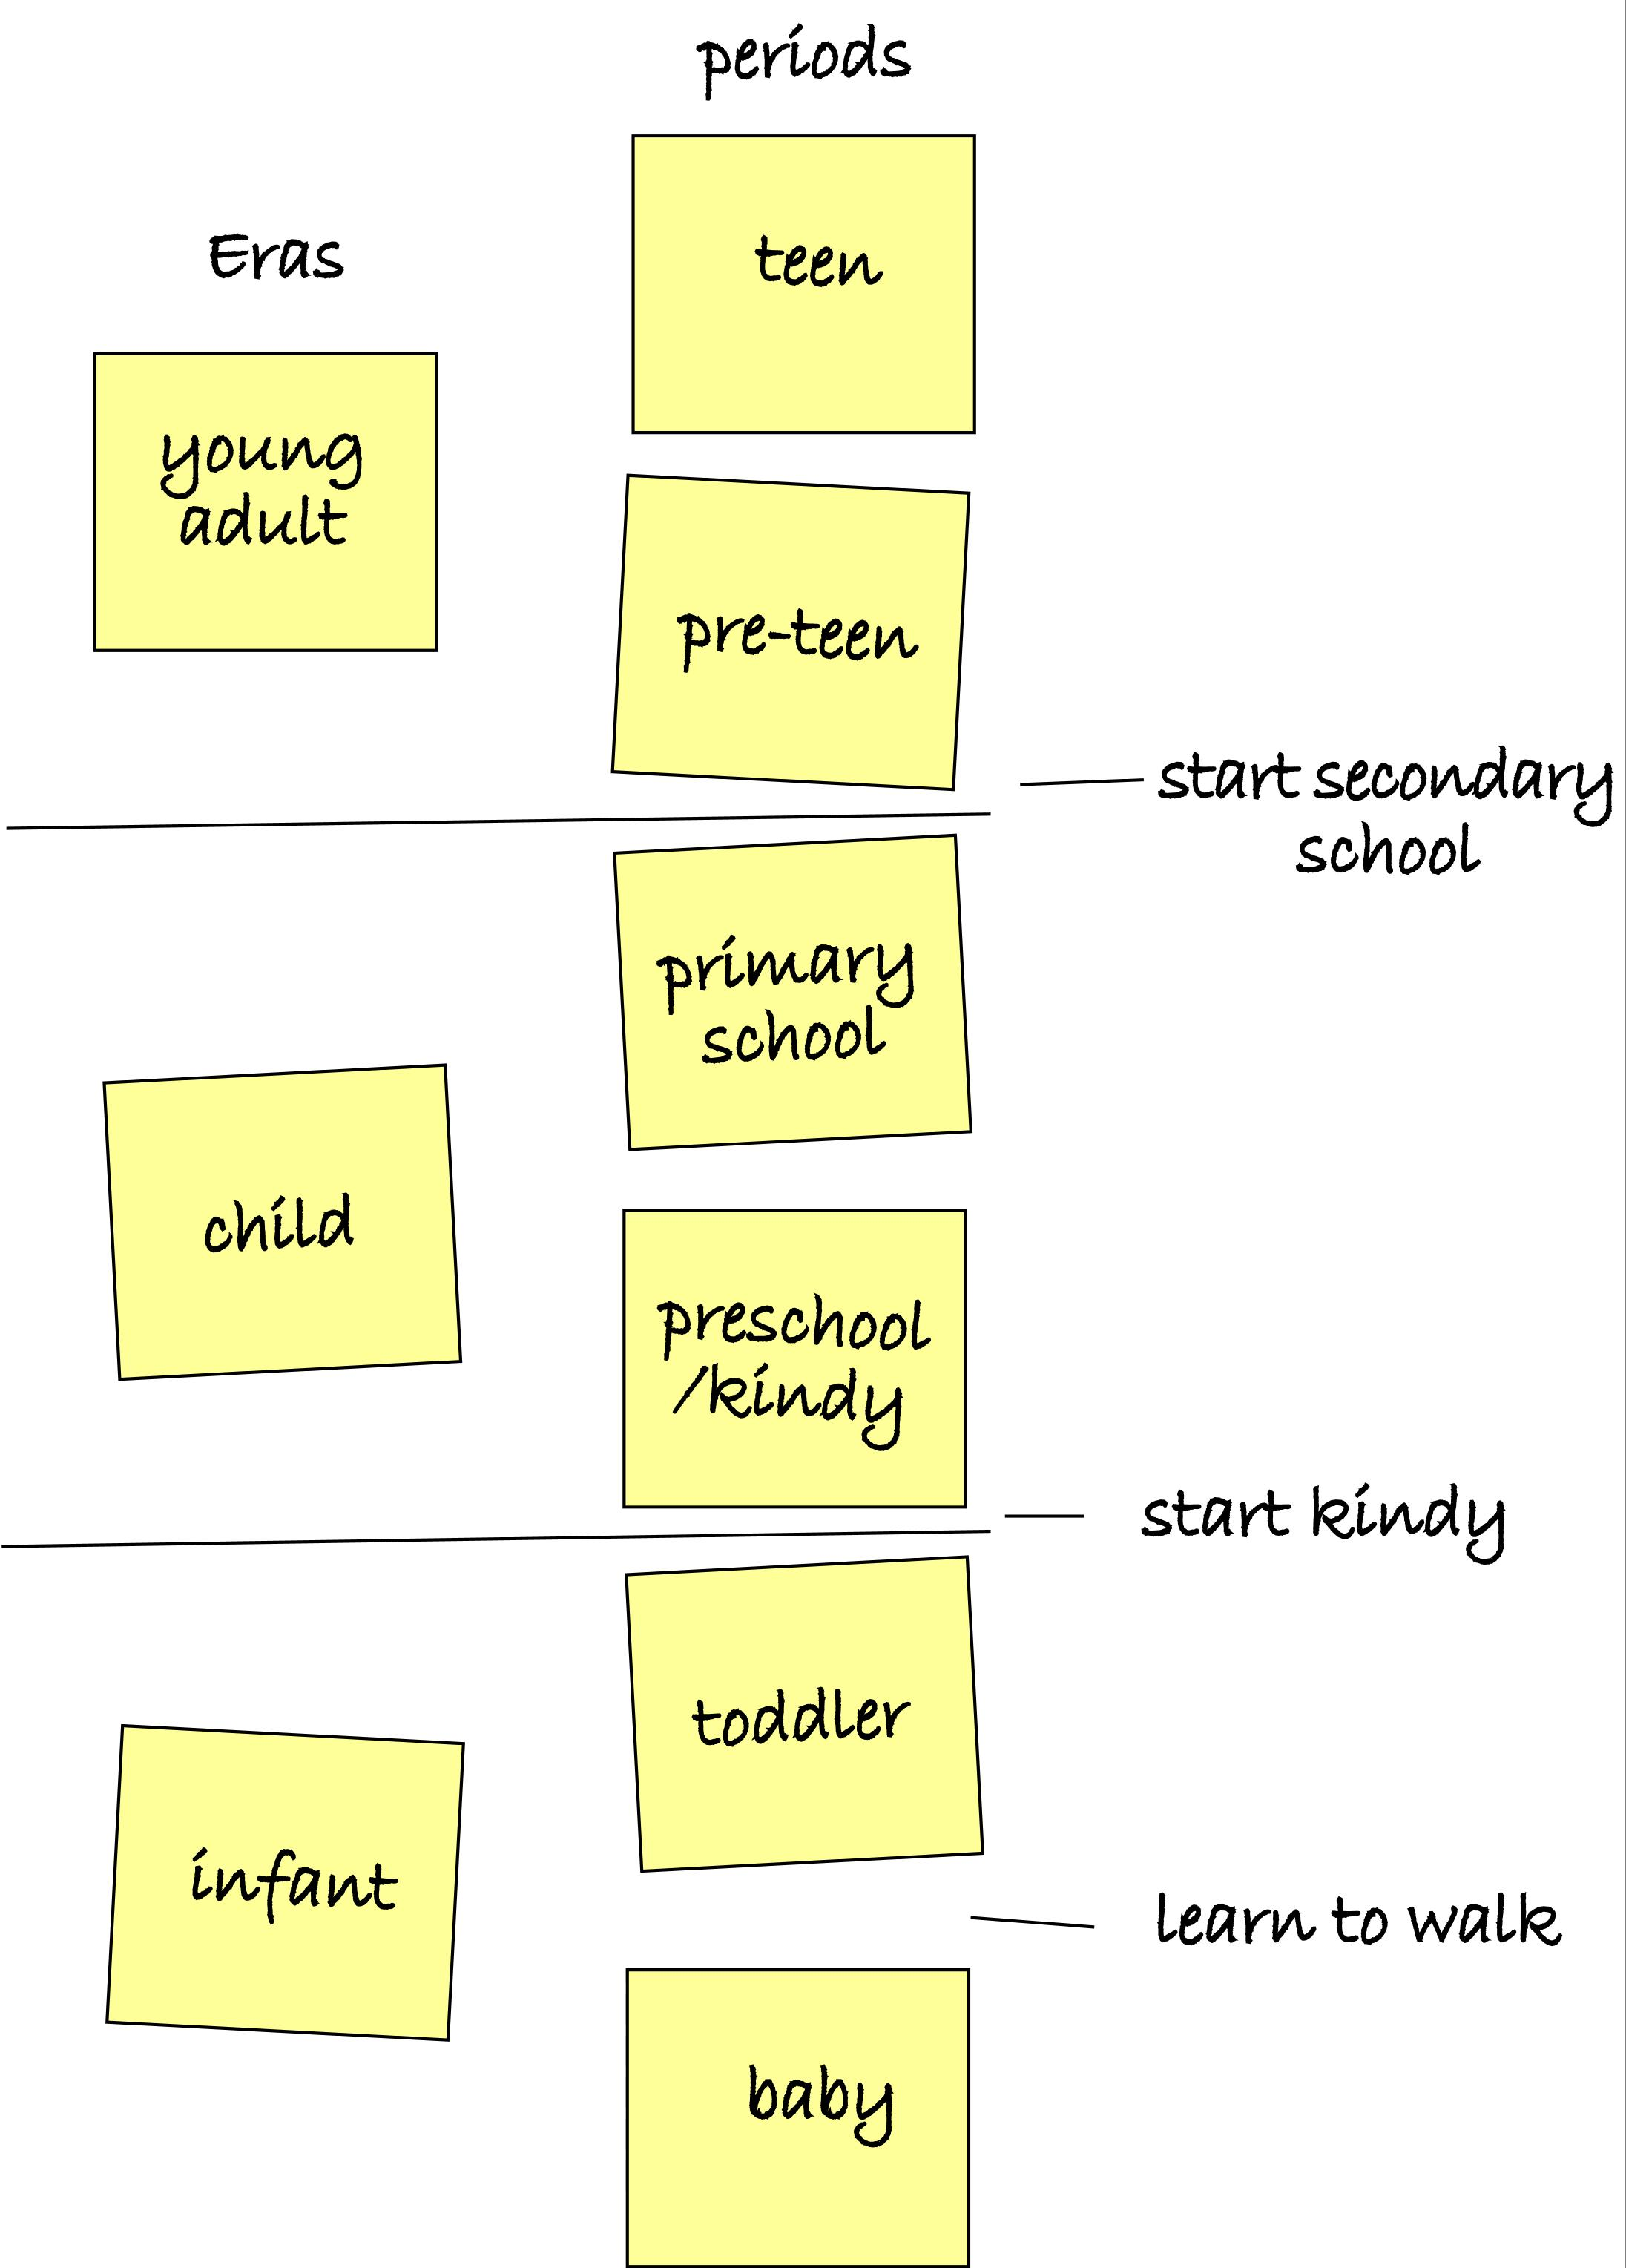

Discussion questions

- Are all the timescales the same? Why/why not?
- Are all the eras or periods the same length?
- Suggest some events that do not mark the boundary between time divisions (for example, learnt to ride a bike). How easy would it be to put actual dates with these?
- What events mark the boundaries between eras? Can these be dated?

Extension ideas

- Have an older person, perhaps someone who has retired, come and talk with the class about their life. Students could ask prepared questions. (Individuals could talk with a member of their own family instead.) They can collect a lot of information about the person’s life, including some dates for events. This information could include (but doesn’t have to) marriage, university, work, family, children, retirement, hobbies, first car, time abroad and so on.
- Students then put together a timescale for the life of the older person. They should devise a few large time divisions (eras) and smaller periods, with actual events and some absolute dates. There are no right or wrong ways of doing the divisions. Much will depend on the type of information obtained. Most older people will probably stick to data that can easily be divided up – such as adulthood divided into single–married–parent–free of children–grandparent or changes of job within their working life. Be prepared for alternative ways of time division – happy/unhappy periods for instance.

Geological timescale for the Earth
