**ACTIVITY: Fossil correlation**

**Activity idea**

In this activity, students date fossils at one site by matching them to fossils already dated somewhere else. They use real data from Mangahouanga, made famous by paleontologist Joan Wiffen.

By the end of this activity, students should be able to:

* understand how the age of fossils in one rock can be obtained using dates from fossils in a different place
* understand that most fossils can only be dated to a time range, not a precise date
* realise that microscopic fossils can be as important as big ones
* read information from scientific charts and share their results with others

Introduction/background notes

What you need

What to do

Discussion questions

Rock sample cards

Late Cretaceous dinoflagellates

How to find a date range

**Introduction/background**

Many fossils, including dinosaurs and marine reptiles, have been found in sandstone rocks at Mangahouanga Stream, north-west Hawke’s Bay. The sandstone has been dated to the late Cretaceous, using its relative position compared to other rocks. However, the late Cretaceous lasted for about 35 million years, and geologists need to know more precise dates if they are to put together the story of New Zealand’s past.

The dinosaur and reptile fossils do not contain material that can be dated directly, so geologists use other fossils found in the rock with them. They use the fossil remains of microscopic single-celled organisms called dinoflagellates, which are common in marine plankton.

By studying rocks in deep-sea cores, geologists have worked out when new species of dinoflagellates appeared and when they became extinct. When they find a fossil dinoflagellate next to a dinosaur fossil in a rock in Hawke’s Bay, they can look at the deep-sea core data and find out when that dinoflagellate lived. They can then say that the dinosaur would have been alive at about the same time. This technique of using fossils from one place to date fossils in another is called ‘correlation’.

In this activity, students use real data from rocks found at Mangahouanga to carry out dating using dinoflagellate correlation.

**What you need**

* Access to the article [Date a dinosaur](http://link.sciencelearn.org.nz/resources/1479-date-a-dinosaur) and video clip [Cretaceous creatures](http://link.sciencelearn.org.nz/videos/808-cretaceous-creatures)
* Copies of Rock sample cards
* Copies of Late Cretaceous dinoflagellates
* Copies of How to find a date range

**What to do**

1. Make sure students know what dinosaurs, mosasaurs and plesiosaurs are. View the article [Date a dinosaur](http://link.sciencelearn.org.nz/resources/1479-date-a-dinosaur) and the video clip [Cretaceous creatures](http://link.sciencelearn.org.nz/videos/808-cretaceous-creatures), which talk about the fossils at Mangahouanga and how they have been dated.
2. Divide the class into 7 groups and give each group one rock sample card and a copy of Late Cretaceous dinoflagellates and How to find a date range.
3. Use the example to explain to students how to use the dinoflagellate information to find a date range for their fossil and enter that information on their sample card.
4. Combine results from all groups. Draw up a chart for the late Cretaceous, showing the date range over which each of the seven fossils lived.

**Discussion questions**

* Which fossil could be dated to the shortest period of time (the most precise dating)?
* Which fossil could only be dated to a wide age range?
* Which gave the most precise dating – samples with one or two dinoflagellate species?
* What could make the dating more precise?

**Rock sample cards**

|  |
| --- |
| **Sample 1 contains:** dinosaur bone  **Dinoflagellates:** *Odontochitina porifera*  **New Zealand stage:** From million years ago to million years ago |
|  |
| **Sample 2 contains:** dinosaur vertebra  **Dinoflagellates:** *Odontochitina spinosa*  **New Zealand stage:** From million years ago to million years ago |
|  |
| **Sample 3 contains:** mosasaur vertebra (*Moanasaurus mangahouangae*)  **Dinoflagellates:** *Odontochitina porifera, Vozzhennikovia spinulosa*  **New Zealand stage:** From million years ago to million years ago |
|  |
| **Sample 4 contains:** mosasaur vertebra  **Dinoflagellates:** *Satyrodinium haumuriense, Vozzhennikovia spinulosa*  **New Zealand stage:** From million years ago to million years ago |
|  |
| **Sample 5 contains:** plesiosaur bone  **Dinoflagellates:** *Odontochitina spinosa, Palaeocystodinium gotzowense*  **New Zealand stage:** From million years ago to million years ago |
|  |
| **Sample 6 contains:** plesiosaur bone  **Dinoflagellates:** *Palaeocystodinium gotzowense*  **New Zealand stage:** From million years ago to million years ago |
|  |
| **Sample 7 contains:** plesiosaur bone  **Dinoflagellates:** *Odontochitina spinosa, Vozzhennikovia spinulosa*  **New Zealand stage:** From million years ago to million years ago |

**Late Cretaceous dinoflagellates** 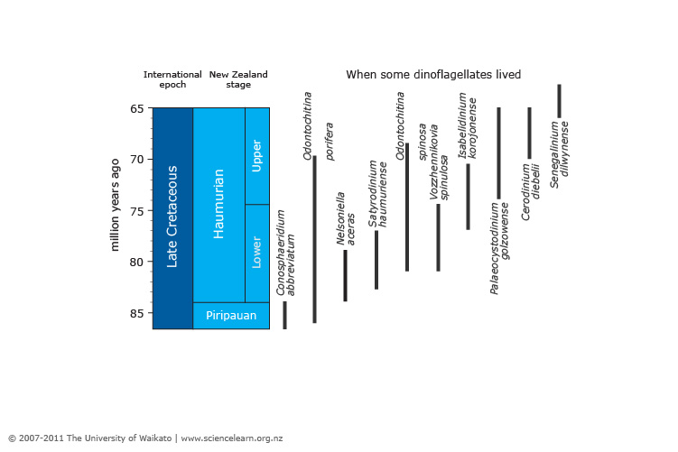

**How to find a date range**

|  |
| --- |
| **Sample A contains:** dinosaur bone  **Dinoflagellates:** *Satyrodinium haumuriense,*  *Odontochitina spinosa*  **New Zealand stage:** From million years ago to million years ago |

1. Find the two dinoflagellate species on the chart.
2. Draw two lines to mark the start and end of when these two species lived together. (If you only have one species on your sample, mark the start and end of when it lived.)
3. Continue these two lines across to the date scale on the left.



You can see that these species lived together in the lower Haumurian stage, 77–81 million years ago.

|  |
| --- |
| **Sample A contains:** dinosaur bone  **Dinoflagellates:** *Satyrodinium haumuriense,*  *Odontochitina spinosa*  **New Zealand stage:** From 77 million years ago to 81 million years ago |

Since the dinosaur fossil was found with these microfossils, we can assume that the dinosaur was around at a similar time.

All you can say is that the dinosaur lived some time in this 4 million year period.