ACTIVITY: Alternative fern collections

Activity idea

In this activity, students use a variety of non-traditional methods to collect and display ferns.

Instead of mounting the dried specimens onto card, students can use cell phone cameras, digital cameras, scanners or photocopiers to create virtual herbaria and explore alternative ways to display ferns.

By the end of this activity, students should be able to:
- find imaginative ways in which to create and display fern collections
- compare multimedia or alternative methods of collection with more traditional methods of collection.

Introduction/background
What you need
What to do
Discussion questions

Introduction/background notes

Traditionally, plant specimens are collected, pressed, dried and mounted onto cardboard for display or storage in museums or personal collections.

While it is still very important to have traditional herbarium collections, advances in technology have opened the way for more creative methods of collecting and displaying ferns.

Use tools familiar to students – cell phones, digital cameras, laminators, etc. – to create alternative fern collections.

During Victorian times, fern albums were passed around/displayed as after dinner entertainment – students could pass around/share their alternative displays, for example, via cell phones.

What you need

- Access to the video clips The value of early collections and Documenting our fern flora
Depending on the method chosen:
- Cell phones
- Digital camera
- Photocopier or scanner
- Materials for preserving ferns – see Traditional fern collections
- Laminating pouches and laminator
- Sun-sensitive paper (available from Crescendo Enterprises)
- Drawing materials

What to do

- Watch the videos The value of early collections and Documenting our fern flora. Both videos show examples of collected fern specimens and discuss why collections are valuable.

- Explain that the lack of technology for early collectors limited how ferns were recorded and displayed. Some of this has changed with advances in technology, while some methods remain, for example, herbarium collections and botanical drawings.

- Have students choose from the following methods to develop their own alternative collections:

Virtual herbarium
- Use a cell phone, digital camera, photocopier or scanner to photograph/scan/photocopy the fern fronds, front and back. Display digital images in an album or as a PowerPoint presentation.

Video herbarium
- Use iMovie, Movie Maker or similar software to create a video about ferns. Use a voiceover to provide similar information normally placed on an identification label. (See the activity Traditional fern collections for label information.)
- Download the video file onto a mobile device like a cell phone or an iPod. Use conversion software (available free on the internet) to create a product ready for transfer to a phone or iPod. On PCs, use a 3G format. On Macintosh devices, use an MP4 format (the iPod option).
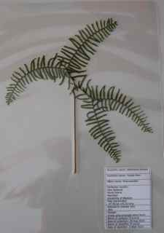
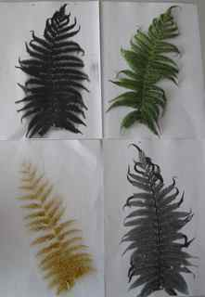
- Transfer the video to a cell phone. If the phones/PCs have Bluetooth capabilities, use this to locate phones and transfer files. Otherwise, transfer files via the phone’s expansion card or its connection cable. If using the expansion card (which is different to the SIM card), place it in an adapter with a micro SD slot. Find the video folder and copy the video file into it. Put the expansion card back into the phone. If you are using a connection cable (now standard with many phones) connect the phone with the PC. Choose Mass Storage or Storage Device, open the video folder and copy the file into the folder.
- For Macintosh devices, use iTunes to load the video. Click on the Share tab, Export using QuickTime, Export: Movie to 3G.

Pass-around herbarium
- Collect, press, dry, and label ferns (see the activity Traditional fern collections), but instead of mounting the fern on cardboard, place the fern and label in a laminating pouch and laminate.
- You can then handle the ferns and can flip the fern around to see sori patterns on the back.

Capturing spores
- Gather multiple fern fronds of the same species displaying sori.
- Photocopy the frond front and back.
- Place the frond on white paper to capture the spores for propagation.
- Remove the frond and photograph the spore pattern. Use the spores as needed for propagation.
- Place a second frond on a sheet of Duraseal or similar sticky, clear plastic. Allow the spores to settle overnight. Carefully remove the frond leaving the spore pattern intact. Cover with a backing of white or coloured paper. Alternatively, place the frond in a laminating pouch and allow the spores to settle overnight. Laminate.
- Display 4 images of the fern species side by side.
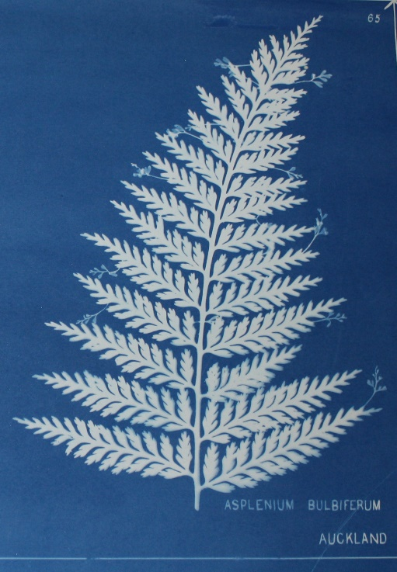
Silhouettes
During the Victoria fern craze, HB Dobbie used a chemical process to illustrate books on New Zealand ferns. The cyanotype process left a white fern silhouette on a blue background.

Because of this, Dobbie’s books are now known as ‘blue books’. You can recreate Dobbie’s famous blue books by using sun sensitive paper.

Other, less expensive methods of creating life-size silhouettes:
- Photocopy – use the darkest setting to create life-size silhouettes. Experiment with frond placement and use coloured paper to create Andy Warhol-type effects.
- Charcoal rubbings are a quick way to create life-size silhouettes.

Botanical drawings
An alternative, though traditional, means of displaying ferns is through botanical drawing. Sketch fern pinnae or sori patterns.

Discussion questions

- Te Papa has a herbarium that holds hundreds of species of dried ferns and an online virtual herbarium. Why do you think they have both?
- Who would be likely to use the virtual herbarium? The real herbarium?
- Which method is more appealing to you – traditional collections or alternative/multimedia collections?
- Why does having a physical specimen remain important?

