ACTIVITY: Conservation ranking in action

Activity idea

In this activity, students work in small groups to rank a number of native reptiles and amphibians according to their conservation threat status or risk of extinction.

By the end of this activity, students should be able to:
- better understand key conservation terms including ‘extinction’, ‘endangered’, ‘threats’ and ‘habitats’
- better understand the importance of a recognised ranking system
- describe typical criteria used by scientists to rank animals according to their conservation threat status
- understand more about human impacts on living things and the most common threats to reptiles and amphibians in New Zealand
- appreciate why it is a difficult job to assign a conservation ranking to a species and that scientists may not always agree.

Introduction/background notes
What you need
What to do
Discussion questions
Extension ideas
Species cards

Introduction/background

Ranking species according to their risk of extinction is an important tool in conservation management. Conservation rankings help DOC to prioritise which species most urgently require action to prevent extinction. They can then allocate their budget according to these priorities.

There are 2 major ranking systems recognised in New Zealand – the IUCN Red List categories and the New Zealand Threat Classification System. The New Zealand system was designed to complement the IUCN system and is tailored to New Zealand’s unique ecology.

The process of assigning rankings is very detailed and is based on scientific evidence. In New Zealand, expert panels of scientists and other specialists get together to discuss a number of species and assign rankings. These are then reviewed periodically.

Criteria used to make an assessment include:
- distribution of the species
- habitat
- major threats
- conservation measures
- population size estimates.

See the useful links and Conservation Rankings article for more information.

What you need

- Species cards – 1 set per group.

What to do

- As a class, watch the video clip Conservation rankings.

- Discuss what is meant by the term ‘conservation rankings’ and why they are important. Come up with a list of criteria that scientists might use to help make their decisions (for example, threats or remaining numbers).

- Divide the class into small groups (3–4 students). Explain that each group represents an expert panel that have gathered to rank a number of reptiles and amphibians from most endangered to least endangered. The students might like to invent a character for themselves, including a name and job title of someone who is likely to sit on an expert panel.

- Hand out 1 set of species cards per group. The group needs to rank the animals on the cards in order from most endangered to least endangered (or highest to lowest risk of extinction).

- Allow sufficient time for the groups to read the information on the cards and make their decisions.

- Give each group the opportunity to feed back to the class and discuss. If appropriate, come up with an agreed ranking order for the whole class based on these discussions.

Discussion questions

- What criteria did you use to make your decisions?
- Do you need any additional evidence? If so, what kind of evidence would be helpful?
- Did you recognise any of the species on the cards? Did this affect your decision?
- Did emotions have an effect on your decision (because some animals are more attractive or more well known than others)?
- Are there any threats common to all species?
- What actions (if any) do you think are needed for each species?
- Are there any conservation strategies that would benefit all species?
- How often do you think conservation rankings should be reviewed?

Extension ideas

- Students could research the specific rankings that scientists assign to different species, for example, ‘critically endangered’ or ‘vulnerable’, and decide which is most appropriate for each species. Refer to the Conservation Rankings article and useful links for more information.
- Students could research the current conservation threat status for each species and use this information to order their cards.

Tuatara

Scientific name: Sphenodon punctatus

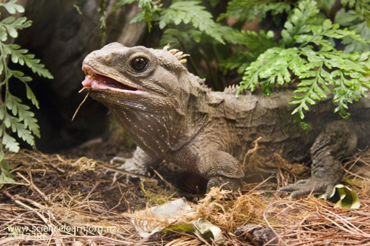

Habitat: Normally live in burrows and prefer coastal shrub and bush.

Current distribution: Offshore and mainland islands that have no mammalian predators.

Past distribution: All over New Zealand.

Diet: They eat almost everything including insects, snails, frogs, skinks and birds’ eggs.

Number of individuals in the wild: Approximately 100,000.

Threats: Introduced mammalian predators, especially rats, habitat loss and smuggling.

Other: Tuatara are the only living representative of a group of reptiles known as Rhynchocephalia (sometimes known in the past as Sphenodontia). The ancestors of tuatara were present on the landmass that would later become New Zealand, when it separated from Gondwana over 80 million years ago.
Archey’s frog

Scientific name: Leiopelma archeyi

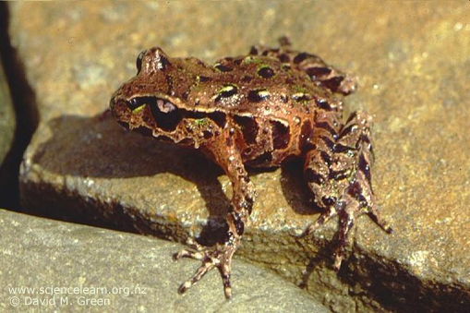

Habitat: Prefers scrubland and forests in sub-alpine areas. They spend most of the day hidden under stones or logs and may climb into trees and bushes at night-time.

Current distribution: Coromandel Peninsula and Whareorino Forest, west of Te Kūiti.

Past distribution: It is thought they were once more widespread and found in Waitomo, Hawke's Bay, Wairarapa and north-west Nelson.

Diet: Small insects, worms and other invertebrates.

Number of individuals in the wild: Unknown. Evidence suggests that the number of individuals has dropped by 80% in the last 10 years.

Threats: Chytridiomycosis disease (caused by chytrid fungus), introduced mammalian predators and loss of habitat.

Other: 1 of only 4 remaining native frog species in New Zealand. Our native frogs are the most ancient and primitive in the world and have many unusual features compared to frogs in other countries.

Otago skink

Scientific name: Oligsoma otagense

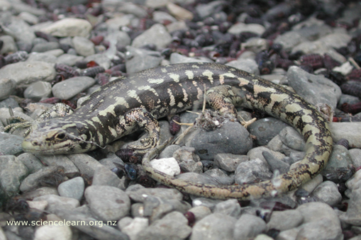

Habitat: Sheltered cracks and crevices of large rocky outcrops (called tors) in upland tussock areas.

Current distribution: Only found in small pockets in Otago. The highest numbers are found in the Macraes Conservation Area.

Past distribution: Throughout upland Otago. Now found in only 8% of their former range.

Diet: A wide variety of invertebrates, soft fruit and vegetation. They occasionally eat small skinks and flower petals.

Number of individuals in the wild: Approximately 2,000.

Threats: Introduced mammalian predators and habitat loss.

Other: The Otago skink is New Zealand’s largest lizard (up to 30cm). They don’t hibernate and can live up to 20 years in the wild.

McCann’s skink

Scientific name: Oligosoma maccanni

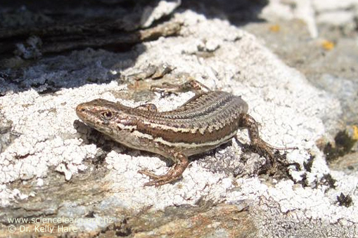

Habitat: Sand dunes, grasslands, herb fields, scrub and rocky areas from the coast up to 1,700 metres above sea level.

Current distribution: Otago, Southland and Canterbury.

Past distribution: Otago, Southland and Canterbury.

Diet: Mostly insects. They will also eat soft fruit and some other vegetation.

Number of individuals in the wild: Unknown.

Threats: Introduced mammalian predators and habitat loss (especially due to land being cleared for farming).

Other: Endemic species (only occur naturally) in New Zealand.
Common gecko

Scientific name: Hoplodactylus maculatus

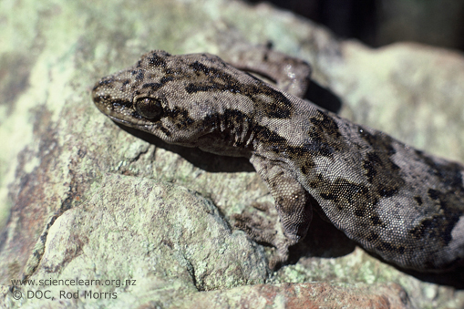

Habitat: All types of open country from coastal areas to rocky hillsides as well as forests. They often make homes among dead wood and boulder banks.

Current distribution: Common throughout the North and South Islands especially in coastal regions.

Past distribution: Common throughout the North and South Islands especially in coastal regions.

Diet: Night-flying insects such as moths and beetles. They occasionally eat nectar and fruit.

Number of individuals in the wild: Unknown but some mainland populations are declining.

Threats: Introduced mammalian predators, especially rats.

Other: Endemic species (only occur naturally) in New Zealand. They are important seed dispersers for many native seeds.

Jewelled gecko

Scientific name: Naultinus gemmeus

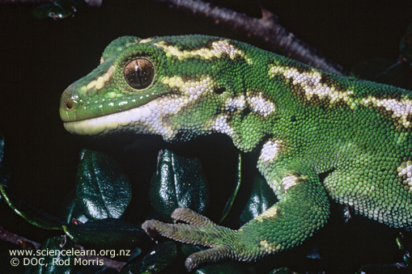

Habitat: Forests, shrubland and tussock grasslands.

Current distribution: Fairly widespread in Canterbury with high numbers on Banks Peninsula. Smaller populations are found south of Otago.

Past distribution: Spread widely across Central Otago as well as Canterbury and Southland.

Diet: Mostly flies, beetles and other insects. They will also eat soft fruit and berries

Number of individuals in the wild: Unknown. It is thought the species is in gradual decline and maybe almost extinct in Otago.

Threats: Loss of habitat and introduced mammalian predators, especially rats. They are also eaten by some introduced bird species.

Other: Because of their colourful markings, jewelled geckos are a popular target for lizard smugglers. Smuggling is illegal and a major threat to the species.

