ACTIVITY: Make a printed circuit board

Activity idea

In this activity, students make a printed circuit board photographically by shining UVA light through a negative artwork mask to cure and harden a thin coating of UV-sensitive material that covers the copper.

By the end of this activity, students should be able to:
- demonstrate the use of UVA light to cure a photosensitive chemical in the process of making a circuit

Introduction/background notes
What you need
What to do
Student handout: Make a circuit board

Introduction/background

This activity is to show students an application of UV light. For those interested in electronics, it’s a chance to make a circuit board of their choice. In the process of producing their boards, students will apply UVA light to cure a thin coating of UV-sensitive material that covers the copper.

Safety
Note that both ferric chloride solution and sodium hydroxide solution can be harmful. Care should be taken when handling them. Rubber gloves should be worn.

What you need

- Pre-coated copper printed circuit board (PCB) (you can purchase this from suppliers such as Jaycar Electronics or Surplustronics – both companies sell a Riston brand PCB, 152 x 152 mm in size) that has a thin film of photo-resist applied to the copper surface – the photo-resist is very sensitive to UVA and needs to be kept away from sunlight or any other UV source
- Craft knife
- Negative artwork of the circuit layout (mask)
- Sheet of glass
- Source of UVA (such as a black light or aquarium fluorescent tube)
- Plastic container
- Developing liquid (you can purchase this from suppliers such as Jaycar Electronics or Surplustronics)
- Soft paintbrush
- Etch-resist felt-tip pen or fingernail polish and a fine paintbrush
- Ferric chloride solution
- Sodium hydroxide solution
- Solder and soldering iron
- Circuit board components
- PCB drill
- Copies of the student handout Make a circuit board

What to do

- Hand out copies of the student handout Make a circuit board and assist students to gather the materials they need, working in small groups. Discuss the results.
Student handout: Make a circuit board

- Cut the PCB to size and place the negative artwork of the circuit layout (the mask) on the coated PCB.

- Cover with a sheet of glass to keep the mask flat on the PCB.  - Expose the mask and board for approximately 3 minutes to a steady source of UVA (such as a black light or aquarium fluorescent tube) or broad daylight. The parts of the photo-resist that have been exposed to UV through the mask will cure and harden. | 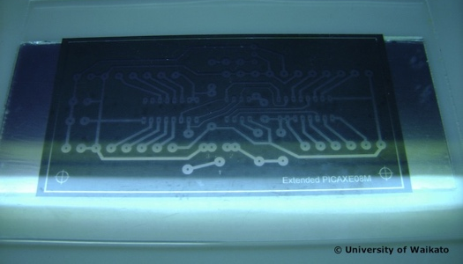
- Use a developing liquid and a soft paintbrush to dissolve the uncured sections. | 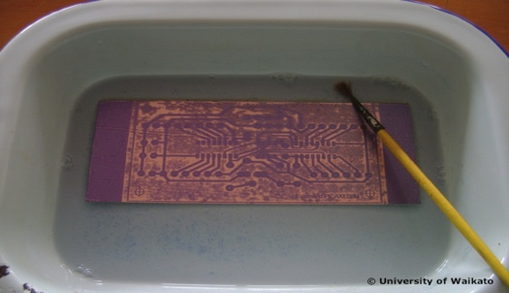
- Touch up any imperfections in the photo-resist using a commercial etch-resist felt-tip pen or a small amount of fingernail polish and a fine paintbrush. | 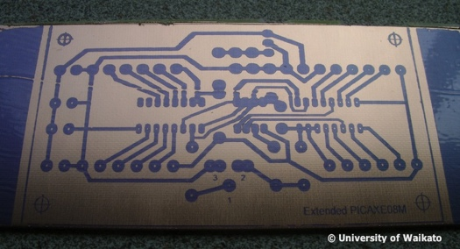
- Use a strong ferric chloride solution to etch away the exposed copper on the PCB. | 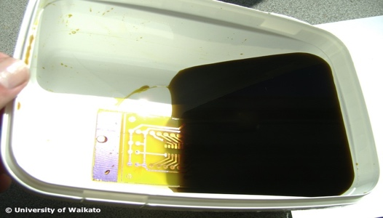
- When fully etched, wash the PCB in warm water and dry. | 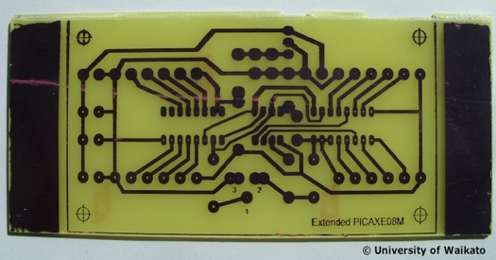
- Use a medium strength sodium hydroxide solution to strip off any photo-resist that remains.  - Trim the PCB and drill the holes. Now you’ve made the circuit board, insert the components and solder them in place. | 