ACTIVITY: Karyotypes

Activity idea

In this activity, students explore the process of amniocentesis and assemble a karyotype.

By the end of this activity, students should be able to:
- assemble and explain a karyotype
- explain amniocentesis and describe the process.

Introduction/background notes
What you need
What to do
Student handout: Producing a karyotype of a foetus
Student handout: Assembling a karyotype

Introduction/background

Doctors are able to obtain information about a developing baby from their karyotype – the group of chromosomes in one of their cells.

A pregnant mother can visit an obstetrician and have amniotic fluid drawn from her uterus so that the karyotype of her baby can be examined. This process is called an amniocentesis.

As the baby develops and grows, a few of its cells rub off and collect in the surrounding amniotic fluid – these cells are examined.

An amniocentesis can show whether a foetus has certain birth defects, especially chromosome abnormalities.

What you need

- Copies of the student handout Producing a karyotype of a foetus
- Copies of the student handout Assembling a karyotype
- Access to the article Cell division

What to do

- As a class, read the Science Ideas and Concepts article Cell division.

- Give each student copy of the student handout Producing a karyotype of a foetus. Ask them to cut up the sheet and assemble it in a logical order on a large sheet of paper and write a title for each stage. Compare and discuss results

- Give each student the student handout Assembling a karyotype. Ask them to:
- cut out all of the chromosomes, making sure they keep the numbers on them.
- match them into pairs and arrange them on a page from 1 to 23.

- Compare results – can they find the genetic abnormality?

Student handout: Producing a karyotype of a foetus

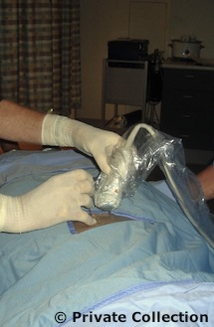
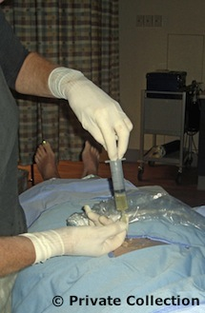
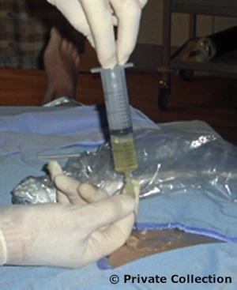
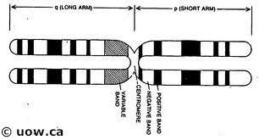
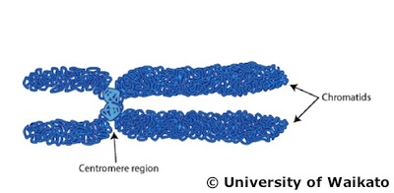
Student handout: Assembling a karyotype
The mother-to-be visits a specialist obstetrician. This doctor will use ultrasound to see where the baby is in the amniotic fluid as they do not want the needle to go near the baby. The doctor will observe a monitor throughout the amniocentesis to check for the position of the baby.
The needle goes through the muscles of the abdomen and the muscles of the uterus into the amniotic fluid. The baby has done a lot of moving and growing, so its cells are in the fluid and so is a lot of its urine. The doctor collects about 20 ml of amniotic fluid so they can extract some cells to look for chromosomes. (The pain the mother feels is no more than an injection from a dentist.)
Once the fluid is at the lab, it is split into a number of tubes (possibly 15). This will ensure results are accurate as repeat tests can be made.

Water is placed in with the chromosomes. This causes them to swell so they are easier to see.

The cells are allowed to multiply, and then at one stage in the cell division cycle, they are made to stop dividing. This point is the best for observing chromosomes.

A picture is taken of the chromosomes, and it is enlarged so the scientist can see the chromosomes properly.

A stain is added that will stain different parts of the chromosome different shades.
Pairs of chromosomes are stained the same and are the same length with the centromere at the same place, so the scientists can arrange the chromosomes into a karyotype – an arrangement of chromosomes according to size order.

