ACTIVITY: Individual pursuit graphs

Activity idea

In this activity, students analyse graphs of speed and force for Alison Shanks, one of New Zealand’s world champion cyclists, in the women’s 3,000 metre individual pursuit track cycling event.

By the end of this activity, students should be able to:
- describe motion based on information from a speed versus time graph
- use a graph to estimate acceleration and distance travelled
- use graphs of speed and force to estimate aerodynamic drag.

Introduction/background
What you need
What to do
Extension ideas
Student worksheet: Analysing individual pursuit graphs
Answers to student worksheet

Introduction/background

Alison Shanks is one of New Zealand’s elite cyclists. In 2009, she won the World Track Cycling Championships in the 3,000m individual pursuit event. This real data from an event in 2008 allows students to analyse the forces acting on Alison and how speed changes through the event. It also allows for some simple calculations.

Graphs are a rich source of data. For the competitive cyclist, graphs are essential to help work out the best power strategy. They experiment with how much effort they apply at the start and throughout the race to find what strategy produces the fastest overall time.

Converting speed
The speed versus time graph gives data in the commonly understood units of kilometres per hour. To convert speed values into metres per second, divide the km/h by 3.6 (53km/h = 53 ÷ 3.6 = 15m/s).

Describing motion
Students need to use terms such as ‘speeding up’, ‘slowing down’, ‘travelling at a constant speed’ or ‘stopped’.

It is interesting to note that the maximum force applied is about 80 newtons at the start of the race. It is at this time that the speed is increasing most rapidly (accelerating). Acceleration can be approximated using change in velocity divided by time taken. This tells how many metres per second the speed changes each second or how many kilometres per hour the speed changes each second. (Approximately 50km/h in 10 seconds means an acceleration of 5km/h each second – this is about 1.4m/s increase in speed each second.)

The slight changes in speed are due to the cyclist slowing down as they go into each corner.

Calculating distance travelled
This is approximately the area under the distance versus time graph. By using a speed of about 15 metres per second, the area under the graph is approximately 15m/s x 200s. This confirms a distance of about 3,000m.

Resultant force and acceleration
Once a constant speed has been reached, the forces are all balanced. The forwards force at this point is equal to the opposing forces (mainly aerodynamic drag).

Balanced forces and constant speed
As speed increases more, the drag forces increase to the stage where the forces become balanced. The resultant force becomes zero so there is no more change in speed.

What you need

- Copies of the student worksheet: Analysing individual pursuit graphs

What to do

- Hand out copies of Analysing individual pursuit graphs.

- Discuss why graphs are useful.

- Allow students to complete analysis of graphs.

- Discuss ideas related to describing motion, using information from graphs, resultant forces and balanced forces.

Extension ideas

How much power can you produce? One way of finding out is to calculate how long it takes you to run up a flight of stairs.

Power is change in energy divided by time taken:

power (in watts, W)
= your mass (kilograms) x height of stairs (metres) x 9.8 divided by the time taken to reach the top (seconds)
= ______ kg x ______ m x 9.8 divided by ______ s
= ______ watts (W)

1 watt means that there is 1 Joule of energy converted every second.

Analysing individual pursuit graphs

One of New Zealand’s world-class cyclists is Alison Shanks. She won the 3,000 metre individual pursuit at the 2009 World Track Cycling Championships in Poland with a time of 3 minutes 29.8 seconds. Her success depended on a balance between excellent aerodynamics, powerful pedalling and good pacing strategy.

In order to win races, cyclists need to exert a lot of power at the start. They try to generate as much acceleration as possible so they can reach the speed they will be able to maintain for the rest of the race. Once they are travelling at a constant speed, all of their pedalling power goes into fighting aerodynamic drag and rolling resistance.

Graphs like these are essential tools for athletes, scientists and coaches to work out a strategy that will give the best overall time.

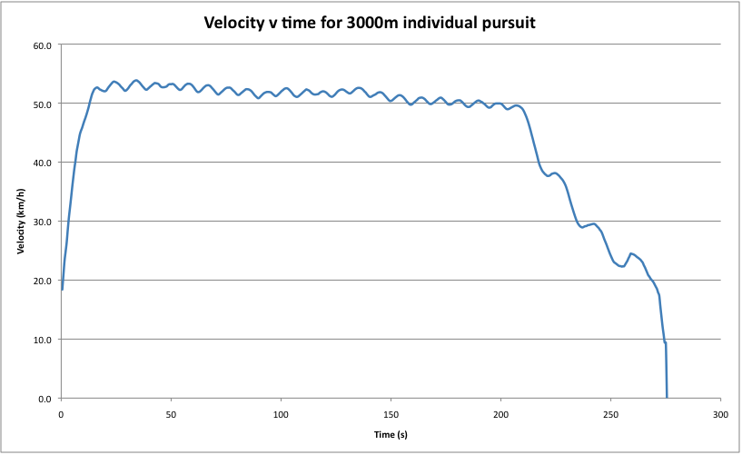

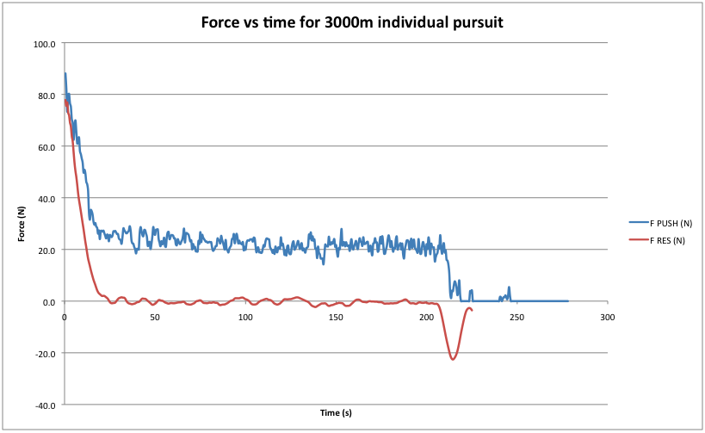

- Describe the motion of this cyclist:

- from 0 to 10 seconds

- between 10 and 20 seconds

- between 50 and 100 seconds

- At what time does the cyclist start to slow down?

- Why do you think the speed seems to be going up and down slightly for most of the race?

- How could the velocity graph be used to work out how far the cyclist has travelled?

- At about what time do the forces become balanced?

- What was the maximum speed reached?

- At maximum speed, how many metres were travelled every second? (km/h ÷ 3.6 = m/s)

- How long does it take the rider to reach 40 kilometres per hour?

- The acceleration of the rider is how much the speed changes every second. During the time it takes to reach 40km/h, calculate the acceleration (acceleration = change in speed ÷ time taken).
acceleration = change in speed ÷ time taken
= ________ (km) ÷ _______ (s)
= ________ kilometres per hour per second

- Acceleration is normally measured in terms of how many metres per second the speed changes each second. This can be found by dividing the kilometres per hour value by 3.6.

acceleration = change in speed ÷ time taken
= ________ (m/s) ÷ _______ (s)
= ________ metres per second per second

- What was the maximum forward force on the bike and rider in newtons, N?

- Once the cyclist is travelling at maximum speed, how much force is needed to balance the aerodynamic drag in newtons, N?

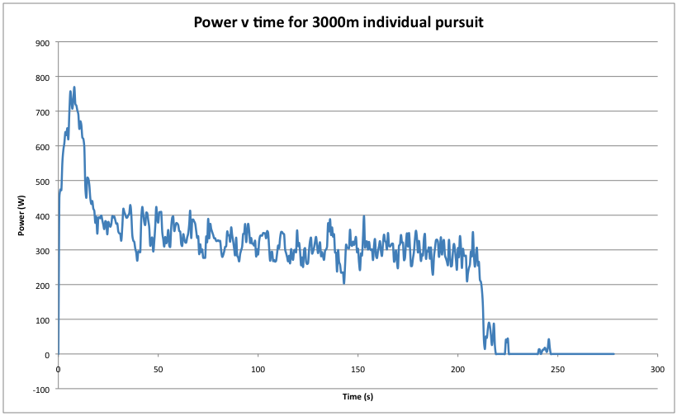

- Racing cyclists train and think in terms of power (how much energy is converted each second), which is the best indicator of how much effort they are using. What is the peak power shown in this graph?

- What is the average power maintained for most of the race?

- How long does this race last in minutes and seconds?
Answers to analysing individual pursuit graphs

- Describe the motion of this cyclist:
- from 0 to 10 seconds – Cyclist is speeding up rapidly.
- between 10 and 20 seconds – Cyclist is still speeding up but not as quickly and then reaches a nearly constant speed of about 52 km/h.
- between 50 and 100 seconds – Cyclist travels at a nearly constant speed that fluctuates between 52 and 53 km/h.

- At what time does the cyclist start to slow down rapidly?
At about 210 seconds.

- Why do you think the speed seems to be going up and down slightly for most of the race?
The rider slows down while cornering at each end of the cycling track.

- How could the velocity graph be used to work out how far the cyclist has travelled?
Distance travelled is the area under a speed versus time graph. Average speed for most of the race is about 52km/h, which is 52 ÷ 3.6 = 14.4m/s. 14.4 m/s multiplied by 210 seconds gives 3,024 metres. (This data is for a 3,000m time trial.)

- At about what time do the forces become balanced?
About 20 seconds.

- What was the maximum speed reached?
About 53 km/h.

- At maximum speed, how many metres were travelled every second? (km/h ÷ 3.6 = m/s)
53km/h ÷ 3.6 = 14.7 metres per second.

- How long does it take the rider to reach 40 kilometres per hour?
About 7 seconds.

- The acceleration of the rider is how much the speed changes every second. During the time it takes to reach 40km/h, calculate the acceleration (acceleration = change in speed ÷ time taken).
Acceleration = 40 ÷ 7 = 5.7 kilometres per hour increase in speed each second.

- Acceleration is normally measured in terms of how many metres per second the speed changes each second. This can be found by dividing the kilometres per hour value by 3.6.
Acceleration = (40 ÷ 3.6) ÷ 7 = 1.6 metres per second per second.

- What was the maximum forward force on the bike and rider in newtons, N?
90N.

- Once the cyclist is travelling at maximum speed, how much force is needed to balance the aerodynamic drag in newtons, N?
About 24N.

- Racing cyclists train and think in terms of power (how much energy is converted each second), which is the best indicator of how much effort they are using. What is the peak power shown in this graph?
770W.

- What is the average power maintained for most of the race?
About 320W.

- How long does this race last in minutes and seconds?
3 minutes and 30 seconds.

