ACTIVITY: Estuaries – a Māori perspective

Activity idea

In this activity, students explore Māori perspectives concerning estuaries.

By the end of this activity, students should be able to:
- explain how a Māori legend can show aspects of early Māori thinking and living
- recognise some Māori words for common items found in an estuary
- explain the concept of kaitiakitanga in simple terms
- describe why people value estuaries from a Māori and non-Māori perspective.

Introduction/background notes
What you need
What to do
Māori legends
Items found in estuaries
Māori name cards

Introduction/background

Estuaries were favourite places for first Māori settlers. They were food baskets where fish, shellfish and birds could be safely harvested. Middens (ancient rubbish dumps) have been found near most sheltered estuary spots in New Zealand – especially northern harbours with large shellfish beds. Estuary rivers gave Māori access inland where they could gather timber and flax and hunt birds and eels. Estuaries still have special significance for Māori today, and many Māori still regard them as food baskets for their staple foods.

Estuaries are valued by tangata whenua because they:
- are a source of identity
- support the mana and wairua of the iwi
- provide a context for learning customs and traditional knowledge
- are tūrangawaewae – a source of health
- are a source of kaimoana to share with guests and for special occasions
- support recreation with whānau and hapū
- provide commercial value and employment.

Unfortunately, many estuaries have become degraded in recent times because of human activity. Māori values have been compromised by environmental changes in estuaries such as:
- a decline in number and size of fish and shellfish
- introduced plants and animals displacing native species and/or changing the environment
- an increase in sedimentation and more muddy sedimentation being deposited
- degraded water quality and risk of contamination of water and kaimoana due to run-off of human and animal waste
- competition with visitors for kaimoana and other resources.

The Māori concept of kaitiakitanga is about guardianship or protection. It involves conservation and sustainability to safeguard the future – for future generations. Read Kaitiakitanga and mana whakahaere to understand the responsibility of kaitiaki.

The following activities introduce students to a Māori perspective concerning the health of the environment, particularly estuaries. Students should consider how science can help Māori and how Māori knowledge can help scientists.

In the first activity, students read brief accounts of three legends. These legends are ‘windows’ into Māori knowledge. For example, the canoe was an important item for food gathering and the North Island was a plentiful food basket – a big fish to enjoy. In the other legends, Māori seem to be offering an explanation as to why eels live both in the sea and in freshwater. In both legends, eels began from the same source, indicating that the freshwater and saltwater eel are a related species.

The second activity is a matching game of Māori names and images from estuaries. The answers are as follows:

mātaitai | shellfish bed
taikoraha | mudflat
onepū | sandflat
mānawa | mangrove
mānatu/mākaka | saltmarsh ribbonwood
karepō/nana | seagrass
tāmure | snapper
aua | yellow-eyed mullet
marakura/kupae | slender sprat
tuangi/huangi | cockle
tio | oyster
pipi | pipi

Students are then introduced to the concept of kaitiakitanga. This could be followed up with a visit from a kaumātua or local iwi (could be parents) giving the students a chance to discuss kaitiakitanga and to ask further questions.

What you need

- Access to the articles Kaitiakitanga and mana whakahaere, Kaimoana in the Hauraki Gulf and Valuing estuaries
- Access to the online Māori dictionary
- Access to the video clip Kaitiakitanga
- Copies of Items found in estuaries
- Copies of Māori name cards

What to do

Activity one

- Distribute copies or read the Māori legends summaries to the class.

- Ask students to think about what they think the legends might mean concerning Māori knowledge. In small groups, discuss what the legends are trying to explain, for example:
- A lot of food for early Māori came from the sea. Consequently, the canoe was an integral part of food gathering and represented the South Island in the first legend. A lot of kaimoana was harvested in the North Island – depicted in the legend as the fish.
- The other two legends acknowledge that early Māori noticed that some eels lived in freshwater and some in seawater. The legends endeavour to explain how this may have come about. In both legends, eels began from the same source, indicating that the freshwater and saltwater eel are related species.

Activity two

- Give groups of students a colour copied sheet of items found in estuaries – images of habitats, plants, shellfish and fish. Also give them a set of Māori name cards cut out.

- Students use the online Māori dictionary to match the items with their Māori names.

Activity three

- Read and discuss Kaitiakitanga and mana whakahaere and view the video clip Kaitiakitanga. Design posters that explains the concept of kaitiakitanga. Include who kaitiaki are and what they do. Share posters with the class. Display posters.

- Interview local iwi (you could ask someone to come to school, or your group could go to visit them). Share with them what you have been studying at school. Ask them what they think about sharing knowledge to help monitor the environment and to restore our environment for future generations. What knowledge has been passed on to them about caring for estuaries or the environment? Would science knowledge be helpful?

- As a class, discuss cultural perspectives:
- In what ways are Māori perspectives concerning estuaries different from the traditional/western views?
- In what ways are they the same? (See Introduction/background and the article Valuing estuaries.)
- Why would damage to estuaries and pollution (including toxins getting into kaimoana) be of particular concern to Māori? Read Kaimoana in the Hauraki Gulf.

Māori legends

Māui, the fish and the canoe
Legend has it that Māui fished up the North Island of Aotearoa – Te Ika a Māui – while sitting in his canoe. The canoe was the South Island. That canoe (South Island) became the provider of food for Māori people, with the North Island’s many estuaries, beaches and rocky shores (full of fish, shellfish and birds).

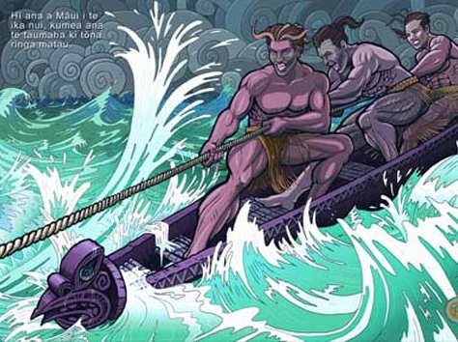
©Learning Media Ltd
Reference: Eke Panuku 14, Wellington: Learning Media Ltd, 2004.
Artwork by Manu Smith

Māui and Tuna
The demigod Māui fought Tuna, a supernatural giant eel, because it had frightened his wives. Māui cut the eel in half. One half became the conger eel (ngōiro in the North Island and kōiro in the South Island) that dwells in the sea, and the other half fell into a river and became a freshwater tuna (eel).

Puna-kauariki
In this legend, Tuna came from a spring (Puna-kauariki) in the heavens. He lived with Pāra (frostfish), Ngōiro (conger eel) and Tuere (hagfish or blind eel). The waters in heaven dried up, so this group came down to Papatūānuku (the Earth). Tuna went into the freshwater while the others all went into the sea.
Items found in estuaries

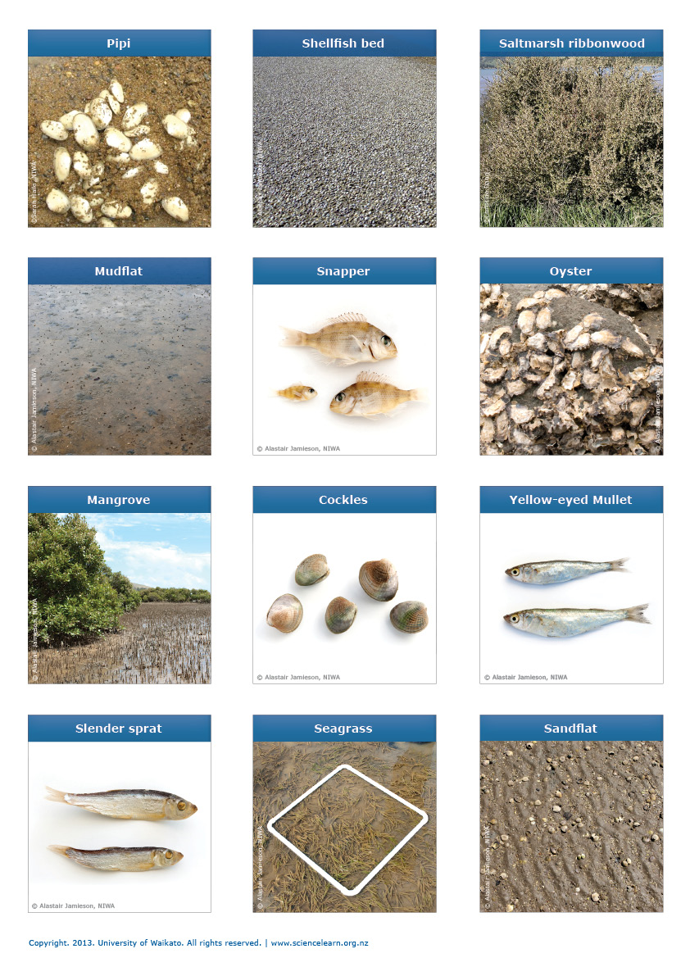
Māori name cards
