ACTIVITY: New Zealand bush ecosystems

Activity idea

In this activity, students build a food web representing the New Zealand bush ecosystem. Students use images of organisms within the ecosystem to explore the relationships between them.

By the end of this activity, students should be able to:
- understand the difference between a food chain and a food web
- describe some of the relationships between organisms within the New Zealand bush ecosystem
- explain why birds have an important role in the New Zealand bush ecosystem
- explain possible outcomes of an imbalance of diversity within our ecosystems.

Introduction/background notes
What you need
What to do
Discussion questions
Ecosystem organisms – student worksheet
Organism cards
Food web example

Introduction/background

Feeding relationships are often shown as simple ‘food chains’, but in reality, these relationships are much more complex, and the term ‘food web’ more accurately shows the links between organisms within an ecosystem.

A food web diagram illustrates ‘what eats what’ in a particular habitat. Pictures represent the organisms that make up the food web, and their feeding relationships are typically shown with arrows. The arrows represent the transfer of energy and always point from the organism being eaten to the one that is doing the eating.

Common student alternative conceptions about food webs include:
- organisms shown in food webs represent individuals rather than populations of organisms
- an organism that is not directly linked to another by a feeding relationship will not be affected if that organism is removed.

The following activity gives an example of some of the feeding relationships within the New Zealand native bush ecosystem. The article Birds’ role in ecosystems will provide teachers and students with background information about the relationships between some of our native birds and the organisms within our ecosystem.

What you need

- Copies of Ecosystem organisms – student worksheet
- Access to the article Birds’ role in ecosystems (printed or online)
- Non-fiction books for background information on the organisms in the food web (tūī, kiwi, kererū, stoat, possum, rat, tawa, kōwhai and miro trees)
- Large sheets of paper (A2 size is preferable)
- Set of organism cards for each group
- Coloured marker pens
- Glue

What to do

- As a class, discuss the students’ prior knowledge of food webs. (The video clip Understanding food webs in the Life in the Sea context provides background information on food webs.)

- Organise students into groups of 3–4. Give each group a copy of the Ecosystem organisms – student worksheet and ask them to work co-operatively to gather information about the food (or prey) that each organism eats and the organisms that they are eaten by. You might like to give students’ access to the article Birds’ role in ecosystems or encourage them to use non-fiction books or web-based searches to collect this information.

- Give each group a set of organism cards. Depending on the students’ prior knowledge, you may want to start that activity by asking students to use their organism cards to build simple food chains before they move on to building a food web. For example:

Tui

Rat

Invertebrates

Ensure that students are using the arrow direction correctly. The arrow represents the transfer of energy and always points from the organism being eaten to the one that is doing the eating.

- Each group can now be given a large sheet of paper to build their food web on. Students should begin by gluing the organism cards of native New Zealand organisms on to their sheets of paper, leaving room around the edges to later add the cards of introduced predators. An example of layout is shown below:
- Ask the students to assign each of the native birds (kiwi, kererū, tūī) a different coloured marker pen. The students can now show the feeding relationships within the web between the birds, the flora (plants) and invertebrates. Encourage students to think about the transfer of energy within the system and draw their arrows to reflect this.
Invertebrates
Tawa
Kowhai
Miro
Kereru
Kiwi
Tui

- Ask the students to add the introduced predators to the outer edges of their food web (stoats, rats and possums). Students can assign each of these organisms a different coloured marker pen and add the feeding relationships represented by arrows.

- Ask the students to predict possible outcomes of an organism within the ecosystem either being eliminated or increasing greatly in population size. Encourage students to realise that either event would have a flow-on effect to the other organisms due to the connected nature of an ecosystem. The following scenarios could be suggested to the students to give a context to consider:
- Intensive planting efforts of nectar and fruiting trees have produced sufficient food for tūī. This has caused a boom in the population of tūī fledglings.
- An area of native bush is to be converted to farmland. This involves the clearing of the entire native bush in the area to allow the land to be farmed.
- A community group has decided to stop all predator control methods within their local bush area due to the costs involved (this includes the cessation of hunting, trapping, dropping of aerial baits and use of bait stations).

Scenario | Possible Outcomes:
A. Increased tūī numbers | - Increased risk of predation due to larger numbers of tūī (prey). This could cause the numbers of stoats, rats and possums to have a population boom as a consequence.  - Increased competition for nectar with bellbirds and silvereyes.  - Increased competition for fruit with kererū and bellbirds.  - Increased competition for invertebrates with other organisms.  - Enhanced seed dispersal and pollination of bird-dependent species such as miro, tawa and kōwhai.
B. Clearing of native bush | - Loss of habitat and resources for all of the species that live in the environment. This could cause an increase in competition for resources.
C. Cessation of predator control methods | - A population boom of predator species (stoats, rats and possums) could lead to a reduction in native organisms (such as native birds). If native birds decline severely in numbers, the predator species will have increased competition for food and resources, which could impact on their population size.

Discussion questions

- What does a food web tell us about the relationships within an ecosystem?
- Why do New Zealand native birds (particularly the tūī and kererū) have such an important role in our ecosystem?
- What possible outcomes could occur if tūī were eliminated from the New Zealand bush ecosystem?
- What could occur if stoats, rats and possums were eradicated?
- What could possibly occur if the population of stoats increased greatly?
Ecosystem organisms – student worksheet

Organism | Eaten by… | Feeds on… | Other information
Kiwi

Kererū

Tūī

Invertebrates

Miro tree

Tawa tree

Kōwhai tree

Stoat

Possum

Rat

Organism cards

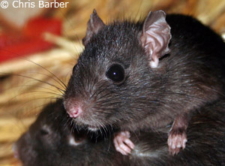  Rat | 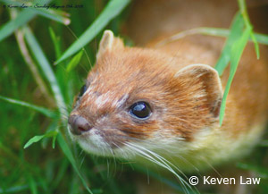  Stoat
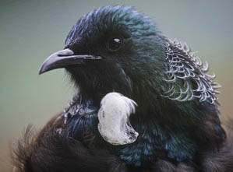  Tui | 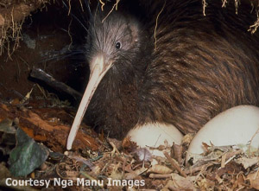  Kiwi
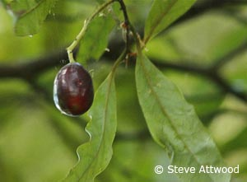  Tawa | 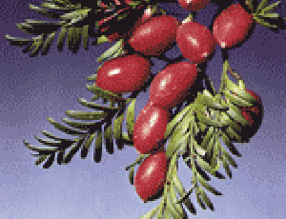  Miro
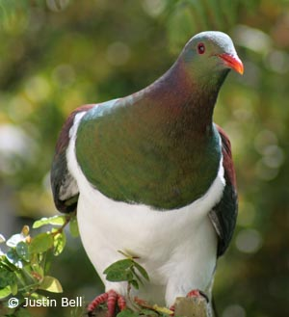  Kereru | 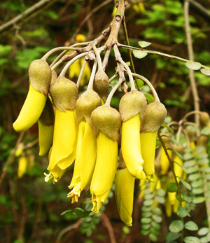  Kowhai
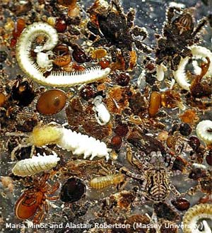  Invertebrates | 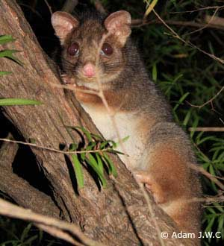  Possum

Food web example

Possum
Tui
Rat
Kereru
Invertebrates
Stoat
Kowhai
Kiwi
Tawa
Miro

