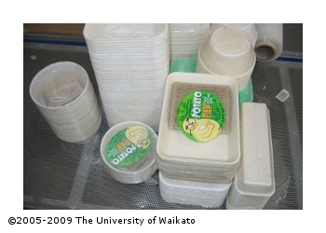
Activity: Promoting potato plates
In this activity, students use their knowledge of potato plates to write a letter promoting their use.
This activity can be adapted to suit different class levels from middle primary to junior secondary by adjusting the target audience and level of content of the letter.
- Discuss why and how we use disposable plates and packaging at home and in the community. What happens to the plates after use?
- Watch the video: What are potato plates? Compare potato plates with plastic alternatives and discuss why they may have been developed.
- Use the Potato plate manufacturing process interactive to explore how the plates are made.
- Discuss product life cycles as a way of understanding the environmental impact of a product. Refer to article: Environmental benefits of potato plates.
- Discuss the life cycle of potato plates and plastic plates. Refer to https://earthpac.co.nz/about/ for the helix of sustainability. List the advantages of using potato plates over plastic plates.
- Write a letter explaining what potato plates are, the advantages of using them over plastic ones and promoting their use as an alternative for a specific activity or situation. Include links to the potato plates website and resources on the Science Learning Hub.
  - Primary students could write a letter home suggesting the family use potato plates instead of plastic ones.
  - Junior secondary students could write a letter to a business, for example, a café, canteen or supermarket where they see an opportunity for potato plates to be used in place of existing plastic or polystyrene.
