ACTIVITY: Microscope parts

Activity idea

In this activity, students identify and label the main parts of a microscope and describe their function.

By the end of this activity, students should be able to:
- identify the main parts of a microscope and
- describe the function of the different parts of a microscope.

Background information for teachers
Teacher instructions
Student instructions

Background information for teachers

Microscopes are the tools that allow us to look more closely at objects, seeing beyond what is visible with the naked eye. Microscopes are used alongside medical imaging techniques when information about a particular tissue or individual cells is required.

Light microscopes (also known as optical microscopes) are the original microscopes. These are the ones you’re most likely to find in the classroom or school science lab. They use visible (white) light to illuminate (light up) the object being looked at and focus the light using one or more glass lenses.

Two kinds of light microscope are common in the classroom:
- The stereomicroscope – looks at the surface of a sample.
- The compound microscope – looks at a thin cross-section.

All microscopes share features in common.

Teacher instructions

- Show students the compound microscope (light) and stereomicroscope (light) sections of the Which microscope? interactive.

- Allow students time to complete the handout. Refer them to the Science Learning Hub articles Light microscopes, How microscopes magnify and Looking inside your body to find out more about light microscopes. Encourage students to use the class microscopes to work out the functions of the various microscope parts.

- As a class, discuss the names and functions of the various parts of the microscope and use the interactive Label the microscope to check the learning.

Labelled parts and functions
a | eye piece lens | The lens you look through – normally 10x or 15x magnification.
b | coarse focus adjustment | Moves the lens up or down and adjusts focus.
c | fine focus adjustment | Moves the lens in order to make very small adjustments to gain better focus.
d | base | The bottom of the microscope used for stability.
e | high-power objective | For increased magnification – usually 10x, 40x and 100x magnification.
f | stage | Where the slide is held/placed.
g | Diaphragm or iris | Varies intensity of the light projected upwards onto the slide.
h | light source | Sends light onto the specimen/slide.
Student instructions
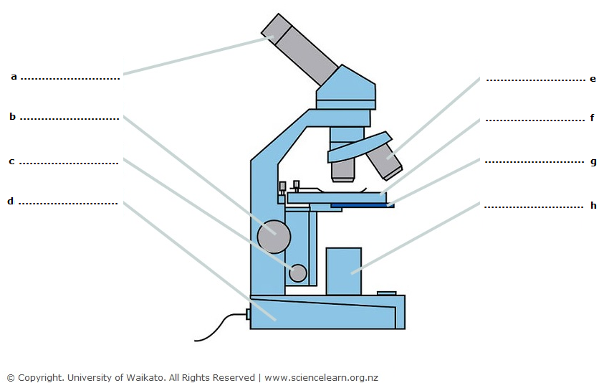

- Using the list of words below, label the microscope parts labelled (a) to (h).

stage high-power objective eye piece lens
base coarse focus adjustment diaphragm or iris
light source fine focus adjustment

- Explain the function of each part of the microscope.

Part | Function
a
b
c
d
e
f
g
h

