ACTIVITY: Discovery and development of X-rays

Activity idea

In this activity, students learn about the discovery of X-rays and their development as a medical imaging technology.

By the end of this activity, students should be able to:
- research an aspect of the discovery of X-rays and their development as a medical imaging technology
- present their research to their student groups.

Introduction/background notes
What you need
What to do
Research topics

Introduction/background

This activity uses the jigsaw cooperative learning approach. Using this approach, individual students become experts and are responsible for information regarding a particular aspect of the discovery and development of X-rays as a medical imaging technology.
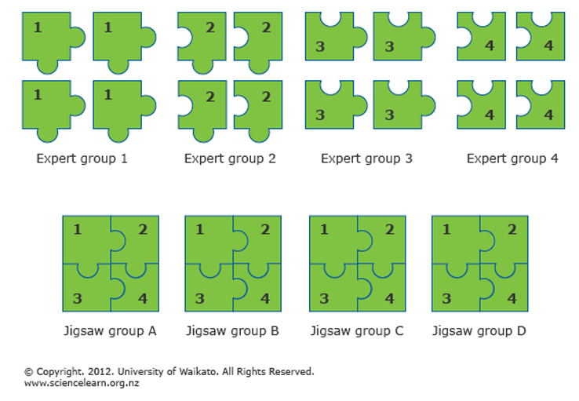
Each student is assigned a home group – their jigsaw group. Within that group, each student is assigned a research topic to specialise in. Students then meet with members from other jigsaw groups who are assigned the same research topic. After researching and gathering information on their research topic, the individual students return to their jigsaw groups and present what they’ve learnt to the other group members.

An all-class discussion can take place or each jigsaw group can creatively present back to the class.

What you need

- Access to the See-through Body Timeline – Developments in medical imaging
- Access to the articles listed in the Research topics

What to do

- Divide the class into four groups of 4 students. These are the jigsaw groups.

- Have the students number off within their groups.

- Assign research topics to jigsaw group members by listing their numbers and corresponding research topics on the board.

- Have students move to their expert groups, where everyone in the group has the same research topic as themselves.

- Have students work with members of their expert group to read and research their topic using the recommended resources from the Science Learning Hub. If additional internet research/library research is used, ensure that the students document these resources by recording the web address of any information they use or the book title and Dewey number.

- Have students decide how they will teach their topic to their jigsaw group and prepare a short presentation (notes/oral presentation, poster, PowerPoint etc.)

- Students return to their jigsaw groups and take turns teaching their group members the material.

- The whole class then participates in a review of all the content.

Research topics

Expert group 1: Research how and when X-rays were discovered as well as who discovered them.

Resources:
- Dr Wilhelm Roentgen
- See-through Body Timeline – Developments in medical imaging
- X-ray imaging

Expert group 2: Research what an X-ray is and what they can and cannot be used for.

Resources:
- X-ray imaging
- Improving breast cancer detection
- Looking inside your body

Expert group 3: Research new developments.

Resources:
- X-ray technology for the future
- Seeing X-rays in colour
- X-rays help yields and pollution

Expert group 4: Research radiation and EMS

Resources:
- X-ray imaging
- Radiation
- Looking inside your body

