ACTIVITY: Water and nutrient leaching

Activity idea

In this activity, students demonstrate how substances are dissolved and transported by water through the soil.

By the end of this activity, students should be able to:
- demonstrate the leaching of a substance through sand (soil)
- explain how irrigation and rain can affect nitrate and phosphate leaching.

Introduction/background notes
What you need
What to do
Discussion questions
Student handout: Investigating leaching

Introduction/background

This is a simple and quick activity to show how too much water can result in the leaching of fertilisers. Excessive water (through rain or irrigation) on farmland can push fertilisers (nutrients) below the root zone, making them unavailable for plant uptake.

Nitrate is highly soluble and will move with water filtering through the soil. Phosphate can leach also but to a lesser extent because its chemical structure binds it to soil particles.

Too much water not only puts nutrients out of reach of plants but also leads to possible groundwater contamination. Fertiliser applications on farms should be avoided before periods of heavy rain, and excess irrigation should be avoided after fertiliser applications.

In this activity, the sugar represents soluble nitrate. The coloured sugar dissolves depending on the amount of water added. The differing intensity of colour in the bowls helps to show us that the amount of ‘leaching’ differs with the various quantities of water. Sand is used instead of soil to ensure water clarity. Soil can discolour the water, making it difficult to see the coloured sugar solution.

What you need

For each group of students:
- 4 clear plastic cups
- Clean white sand
- Granulated sugar
- Food colouring
- Water
- Measuring container
- 3 bowls for catching leached water
- Access to the articles Fertiliser and Farming and environmental pollution
- Access to the video clip Nutrient leaching
- Copies of the student handout: Investigating leaching

What to do

- Prior to the activity, punch drainage holes in the bottom of the cups. Thoroughly mix food colouring with granulated sugar (6 drops for every ¼ cup) and spread over a flat surface to dry. Clean the sand by rinsing it under the tap. Continue to rinse it until the water runs clear. Spread the sand over a flat surface to dry.

- Hand out copies of the student handout Investigating leaching and assist students to gather the required materials and equipment and carry out the investigation.

- Discuss the results.

Discussion questions

As a class or in small groups, discuss what happened:
- How did the water move the coloured sugar through the sand? (It dissolved the sugar and carried it down through the sand.)
- What effect did increasing the amount of water have on the movement of the coloured sugar through the sand? (Water dissolves the sugar, so the more water, the more leachate.)
- How did the water leaching from the cups differ in amount and colour?
- What natural processes does this activity demonstrate?
- How might over-irrigation or excessive rain affect water quality?
- What can be done to prevent over-irrigation of pasture or crops?
- What can be done to reduce the effects of leaching during periods of heavy rainfall? (See the articles Managing nutrients and Farm management practices.)

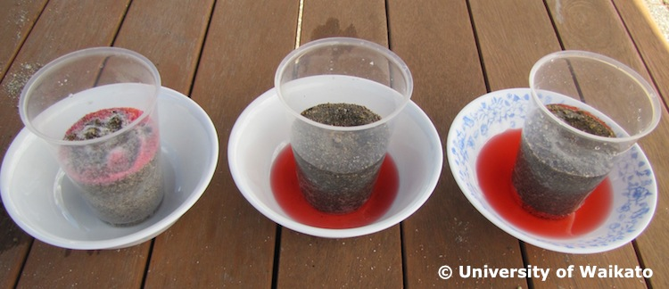

Student handout: Investigating leaching

- In pairs, read and discuss the article Fertiliser and the ‘Water pollution’ section of the article Farming and environmental pollution and watch the video clip Nutrient leaching.

- Put three cups into three bowls and half fill the cups with sand. Sprinkle three teaspoons of coloured sugar on the surface of the sand in each cup.

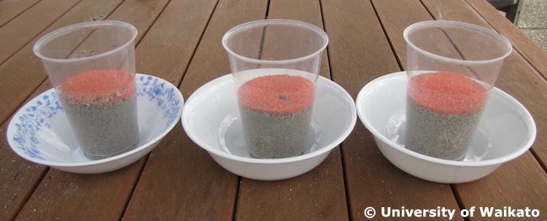

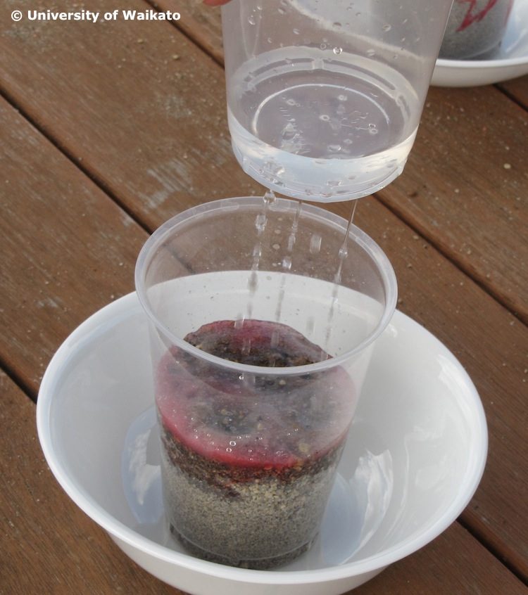
- Using the fourth cup as a watering can, sprinkle:
- 50 ml of water onto the sugar of cup 1
- 100 ml of water onto the sugar of cup 2
- 150 ml of water onto the sugar of cup 3.

- Allow the water to thoroughly drain from each cup, catching the leachate in the bowls.

- Compare the dispersion of the coloured sugar in each of the cups. Observe the colour of the ‘effluent’ draining from each cup.

