ACTIVITY: Clover and nitrogen fixation

Activity idea

In this activity, students observe the colour inside the root nodules of clover (or other legume) to see if they are fixing nitrogen.

By the end of this activity, students should be able to:
- explain nitrogen fixation
- explain how clover and other legumes fix nitrogen
- demonstrate whether a legume is fixing nitrogen or not.

Introduction/background notes
What you need
What to do
Student handout: Nitrogen fixation

Introduction/background

In this activity students collect clover and then observe the colour inside the root nodules to see if they are fixing nitrogen.

Nitrogen fixation is the conversion of atmospheric nitrogen gas (N₂) to a form that is biologically available to plants and animals. This can happen in a number of ways (see The nitrogen cycle). The major contributors of nitrogen fixation into the soil, however, are legumes.

Legumes include clover, peas, alfalfa, lucerne, lupins and soybeans. These plants have small swellings on their roots called nodules. Special bacteria called rhizobia live in these nodules. Rhizobia take N₂ from the air and convert it to ammonium (NH₄⁺).

The legume plants provide food for the rhizobia, and the rhizobia in return produce a usable form of nitrogen from which the plants can produce protein. Once the legumes die and decay, the nitrogen compounds become part of the soil’s organic matter. Other bacteria then transform the nitrogen compounds into simpler forms that can be taken up by other plants through their roots.
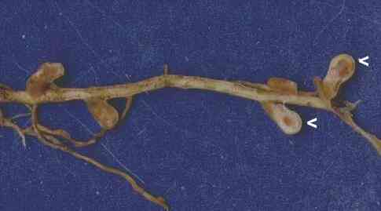
Clover is perhaps the most easily obtained legume for this activity, but any legume will do. If nitrogen fixation is occurring in the plant nodules, they will be a pinkish-red colour. The pinkish-red colour is caused by leghaemoglobin (a protein similar to haemoglobin in blood) that controls oxygen flow to the bacteria. If there is too much or too little oxygen, the bacteria will not fix nitrogen.

If the clover is from an area that has been fertilised, it is unlikely that nitrogen fixation is taking place (so the nodules will not be red). This is because the bacteria prefer the available nitrogen (the ammonium or nitrate fertiliser) rather than fixing nitrogen. Students could collect clover plants from both fertilised areas and non-fertilised areas (the side of the road) and compare the nodules of each.

The gathering of the clover could be a homework activity to give students time to find good samples with large nodules on the roots that can be easily observed.

Use a shovel to unearth the roots – you are less likely to break roots off.

What you need

- Several good-sized clover plants – dug (rather than pulled) out of the earth with their roots intact. Collect clover from non-fertilised areas such as the side of the road. If possible, also collect some plants from a fertilised area (lawn) for comparison.
- Magnifying glass
- Copies of the articles The nitrogen cycle and The role of clover
- Access to the interactive The terrestrial nitrogen cycle
- Access to the video clip The importance of clover

What to do

- In pairs, read and discuss the article The nitrogen cycle and/or explore the interactive The terrestrial nitrogen cycle. Have students tell their partners about fixation and its place in the nitrogen cycle.

- In pairs or as a class, read and discuss the article The role of clover and watch the video clip The importance of clover.

- Hand out copies of the Student handout Nitrogen fixation and discuss.

- Assist groups to gather the materials and equipment they need and carry out the investigation.

- Discuss in pairs or as a class how nitrogen fixation helps soil fertility, the leguminous plant and all other plants. What are some reasons why nitrogen fixation does not occur?

Student handout: Nitrogen fixation

- Rinse the soil from the roots of your clover and lay on a tray.

- Look for nodule formations. Remove a few nodules from plant roots.

- Cut nodules in half with a sharp knife or your fingernail.

- Determine whether nitrogen fixation is taking place. Use a magnifying glass for close observation. Pinkish-red nodules show that nitrogen fixation is taking place. Brown nodules are mature and ready to fall off the roots. Green or white colouring shows nitrogen is not being fixed.

- Is nitrogen fixation happening in each of the plants? Did some plants have both red and green/white nodules?

- Compare the inner nodule colour of the plants dug from the side of the road and plants dug from a fertilised area. Is there a difference? Why might this be?

