ACTIVITY: Tectonic sandwiches

Activity idea

In this activity, students make sandwiches to investigate tectonic plate boundaries and how they move during an earthquake.

By the end of this activity, students should be able to:
- begin to use content vocabulary terms like ‘tectonic plates’
- demonstrate different ways in which the tectonic plates move during an earthquake.

Introduction/background notes
What you need
What to do

Introduction/background

The Earth’s crust is made up of large separate plates or areas that fit together rather like a huge jigsaw puzzle. They float on the partially molten mantle. Where the plates meet – the boundaries – movement happens. The plates can move apart, they can move horizontally past each other or they can move towards each other. The movement is very slow – often just a few millimetres per year. The plates do not glide easily past one another. Friction holds the plates in place and pressure builds up. The sudden release of pressure or energy causes seismic waves that make the ground shake.

In this activity, students use bread to model different types of movement at tectonic plate boundaries. The three types of boundaries are:
- transform boundaries – where plates move horizontally
- divergent boundaries – where plates move apart
- convergent boundaries – where plates move towards each other. They may buckle and compress, or one plate moves under the other.

Alternatively, the activity can be a teacher demonstration. To do this, make a cake and cut it into three pieces before icing it and adding LEGO houses and plastic animals to resemble a landscape. Move the cake along the tectonic boundaries (cuts) to demonstrate the different types of movements.

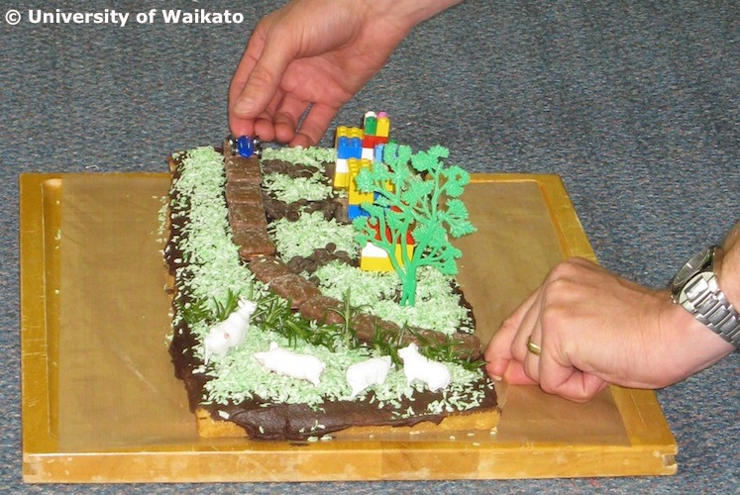

What you need

- Access to the article The moving Earth and the image Three types of plate boundaries
- A block of polystyrene to demonstrate the tectonic plates
- Paper plates or paper towels for each student
- Plastic knives
- Sliced bread for each student
- A selection of food items – Nutella or Vegemite for soil, green-coloured coconut for grass, carrots and celery cut into cubes to represent houses, pineapple lumps for roads etc.

What to do

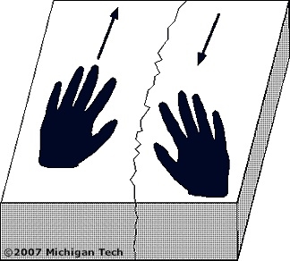
- If appropriate, read The moving Earth with the students. Focus on the image Three types of plate boundaries. Discuss how the Earth’s crust is broken into slow-moving tectonic plates.
- Break a block of polystyrene in half. Put the pieces on a smooth table. Put the rough edges together. Push one piece away from you while you pull one piece towards you to demonstrate a transform boundary. See how they stick? Push and pull until some of the particles break off. The pieces will suddenly slip past each other. That slipping is the earthquake.

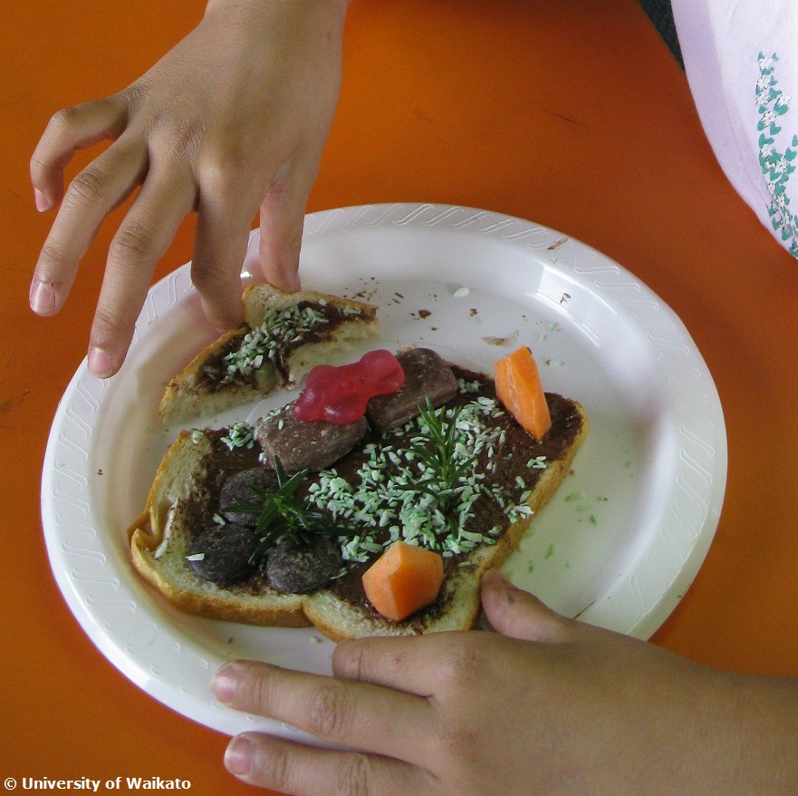
- Demonstrate the other types of movement that can happen at tectonic boundaries – how the plates move apart and how they push together either compressing both plates or one plate sliding under another.

- Pass out the bread, spreads and edible landscape items.

- Students first cover their bread with Nutella or Vegemite ‘soil’.

- Students cut the bread to model a plate boundary. Push the boundaries back together to make a whole slice of bread.

- Students decorate their landscape with coconut grass, vegetable buildings, chocolate roads, gummy animals etc.

- Students use their sandwiches to demonstrate the various ways in which the land moves during an earthquake.

- Discuss how these movements affect the land. For example, horizontal transform boundary movements occurred in the recent Canterbury earthquakes, whereas the Southern Alps are a result of convergent movement.

- Either let the students eat their tectonic sandwiches or do the activity at the end of the school day so the students can take them home to show/discuss with their families. Consider sending home information from Civil Defence (www.getready.govt.nz) for family discussion.

