ACTIVITY: What makes up soil?

Activity idea

In this activity, students a paper-based graphic organiser to explore their ideas about the components of soil.

By the end of this activity, students should be able to:
- recognise that inorganic mineral particles are components of soil
- recognise that organic matter (including living things) is a component of soil
- recognise that water and air are components of soil
- justify their choices.

Introduction/background notes
What you need
What to do
Answers
Images for classifying
Graphic organiser worksheet: What makes up soil?

Introduction/background

All soil is made up of inorganic mineral particles, organic matter (including living things), air and water. The mineral particles come from the rocks (parent materials) that formed the soil. Different amounts and difference combinations of these components give soils their special properties.

Some of the images are not straight forward or are open-ended to encourage student thinking and debate. For example, components from soil are used to make concrete, but concrete does not make up soil. Volcanic material, such as pumice, is part of some New Zealand soils but not the whole volcano.

What you need

- Tray of soil (actual soil is preferred over potting mix)
- Access to the interactive What makes up soil? – graphic organiser and the paper-based images for classifying and graphic organiser worksheet What makes up soil?
- Access to the science ideas and concepts article What is in soil?
- Access to the science ideas and concepts article Soils are all different

What to do

- Ask individual students to handle and observe the soil. Ask them what they think makes up the soil. Discuss the results with the class and make a class list of soil components.

- In small groups, use the online or paper-based version of the graphic organiser to explore ideas. If using the paper-based version – cut-up images for classifying and the graphic organiser worksheet What makes up soil?

- As a whole class, complete the organiser on an interactive white board or similar. Students are allowed to move an image card if they do not agree with its position, but the student must justify why it is being moved.

- If students disagree or are unsure of any of the images, refer to the articles What is in soil? and Soils are all different to aid discussion.

- Refer back to the class list of soil components. Discuss differences.

- If desired, print or save the completed graphic organisers for assessment/portfolios.

Answers

Item | Makes up soil – yes or no
Sand | yes
Pebbles | yes
Air | yes
Clay | yes
Earthworms | yes
Dead insects | yes
Dead leaves | yes
Concrete | no
Volcano | no
Diamond | no
Toy turtle | no
Water | yes
Microbes | yes
Sun | no

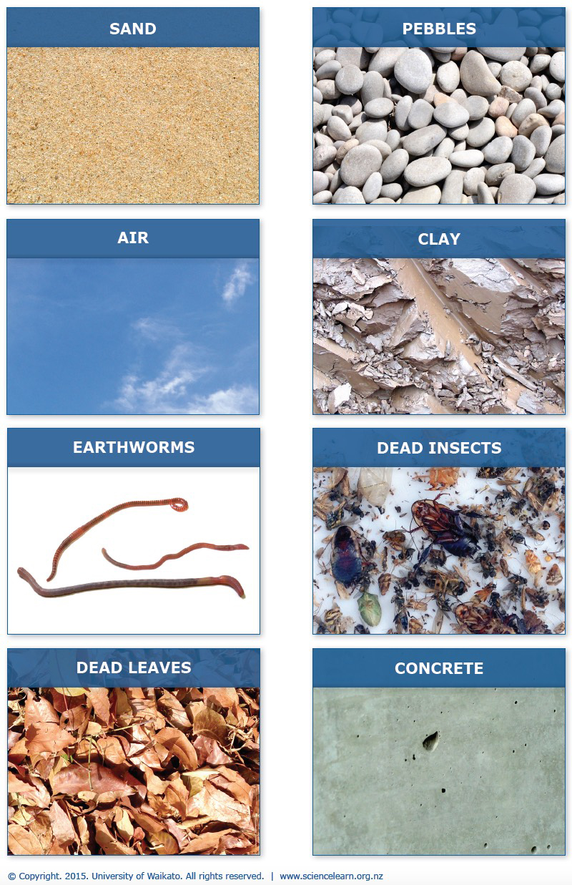
Images for classifying
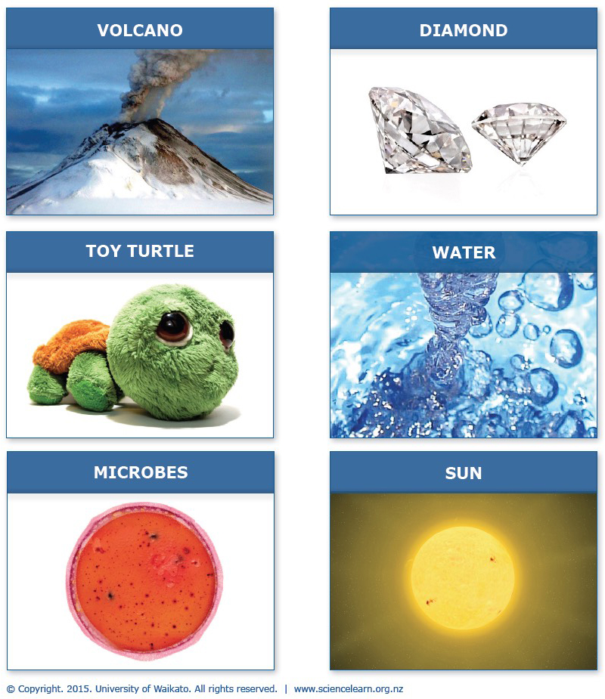

Image card acknowledgements
Pebbles by Joanbanjo. Licensed under CC BY-SA 3.0
Drops Impact by Marlon Felippe. Licensed under CC BY-SA 2.0
Clay-ss-2005 by Siim. Licensed under CC BY-SA 3.0
Leaf litter by Mokkie. Licensed under CC BY-SA 3.0
Concrete Casting Defect Blowhole by Elgewen - Own work. Licensed under Creative Commons 1.0
Two diamonds by Washington Diamonds Corporation/Inbal-Tania Studio. Licensed under CC BY-SA 3.0
Turtle plushie by Anil Öztas. Licensed under CC-BY-SA-3.0-de
Microbes, earthworms and dead insects, © University of Waikato

What makes up soil?

