ACTIVITY: Observing soil differences

Activity idea

In this activity, students gather soil samples from their homes to view how soils differ from location to location.

By the end of this activity, students should be able to:
- observe similarities and differences among soil samples
- offer simple explanations about why the soil samples are different
- use online resources to view soil profiles and a New Zealand soil map.

Introduction/background notes
What you need
What to do
Student handout: Collecting a soil sample

Introduction/background

All soils have some things in common. They all consist of mineral particles, organic matter, air and water. Soils differ due to how and where they were formed. Soils change with topography – sometimes even over the space of a few metres. New Zealand soils have been classified into nearly 2000 soil series.

This activity is designed to introduce students to the concept that soil is not a uniform medium that covers the land. It differs from place to place.

What you need

- Access to articles What is in soil? and Soils are all different
- Copies of the student handout Collecting a soil sample
- Empty jars (students provide)
- Soil from various locations (students provide)
- Hand lens or digital microscope
- Access to NZ Soils picture resource
- Access to NZ Soils soil order maps
- Access to S-map digital soil map

What to do

- Read the articles What is in soil? and Soils are all different either with the class or for your own background knowledge.

- Prepare a soil jar for class display as per the instructions on the student handout Collecting a soil sample. As a class, discuss the following:
- Layers in the soil sample. The heavier sand particles settle to the bottom first. Silt and clay particles are lighter and rest on top of the sand layer. Organic matter usually makes up the top layer, and some floats on the water’s surface.
- Different colours in the soil layers.

- Give students a copy of the student handout Collecting a soil sample or post it on the class blog. Ask students to follow the instructions and bring in a soil jar from their home or other location.

- Place the jars side by side for observation. Observe and discuss the visual differences. Changes may be subtle if the students simply dig into topsoil, but careful observation will highlight differences.

- Consider placing the soil jar locations on a local map. Do soils from the same area look the same? Do soils change as the locations become more distant?

- Use the online resources NZ Soils picture resource and NZ Soils soil order maps to view different soils and where they are located around New Zealand. The S-Map digital soil map lets users learn about the soil in their backyard or paddock.

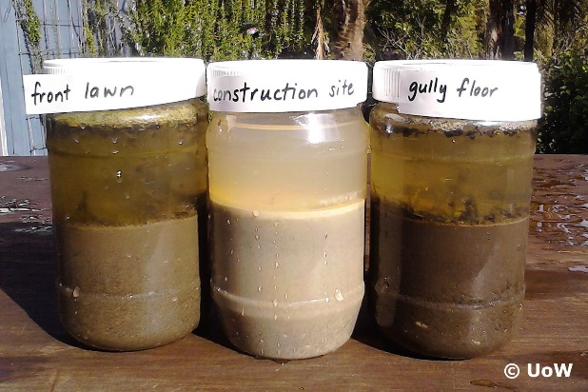
Student handout: Collecting a soil sample

Do you think the soil at your house is the same as the soil at school or the local park? This activity will help answer that question.

You will need:
- A garden trowel
- A jar
- Water

What to do

- Find a place you are allowed to dig a small hole. Don’t use a vegetable garden. Gardeners usually add compost, and that changes the soil. The hole won’t be too deep, but be careful not to dig where there are services like gas, water or power.

- Use the hand trowel to dig into the soil. Remove any grass and set it aside.

- Keep the hole narrow but dig down so you get a combination of topsoil and the soil below.

- Put the soil in the jar until it is half full.

- Put extra soil back in the hole and put any grass/turf back on top of the hole. (We don’t want anyone to step in the hole and get hurt!)

- Write the location on the jar lid. This might be your address or a different location – like a stream bank or patch of native bush.

- Fill the jar with water. Shake it well.

- Bring the jar to school and compare the soil with other soil samples collected by your class.

You can also get soil from a river bank or a patch of native bush. If you live in a hilly area, think about getting soil from the top of the hill for one jar and soil from the bottom of the hill for another. If it is safe, you can get soil from a building site. Sometimes, these sites have subsoil dug from deep foundations. It usually looks quite different to topsoil.

