Activity: Instrumental firmness test

In this activity, students test and compare the firmness of different apple varieties using an instrumental method adapted for the classroom. The activity forms part of the unit plan Developing future apple varieties.

By the end of this activity, the students should be able to:
- effectively conduct an instrumental test to accurately measure the flesh firmness of a range of apple varieties.
- analyse and compare the results of a test to define flesh firmness of a range of apple varieties
- evaluate the effectiveness of the test method used.

Introduction

Firmness is an important apple trait. It contributes to the ‘mouth feel’ of an apple. To test firmness, breeders use an instrumental test with a specialised piece of equipment called a penetrometer. A penetrometer allows breeders to test apple firmness quickly and easily by measuring the force required to penetrate the apple flesh.

An instrumental firmness test could be conducted in the classroom using alternative equipment.

What you need:

- Access to the interactive Assessing apple attributes
- 5–6 apple varieties – use the same varieties used for the sensory tests (see Consumer research on future apples) such as Granny Smith, Braeburn, Pink Lady, New Zealand Rose, Royal Gala, Jazz
- Knives and cutting boards
- Phillips screwdriver (medium size)– a standard screwdriver may split the apple
- Ruler and pencil
- Cardboard tubes – longer than 50cm is more effective

What to do

- View the video clip Flesh firmness in the interactive Assessing apple attributes.
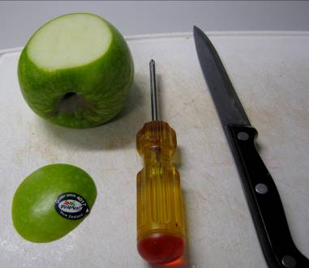
- Discuss possible alternatives for conducting this test in the classroom using alternative equipment. (The following steps describe 1 possible method.)

- Complete testing on 1 apple variety at a time, as the apple texture can soften over time. (Do 3 tests on each variety and average the results.)

- Cut a thin slice off 2 opposite sides of the apple to create 2 flat surfaces. Place the apple onto the cutting board. Ask students to predict the relative firmness of each apple variety after they cut them.

- Hold a cardboard tube vertically on the flat surface of the apple.

- Hold the screwdriver level with the top of the tube and let it drop onto the apple slice – ensure the screwdriver is dropped from exactly the same height and that it pierces the apple in a different place each time.

- Mark the level of penetration on the screwdriver with a pencil – measure and record the distance of penetration, then wipe the screwdriver to remove the pencil mark before testing again.

- Compare the relative firmness of each apple variety by presenting a bar graph of the results showing the apple variety on 1 axis and the firmness (depth of penetration) on the other.

- Create a scale with descriptors to define the relative firmness of each variety.

Discussion points

- How do the results compare with students’ earlier predictions?
- How could the freshness or ripeness of the apple affect the results?
- How do these results compare with the results of the sensory test for firmness in the Investigating apple attributes activity? Discuss possible reasons for any irregularities.
- How effective was the test method in achieving consistent and accurate results?

