Activity: Exploring wool fibre properties

By the end of this activity, students should be able to:

- describe the cellular structure of wool fibre
- identify wool’s properties and their relationship to the fibre structure
- understand how wool’s properties affect its suitability for particular end uses.

Introduction

Wool was made into cloth for many years before recorded history. Developing a better understanding of the wool fibre has enabled scientists to develop new technologies and processes for converting it into useful products.

Wool has a complex physical structure that is responsible for the range of desirable properties it exhibits in products. Understanding this structure and how it creates these properties is helpful for developing a better understanding of wool’s properties and its uses.

Understanding a material’s properties is essential for making informed decisions about material selection for particular purposes.

What you need

- Printed copies of the exploded wool fibre diagram and lists of fibre components and properties.
- Access to the interactive Wool fibre structure and properties.
- Access to or printed copies of the article Wool fibre properties.

What to do

- Brainstorm what students already know about wool. List the outcomes of the discussion on the whiteboard in 3 columns: Uses, Desirable properties, Undesirable properties. Ask about students’ experiences and preferences for wearing wool garments as opposed to other fibres. What garments and other products are made from wool and why is wool used? What are some of the properties wool brings to the products that make them suitable for their use? Are there any undesirable properties? Some properties may be considered both desirable and undesirable depending on the use of the fabric, for example, the ability to felt allows you to make fabrics with different characteristics but it makes fabrics difficult to care for if they don’t have a special finish applied.
- Have students explore the interactive Wool fibre structure and properties and read the article Wool fibre properties. Follow this up with discussion and add to the lists on the board.
- Using the resources below, students label the parts of the wool fibre and match the property names to the part of the wool fibre that creates that property. This could be done in small groups or individually first and shared in pairs or small groups.
- When students have completed the activity have them feedback any difficulties and refer back to the article Wool fibre properties to resolve these.

Extension ideas

- Have students consider how the properties of wool make it suitable for particular end uses by completing the chart Wool products’ function and properties. Referring to the interactive Wool fibre structure and properties and/or the article Wool fibre properties, encourage students to think of more than 1 property that makes wool suitable for particular products and purposes and to add more wool products to the list.

Wool fibre diagram
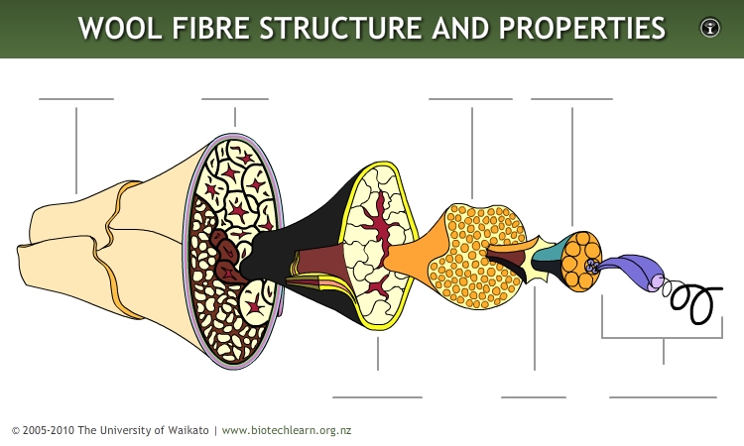

Wool fibre properties

Low abrasion resistance | Water-resistant
Sensitive to chemicals | Good absorbency
Good insulator | Good breathability
Resistant to soiling | Holds colour well
Stain-resistant | Flame-resistant
Antistatic | Good elasticity
Resilient | Good wrinkle recovery
Ability to felt | Good drape

Wool fibre components

Macrofibril

Cortex

Cortical cell

Cuticle

Microfibril

Twisted molecular chain and helical coil

Matrix

Wool products’ function and properties

Wool product | Function/purpose | Wool properties that make the product fit for purpose | Explanation
Felt hat
Singlet
Socks
Knitted jumper
Winter coat
Carpet
Ceiling insulation
Duvet inner
Mattress cover
Evening dress
Tramping clothes
Upholstery

