Activity: Safety in cheesemaking

In this activity, students learn how to identify potential safety hazards in a cheesemaking process. They learn how these can be minimised or eliminated to prevent contamination by foreign bacteria and the potential for foodborne illnesses.

By the end of this activity students should be able to:
- identify potential safety hazards in a cheesemaking process
- create a HACCP plan to show how safety hazards can be minimised at each stage of a cheesemaking process

Introduction/background
What you need
What to do
Extension activities
Useful links
Student handout: HACCP plan for making cheese
HACCP Plan for making cheese – sample answers

Introduction/background

Before undertaking any cheesemaking activities in the classroom, it’s essential that students understand the food-safety risks and how to manage them. The cheesemaking process provides ideal conditions for the growth of bacteria – warm temperatures, food, moisture and time. Therefore, it’s essential to ensure that no foreign bacteria are introduced at any stage of the process.

Cheese contamination can occur from microbiological, chemical or physical sources via unclean or contaminated equipment, surfaces or ingredients or poor personal hygiene of people at any stage of the process:
- Microbiological sources include pathogenic bacteria present in the milk or introduced from contaminated equipment or people.
- Chemical sources include contamination of the milk from animal drugs, hormones, pesticides or cleaning solutions.
- Physical sources include foreign material such as metal or paint fragments from damaged or poorly maintained surfaces or particles from workers’ clothing.

In all commercial cheesemaking facilities, a planned process known as Hazard Analysis of Critical Control Points (HACCP) must be implemented and documented for compliance with the New Zealand Food Safety Authority (NZFSA) regulations. NZFSA is an organisation that governs the performance of New Zealand’s animal, plant, food and related sectors. A HACCP plan analyses what the risks are at each stage of the production process – from supply of raw ingredients to storage and distribution of the final product – and what steps need to be taken to prevent contamination.

Any cheesemaking in the classroom or at home needs to be undertaken in a sterile environment using safe and hygienic procedures and with an understanding of the sources of risk and how to minimise them. Designing and implementing a HACCP plan tailored to the specific classroom context will help ensure all hazards and methods of minimising them are identified.

What you need

- Access to the interactives Making cheese - first steps, Making cheese - the final steps and Quality control in cheesemaking
- Copies of or the information sheet Manufacturing Gouda cheese
- Copies of the student handout HACCP plan for making cheese

What to do

- Start by discussing the key stages and ingredients of the cheesemaking process. Review what students may already know about the conditions that support bacterial growth, for example, warm temperatures, moisture, time and food. Ask them about the conditions present in the cheesemaking process and where there could be risk of bacterial growth. How could foreign bacteria be inadvertently introduced? How could physical or chemical contamination occur?

- Discuss the risk of foodborne illness from cheese. See articles in useful links on unpasteurised cheese and Listeria food poisoning from cheese.

- Discuss the concept of HACCP planning – a legal requirement in the food industry to manage food safety.

- Divide students into small groups and hand out copies of the article Manufacturing Gouda cheese and the student handout HACCP plan for making cheese.

- Have students view the interactives Making cheese - first steps and Making cheese - the final steps and discuss in their groups what the possible microbiological, chemical and physical risks are for this cheesemaking process at each stage. What procedures do they observe at each stage that minimise the risks?

- On the student handout HACCP plan for making cheese, have students list the processing steps, the hazards and the preventative measures at critical control points.

- When they have recorded their ideas, have them view the interactive Quality control in cheesemaking and review their HACCP plan.
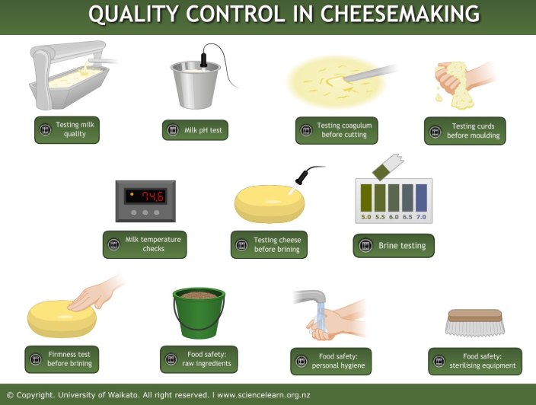

- Share group responses with the class, discuss differences and allow students time to review and adjust their group responses if necessary. (Note that the video clips don’t cover every possibility so it is possible students could mention valid control measures that are not included in the video clips.)

Extension activities

- If students are going to experiment with or make cheese in the classroom, have them complete the HACCP plan for that activity or recipe.
- Have students research pasteurisation and find out about the debate surrounding raw milk versus pasteurised milk.
- Encourage students to review the regulations around unpasteurised cheese in New Zealand – see useful links. Students may already be aware of this or know someone who has suffered a foodborne illness from contaminated cheese. Are they aware that unpasteurised cheeses are sold in New Zealand now? Are they aware how these unpasteurised cheeses can be identified? What groups are at risk from these cheeses? Write a report stating and justifying their views on this change in legislation. Alternatively, prepare an argument for a debate from the perspective of a key stakeholder in the controversy.

Useful links

Varieties of milk
An introduction to some milk nutrition facts. Download the Milk booklet PDF for more, including descriptions of the composition of the different varieties of milk available.
www.milk.co.uk/nutritious-dairy

Reviewing rules about raw milk cheese in New Zealand
An article in the New Zealand Herald in 2006 about NZFSA’s review of the rules about raw milk cheese in New Zealand at the time.
www.nzherald.co.nz/business/news/article.cfm?c_id=3&objectid=10370270

NZ raw milk cheesemakers face 'impossible' hurdles
An article from Stuff from 2017 about the three raw milk cheesemakers currently operating and the difficulties they face.
www.stuff.co.nz/life-style/food-wine/food-news/88731205/nz-raw-milk-cheesemakers-face-impossible-hurdles

Raw milk cheese in New Zealand
The current status of regulations in New Zealand for production and importation of raw milk cheeses in the Food Safety section of the MPI website – updated in 2018.
www.mpi.govt.nz/food-safety/food-safety-for-consumers/is-it-safe-to-eat/raw-milk/raw-milk-regulations

Dairy product manufacture legislation
Learn about food safety legislation for dairy products in New Zealand in downloadable documents in the Food Safety section of the MPI website – updated in 2018.
www.mpi.govt.nz/processing/dairy-products/dairy-manufacturing

Pasteurisation
Learn about the history, methods and effects of pasteurisation of milk.
www.raw-milk-facts.com/pasteurization_T3.html

HACCP planning for cheesemaking
Download the PDF to learn more about Hazard Analysis of Critical Control Points (HACCP) planning for cheesemaking.
www.internetjfs.org/articles/ijfsv10-1.pdf

Food safety and cheese
Read about food safety and cheese on the Dairy Research and Information Center (UC Davis, University of California) website.
https://drinc.ucdavis.edu/dairy-foods/food-safety-and-cheese

Reducing Listeria risk in cheesemaking
Read these news articles to learn more about the risk of cheese contamination from Listeria monocytogenes and preventative strategies.
www.bakeryandsnacks.com/Article/2010/03/10/Plant-design-and-personal-hygiene-crucial-to-reducing-listeria-risk
www.digitaljournal.com/article/316110
www.nzherald.co.nz/business/news/article.cfm?c_id=3&objectid=11915398

HACCP plan for making cheese

Cheesemaking steps | Identify the hazards – microbiological (M), chemical (C), physical (P) |  | Describe preventative measures at critical control points
Pasteurisation | M
 | C
 | P
Coagulation | M
 | C
 | P
Cutting | M
 | C
 | P
Releasing the whey | M
 | C
 | P
Moulding | M
 | C
 | P
Brining | M
 | C
 | P
Coating | M
 | C
 | P
Maturing | M
 | C
 | P
Packaging | M
 | C
 | P
HACCP plan for making cheese – sample answers

Cheesemaking steps | Identify the hazards – microbiological (M), chemical (C), physical (P) |  | Describe preventative measures at critical control points
Pasteurisation | M | Survival of pathogenic bacteria. | - Check temperature and time (72 °C, 15 seconds) and adjust setting if needed.  - Sanitise all equipment.  - Monitor quality of milk supply – test for chemical contaminants.
 | C | Contaminated milk.
 | P
Coagulation | M | Inadequate growth of starter bacteria. | - Check freshness and storage temperature of starter bacteria and rennet.  - Proper sterilisation of vat and equipment.  - Proper personal hygiene and handling.  - Correct measure of starter bacteria and temperature for growth and/or pH test.
 | C | Contamination of rennet or starter bacteria.
 | P
Cutting | M | Contamination from unclean cutting blades. | - Check time and temperature settings of cheese vat, curd size and consistency.  - Measure pH.  - Proper sterilisation of cutting blades.  - Proper personal hygiene and handling.
 | C | Chemical residues from sanitisers on equipment.
 | P | Foreign particles from cheesemakers’ clothing or cutting blades.
Releasing the whey | M | Optimum moisture content of the curd. | - Check temperature setting of cheese vat.  - Monitor amount of whey released.
 | C
 | P
Moulding | M | Contamination from workers or unclean moulds. | - Proper personal hygiene and handling.  - Clean, white clothing and hairnets.  - Proper sanitising and rinsing of cheese moulds.
 | C | Chemical residues on moulds.
 | P | Contamination from workers’ clothing and mould materials.
Brining | M | Salt concentration inadequate to prevent spoilage. | - Check purity of salt before use.  - Test brine saturation level.  - Check time in brine bath.
 | C | Contamination of the salt.
 | P | Foreign particles in the salt.
Coating | M | Coating protects from microbiological contaminants. | - Coating applied as soon as brined cheese is dry.  - Check source and quality of coating supply.  - Sufficient number of coats applied to protect cheese.
 | C | Impurities in the coating material.
 | P | Coating protects from physical contaminants.
Maturing | M | Contamination from moisture and mould growth on surface; environmental hazards such as pests or rodents. | - Monitoring temperature and humidity levels in maturing room.  - Turning and wiping cheeses daily.  - Maturing room kept clean, well maintained, closed and pest-free.
 | C
 | P
Packaging | M | Contamination from cutting equipment, surfaces or workers; incorrect storage temperature. | - Proper sterilising of surfaces and equipment for cutting the cheese.  - Workers wear clean, white clothing, aprons, hairnet, gumboots – worn only in cheesemaking area.  - Proper personal hygiene of workers.  - Use appropriate plastic for packaging.  - Monitor correct refrigeration temperatures.
 | C | Contamination from inappropriate packaging materials or chemical residues on equipment or surfaces.
 | P | Introduction of foreign particles from cutting equipment, surfaces or workers.

