Activity: Identifying cheese characteristics

In this activity, students investigate a range of cheeses to identify their characteristics and determine how these different characteristics are created.

By the end of this activity students should be able to:
- describe the characteristics of a range of different cheeses
- identify similarities and differences between cheeses
- devise a system of classifying cheeses
- explain how key differences in cheese characteristics are achieved.

Introduction/background
What you need
What to do
Extension activities
Useful links
Student handout: Cheese characteristics
Student handout: Matching cheeses with characteristics
Student handout: Cheese-processing operations

Introduction/background

Cheese is all made from the same basic ingredient – milk – and it all undergoes the same process to be made into cheese. However, there are numerous varieties of cheese available, all made in different styles with different textures and flavours. There is no one single method of classifying cheeses.

What you’ll find is that, to group or classify cheeses, one or a combination of a number of different criteria/characteristics are used.

These include:
- the type of milk used (for example, cow, sheep, goat)
- whether the milk is pasteurised or not
- the country or region of origin
- the texture of the cheese
- appearance (colour, firmness, shape)
- fat content
- the microorganisms used
- the method of making (for example, traditional, artisan, mass-produced)
- whether the cheese is aged or not.

This activity can be tailored to suit different levels by providing and/or requiring more or less information.

What you need

- Samples of 8–10 different types of cheese, including textures from very soft to very hard – a suitable range could include, cottage cheese, goats’ milk Feta, Camembert, mild Gouda, blue cheese, Emmental, Parmesan and mozzarella (where possible, include the labels that accompany the cheeses)
- Access to or copies of the article Creating different cheese characteristics
- Access to the video clips Characteristics of Gouda cheese and Processing variations for different Gouda varieties
- Copies of the student handout Cheese characteristics
- Copies of the student handout Matching cheeses with characteristics (2 pages)
- Copies of the student handout Cheese-processing operations

What to do

- Start by discussing with students what they know about cheese. What is cheese? What ingredients is it made from? How is it made in basic terms? What are curds and whey, and how are they formed? How many different types of cheese can they name or describe?

- Show the video clip Characteristics of Gouda cheese and have students list the characteristics mentioned to introduce types of characteristics and words they might use. Ask the students to describe other characteristics they have experienced in cheeses they have seen or tasted. Discuss appropriate words to use to reflect the descriptions given by the students and compile a list to display for reference.

- Working in small groups, have students look at the different cheese samples and identify characteristics that make them different from each other, such as colour, firmness, texture, aroma and so on. Ask them to examine their characteristics closely, taste each of the different cheeses, discuss and record the characteristics on the student handout Cheese characteristics. Adapt the chart as required for more or fewer cheese samples and types of characteristics.

- Supplement the cheese samples with the student handout Matching cheeses with characteristics, which contains images of cheeses to match with their characteristics for students to match up. Use useful links for research to support this activity if needed. Cheese images shown:
Caerphilly | Aged Gouda | Gruyere | Mascarpone | Edam
Maasdam | Gorgonzola | Jack cheese | Cream cheese | Roquefort

- Have students decide on a way of classifying the cheeses. There’s no right or wrong method but the group needs to agree. Decide on a name for each group of cheeses and record the common characteristics. Have groups share with the class how they grouped the cheeses and explain their reasons.

- Discuss how they think the differences in characteristics may be created. Have students read the article Creating different cheese characteristics and watch the video clip Processing variations for different Gouda varieties. Ask them to return to their group’s method of grouping the cheeses and decide whether to revise it or not.

- Give each group a copy of the student handout Cheese-processing operations. Using the information they have learnt and the list of processing operations, ask them to create a flow diagram of the relevant processing operations for each of their cheese groups and record a brief explanation of the unique characteristics of each group of cheeses in terms of the processing operations.

Extension activities

- Research the country of origin of each of the cheeses.
- Research the history of cheese and write a report on how and why so many different cheeses have evolved.
- Research the role of microbes in cheesemaking and explain how they contribute to the characteristics of different cheeses.

Useful links

Cheesemaking
Read about a small range of cheeses, including information on the history of the cheeses, their characteristics and how they are made.
www.cheesemakingrecipe.com/Mozzarella_Cheese.html

Encyclopaedia of cheese
This site presents a comprehensive list of cheeses grouped by country of origin. It includes information about the origin of the cheeses and describes their characteristics. Many also link to images and further information.
www.igourmet.com/st/encyclopedia.asp

Types of cheese
Read an introduction to different ways of categorising cheese, including some examples and descriptions of key characteristics.
http://en.wikipedia.org/wiki/Types_of_cheese

A history of cheese
Read about the history of cheese from its early beginnings to the present.
www.thenibble.com/REVIEWS/main/cheese/cheese2/history.asp

Cheese characteristics

Cheese name | Appearance  e.g. wheel, wax coat, natural rind, holes/‘eyes’, green or blue coloured veins, firm white outer shell | Flavour  e.g. mild, tangy, buttery, nutty, spicy, sour, sweet, salty, full-bodied | Texture  e.g. moist, crumbly, grainy, sliceable, spreadable, thick, creamy, smooth, rubbery, runny | Firmness  e.g. soft, semi-soft, semi-hard, hard, very hard | Type of milk  e.g. cow, whole, skimmed, cream, goat, sheep, raw (unpasteurised)
Matching cheeses with characteristics

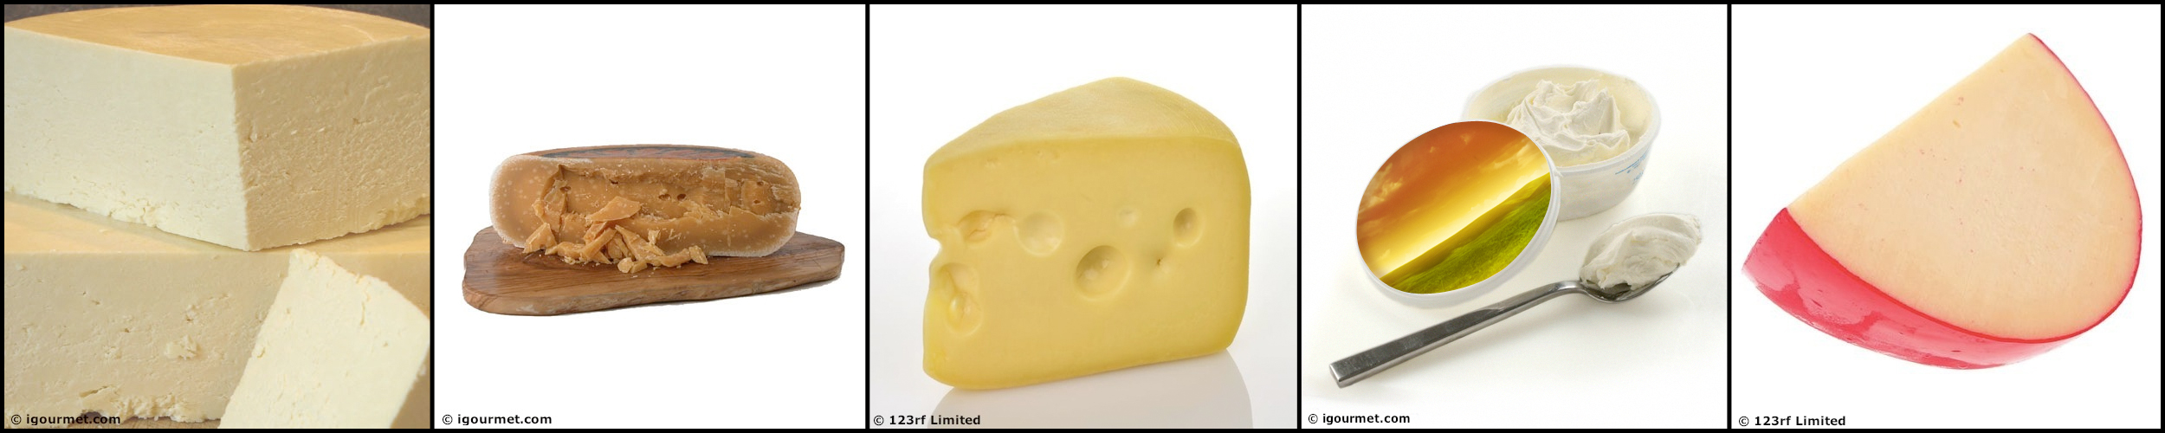

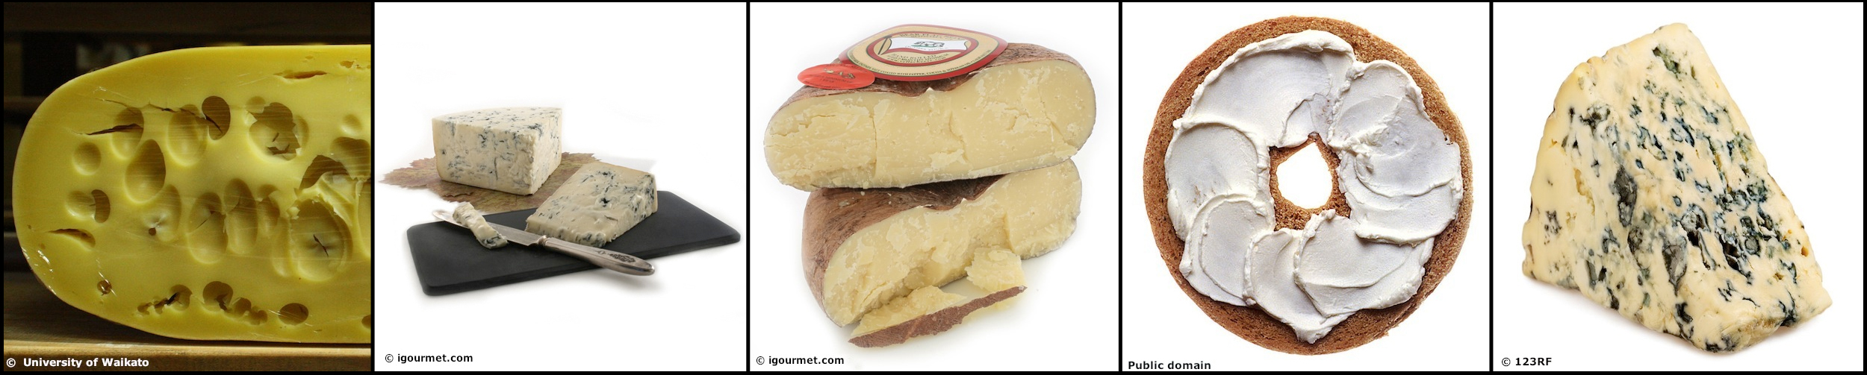

Aged Gouda | Caerphilly | Cream cheese | Edam | Gorgonzola
Appearance: Comes in round wheels and has a natural rind  Colour: Caramel  Firmness: Very hard  Texture: Dry, crumbly  Flavour: Full-bodied flavour  Milk type: Cows’ milk | Appearance: Traditionally made in rounds with thin natural rind  Colour: White  Firmness: Semi-hard  Texture: Moist and creamy  Flavour: Mild with slightly sour tang  Milk type: Cows’ milk (traditionally raw) | Appearance: A spreadable cheese  Colour: White  Firmness: Soft  Texture: Smooth and spreadable  Flavour: Mild, slightly acidic, often flavoured with fruit or herbs  Milk type: Made from whole milk, enriched with cream | Appearance: Comes in round wheels with red or yellow wax coating  Colour: Pale yellow  Firmness: Semi-hard  Texture: Sliceable, melts readily  Flavour: Mild, slightly salty, nutty  Milk type: Made from partly skimmed milk | Appearance: Streaks of blue throughout  Colour: Creamy white, streaked with blue  Firmness: Semi-soft  Texture: Moist, almost spreadable  Flavour: Creamy, tangy  Milk type: Cows’ or goats’ milk
Gruyere | Jack cheese | Maasdam | Mascarpone | Roquefort
Appearance: Comes in large round wheels with natural rind, small holes and cracks when aged  Colour: Yellow  Firmness: Semi-hard  Texture: Slightly grainy mouth feel  Flavour: Nutty, spicy flavour  Milk type: Cows’ milk (traditionally raw milk) | Appearance: Comes in a round wheel shape  Colour: Pale yellow  Firmness: Semi-hard to very hard (depends on ageing)  Texture: Crumbly  Flavour: Sweet nutty flavour  Milk type: Cows’ milk | Appearance: Round shape with natural rind and large ‘eyes’ created by propionic bacteria  Colour: Yellow  Firmness: Semi-hard  Texture: Creamy  Flavour: Mild, subtle flavour  Milk type: Cows’ milk | Appearance: A very soft dessert cheese that comes in containers  Colour: Ivory  Firmness: Very soft  Texture: Thick, smooth, creamy  Flavour: Semi-sweet, cream-like  Milk type: Made from cream | Appearance: Streaked with veins of green mould, created by Penicillium roqueforti and aged in caves  Colour: White, streaked with green  Firmness: Soft  Texture: Crumbly, slightly moist  Flavour: Tangy  Milk type: Raw sheep’s milk

Cheese-processing operations

Pasteurise milk | Age – long period
Acidify | Put curds into shaped mould
Coagulate | Press gently
Drain whey | Press firmly
Cut curd | Stretch curd
Release whey | Heat curds to release whey
Add mould spores | Add acid
Ripen | Add starter bacteria
Age – short period | Add rennet

Teacher answer sheet

Caerphilly Aged Gouda Gruyere Marscapone Edam

Maasdam Gorgonzola Jack cheese Cream cheese Roquefort

The Science Learning Hub acknowledges the contribution of a number of images for this activity from www.igourmet.com.

