ACTIVITY: Constructing an aquifer model

Activity idea

In this activity, students build an aquifer model and examine how water gets into an aquifer system.

By the end of this activity, students should be able to:
- discuss the part groundwater plays in the water cycle
- describe the various pathways precipitation can take once it falls to the ground – evaporation, infiltration, run-off and uptake by plants
- discuss the link between groundwater, surface water and the water table.

Introduction/background notes
What you need
What to do
Student handout: Making an aquifer

Introduction/background

We know that, when rain falls onto a hard surface, the water gathers in puddles and eventually it evaporates, or if there is enough rain, the water runs off into the storm drains and is discharged to surface water somewhere.

But what happens when water falls onto a garden or paddock?

When precipitation falls onto the ground, some of the water infiltrates the soil. In the soil, plant roots take up some of the water and it eventually makes its way back to the atmosphere via transpiration.

Some of the water in the soil evaporates, but some continues to filter downwards through the soil. This is called groundwater. Groundwater is stored in an aquifer – a layer of geological material like sand, pumice, limestone or fractured rock.

Groundwater and aquifers are the part of the water cycle that happens underneath our feet. This activity simulates an aquifer and allows students to visualise the processes that happen underground and out of sight.
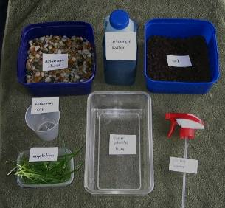
What you need

- Clear plastic container
- Aquarium stones
- Soil
- Grass clippings
- Plastic cup with small holes in the bottom
- Coloured water
- Spray nozzle
- Coffee filter
- Rubber band
- Copies of the student handout Making an aquifer

What to do

- Hand out copies of the student handout Making an aquifer and assist students to gather the materials they need to create the model, working in small groups. Discuss the results.

Student handout: Making an aquifer
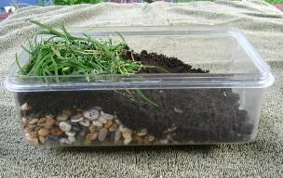
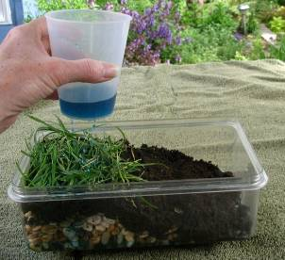
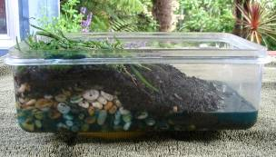
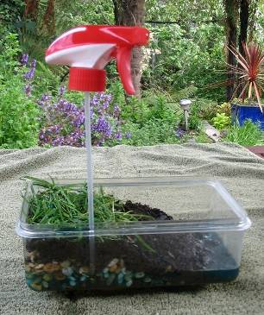
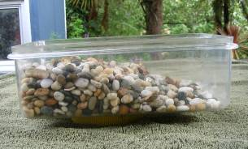
- Put the aquarium stones in the plastic container. Slope the stones to form a depression at one end of the model. This depression will become a lake or other form of surface water.

- Add a layer of soil on top of the stones. Pat the soil down to minimise erosion.

- Add a layer of grass at the top of the slope to represent vegetation.

- Hold the cup over the model. Pour some coloured water into the cup to simulate rain. Move the cup around so that it rains over the entire model. Refill the cup as needed and continue to rain on the model until a small lake forms.

- Watch what happens to the rain as it falls onto the model. Some of the rain falls onto the soil and runs off into the depression, forming a lake. Some of the rain infiltrates the soil and begins to fill the aquifer. Some rain remains on the surface of the vegetation.

- Look at the lake. It is fed directly by rain, through run-off and also by water moving through the aquifer.

- Stop the rain once the lake is a few centimetres deep. Avoid turning the model into a swamp.

- Look at the water table – the top of the saturated layer. The water table fluctuates depending on how much water enters into or is discharged from the aquifer. The water table rises if more rain falls on the model or falls as water is removed from the system.

- Groundwater is used extensively for drinking water and irrigation. To obtain the water, a bore is drilled deep enough to penetrate the water table. Use a spray pump to represent a bore or a municipal well. Cut small strips from the coffee filter. Use these to cover the bottom of the spray nozzle’s tube. Secure the filter with a rubber band. The filter prevents fine particles from entering the tube and plugging the spray nozzle. Work the spray nozzle and ‘pump’ water from the aquifer.

All images © Copyright University of Waikato. All rights reserved.

