ACTIVITY: Exploding flour

Activity idea

In this activity, students observe the teacher igniting flour when it is in a basic combustion chamber.

By the end of this activity, students should be able to:
- understand how surface area of fuel affects fire behaviour – the more surface area, the more quickly ignition will take place.

Introduction/background notes
What you need
What to do
Scientific explanation

Introduction/background

The exploding flour experiment involves attempting to ignite some flour that is packed tightly in a bowl. Then, ignite some loose, swirling flour and compare the results. You will notice that it is difficult to ignite the packed flour, whereas the small, separated particles ignite easily. Why is this?

Warning

Any activity involving fire is inherently dangerous. You need to work as safely as possible. Keep a damp towel and a container of water beside you. Make sure the students stand well back when you blow into the straw.

What you need

- Large baked bean can
- Candle
- Straw
- Matches
- Flour
- Bowl
- Damp towel
- Container of water

What to do
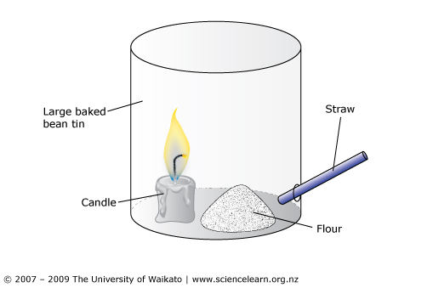
- Set up the experiment before the lesson. Prepare a bowl of flour. Set up a combustion chamber (see diagram). Carefully attach a candle to the bottom of the combustion chamber (can).

- Discuss the concept of fuels with the class. What burns easily? What do people use for fuel? Have students name some common fuels (methane, propane, octane and butane gases, methylated spirits, petrol, wood, coal, oil). Extend the idea that fuel is anything that will burn.

- Show the students the bowl of flour and ask if they think the flour will burn. Drop a lit match on top of the bowl of flour. Why doesn’t it burn?

- Explain that you will try a different way. Place some of the flour from bowl in the combustion chamber. The pile of flour should be between the candle and the hole with the straw. Light the candle with a long match. Have the students stand well back. Blow carefully into the straw. The flour will blow around inside the can and become heated by the flame. When the small particles of flour become hot enough, they will ignite. The flames may reach 500mm high so PLEASE USE CAUTION. (Having a darkened area adds dazzle to the experiment.)

Scientific explanation
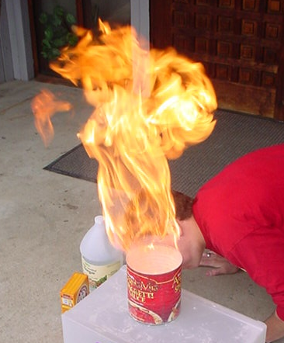
The main ingredient of flour is starch. This is a carbohydrate that, under the right conditions, will burn.

Why do the small particles ignite when the large bowl of flour didn’t? The large pile was made up of many small particles packed tightly together. Most of the particles were nowhere near the match and the overall particle surface area was reduced. Oxygen in the air cannot make contact with many of the flour particles. The single match to burn the pile had not supplied enough heat.

On the other hand, the small particles in the combustion chamber could each be ignited because they were floating freely (blown by the air from the straw) and had all of their sides exposed to oxygen in the air and the heat from the candle. The overall particle surface area was increased and the flour burned.

Other conceptions

Students often confuse the surface area of big objects, like a sugar cube, to be bigger (because the object is bigger) than the powdered sugar. Many tiny grains of sugar give more surface area than the solid cube.

