ACTIVITY: The great candle experiment

Activity idea

In this activity, students cover a lit candle with an inverted jar in a saucer of water. The flame expires and the water rises up in the jar.

By the end of this activity, students should be able to:
- engage in scientific debate, using observation to present ideas
- understand the effects of heat in terms of expansion and contraction in this experiment.

Introduction/background notes
What you need
What to do
Discussion questions
Scientific explanation
Student instructions

Introduction/background

Careful observation is part of being a scientist. In this activity, students are encouraged to observe carefully – they could take notes about what happens and then offer explanations about what they see and think is happening.

This classic candle experiment involves a lit candle covered with an inverted jar in a saucer of water. The flame expires and the water rises up in the jar.
- Why does the candle go out?
- Why does the water rise in the jar?

You may have done this experiment when you were at school. What were you taught? Do you think it is right?

Observe, ask questions and enter into scientific discussion with the students. Be careful not to inhibit students’ opportunities to express their opinions.

Warning

Any activity involving fire is inherently dangerous. Students need to be made very aware of the dangers and the need to work as safely as possible:
- Students should be taught how to strike a match – firmly and away from you – so that they can do this with confidence. Burning matches are often dropped by students who are unsure what to do and are making nervous attempts. Alternatively, the teacher might be the only one to light the candles.
- Teach students to check that the match is completely out. Have a saucer handy to put used matches in.
- If a candle is accidently tipped over, use a damp towel to cover it.

What you need

- Student instructions
- Candles (birthday cake candles, normal sized candles and larger ones)
- Glass jars and bottles (of varying sizes – collected by students prior to the activity)
- 2 litres of water in a jug (for safety)
- Saucer or plate
- Damp towel (for safety)
- Food colouring (optional)
- Modelling clay or plasticine

What to do

- Have the students work in groups. Give out a copy of the student instructions and the necessary equipment to each group of students.

- Read through the instructions together so students understand what to do. Before they begin, students can predict what they think might happen and why. Encourage them to be talking about what is happening while they work.

Discussion questions

- Why does the candle go out?
- Why does the water rise?
- What effect does the size of the candle have on how high the water rises?
- What effect does the size of the jar or bottle have on how high the water rises?
- What effect does the shape of the jar or bottle have on how high the water rises?
- Do all your observations support your explanations? If not, why?
- Do you think you could prove your explanation?

Scientific explanation

The thermal expansion and contraction of the air inside the bottle is the main effect in this activity. Heat from the candle flame causes the air inside the bottle to expand. Some of the air escapes from the mouth of the bottle, which can be observed as bubbles accompanied by a gurgling sound. Combustion does consume oxygen (but not all of it), and when the oxygen level is too low, the flame expires. The carbon dioxide produced by the flame also contributes to extinguishing the flame, and it is often argued whether it’s lack of oxygen or the carbon dioxide that is the main factor that the flame expires.

Once the flame expires, the air begins to cool. The cooling gas inside the bottle contracts to create a partial vacuum. The pressure in the bottle becomes lower than the pressure outside the bottle. The higher external pressure forces water up inside the bottle until the internal and external pressures are equal.

Check out CG Hodgkin’s explanation at http://srollinson.net/Candle/CandleExpt.html. He even puts a mouse in his jar to prove that there is still oxygen in it (the mouse doesn’t die!).

Alternative conceptions

A common alternative conception that has been taught and learned is that the combustion process consumes all of the oxygen leading to a total decrease in the total volume of gas (air) in the bottle and the water replaces this.

If the oxygen consumption was the principal effect, the water should start rising from when the candle is lit and stop as soon as it expires. Instead the water rises most rapidly after the flame expires. Combustion produces carbon dioxide and water, so the total volume of air doesn’t change that much.

Read the article Alternative conceptions about fire.

Student instructions

- Secure the candle to the saucer with the modelling clay or plasticine. The candle should be about half as tall as the jar or bottle you are using. | 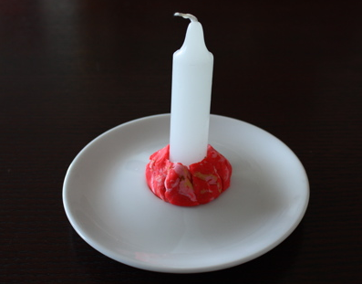
- Pour water into the plate and add a few drops of food colouring if you want to (it might make observations easier). | 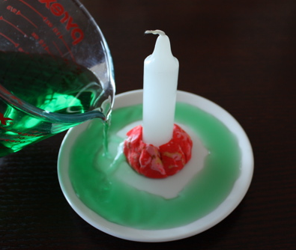
- Light the candle. | 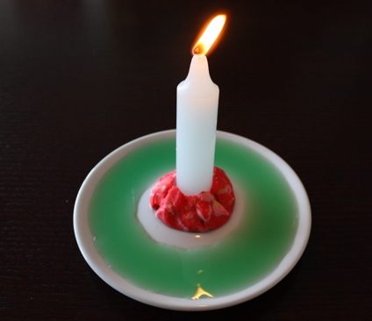
- Cover the candle with an upside down jar or bottle and watch carefully. | 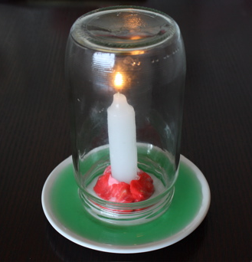
- When you are ready to start again, carefully tilt the jar or bottle to slowly empty it back into the plate. Aerate the jar again or bottle by filling it with water and emptying it again. This removes all the gases in the bottle and replaces it with fresh air.

- Try experimenting with different candles, bottles and jars. Record what happens with each and jot down your ideas on what you think is happening.

