ACTIVITY: Tagging monarch butterflies for science

Activity idea

In this activity, students place small stickers (tags) onto caught or newly emerged monarch butterflies and release them into the environment. The tag number, information about the butterfly and its release location are entered into the Monarch Butterfly New Zealand Trust’s ‘Record a tagged butterfly release’ page.

By the end of this activity, students should be able to:
- explain what tagging is and why tagging is used
- describe the experience of tagging their own butterflies
- record and enter data into the MBNZT online database
- understand the relationship between releasing and recovering tagged butterflies
- appreciate that citizen scientists work in partnership with scientists to answer interesting and relevant questions

Introduction/background
What you need
What to do
Discussion questions

Introduction/background

Tagging monarch butterflies collects useful information in a way that avoids hurting or harming the butterflies. Successful recovery of tagged butterflies can provide information to help answer questions about migration, overwintering, distance flown, dispersal and so on.

Tagging relies on volunteers/citizen scientists, as lots of butterflies need to be tagged during the March–October period for there to be enough information to analyse. For every 100 butterflies tagged, an average of 2 are recovered.

The Monarch Butterfly New Zealand Trust (MBNZT) began tagging monarch butterflies shortly after it was established in 2005. The project is based on methodology developed by Monarch Watch in the USA. The idea behind the project is to collect information so that we can answer questions about where monarch butterflies overwinter in New Zealand and what is happening to the populations. Sightings recorded in the 1960s–1980s report large numbers of monarchs overwintering around Tauranga Bay (now known as Butterfly Bay) in the Far North. More recently, however, observers have found very few butterflies overwintering there. What has happened to this population?

Collection of the tagging information by citizen scientists creates a baseline of data that is added to each year. This information hasn’t been available before because of the time and effort involved for professional scientists to collect it. The MBNZT and their members are able to observe and track butterflies at minimal cost.

By tagging a butterfly, we record the start of its journey, and recovering the tag records where it has journeyed. Tracking the butterfly can answer simple questions like how far it has flown or how long the journey took.

Attaching the tag to a butterfly does not affect its ability to fly. A butterfly weighs around 0.5 grams. The tag weighs around 0.006 grams. That’s 1% of its body weight. The butterfly can handle it, provided the tag is placed on the large distal cell of the hindwing (see image).

MBNZT publishes the data collected on their online database (it has numbers of butterflies tagged and numbers recovered for each of the previous years), and if one of your tagged butterflies is recovered, you’ll receive an email showing where it was recovered and a map showing how far it has flown.

For analysis and to answer questions/test hypotheses, data is referred to scientists. In this case, Barrie Frost of Queen’s University in Canada and Mark Hauber of the University of Auckland and the City University of New York are the scientists involved.
MBNZT is a registered charitable trust. It is funded through grants, through memberships and by its own fundraising.

The article ‘Tag and Release’ by Sue Gibbison (School Journal, Part 2, Number 4, 2009) describes the tagging process.

You could integrate this activity with one on the monarch butterfly life cycle or raising monarchs.

What you need

- Monarch butterflies (either captured or newly emerged)
- Butterfly net (optional)
- Tags (request these from MBNZT before you begin – they are free)
- To be registered with MBNZT so that you can log in and enter your data on the Record a tagged butterfly release page and so that any recovered butterfly tags can be notified back to you.
- Downloaded instructions from MBNZT on how to tag a butterfly
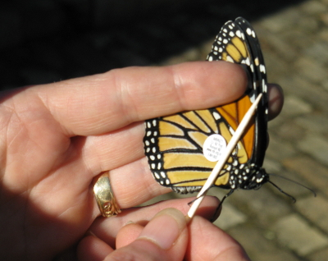
What to do

- Tagging begins in March and runs through the winter – as long as you have monarch butterflies emerging in your garden/classroom.

- Follow the MBNZT instructions on how to tag a butterfly.

Discussion questions

- Are there any questions about monarch butterflies you would like to have answered? How would tagging data help to answer these questions?
- What are the limitations with tagging data and with this method of data collection?
- Why do we collect data like this? Is it useful for conservation, ecology, decision-making (e.g. allowing development to take place that destroys habitat)?
- Is it tricky to put the tag on?
- Did you notice any change in butterfly behaviour? Do you think the tag affects the butterfly’s behaviour once it is put on?

