ACTIVITY: Identifying volcanic rocks

Activity idea

In this activity, students watch a video describing different types of volcanic rocks and then match the chemical composition and type of volcanic eruption each rock is associated with.

By the end of this activity, students should be able to
- name the three different types of rocks associated with volcanoes in New Zealand
- explain how scientists group rocks together into different classifications
- describe which rocks are associated with which type of volcano
- explain the different types of magma and how scientists can use information from rocks to find out when eruptions occurred.

Introduction/background notes
What you need
What to do
Which rock?
Completed chart

Introduction/background

There are many different types of volcanoes around New Zealand, from volcanic fields in the north, to cone volcanoes and calderas in the south. Each type of volcano is associated with a different type of lava, which cools to form rocks. By examining the chemical composition of rocks that they find, geologists can find out what volcano it came from and possibly when.

The key chemicals that geologists look for are silica (silicon dioxide), iron and magnesium.

The relative amounts of each of these chemicals can be determined and the information used to help geologists figure out where the rock came from:
- Rocks high in silica and low in magnesium and iron are associated with rhyolite magma. They can form caldera volcanoes like Lake Taupō or cone-shaped volcanoes like Mt Maunganui.
- Rocks low in silica but high in iron/magnesium are associated with basalt magma, often associated with shield volcanoes like Rangitoto Island.
- In between is andesite, which has medium silica levels, medium iron and medium magnesium. Andesite rocks are often associated with cone volcanoes such at Mt Ruapehu or Mt Taranaki.

What you need

- Copies of Which rock?
- Scissors

What to do

- As a class, watch the video Differences in rocks featuring Professor Richard Price. During the video, have students note down the descriptions that are given for each of the different rock types – andesite, basalt and rhyolite. You might need to pause or rewind the video to make sure you have time to record all the details.

- Ask students to check they can answer the following questions:
- Which type of rock has a low silica content?
- Which type of rock has a high silica content?
- Which type of rock has a low iron content?
- Which type of rock has a high iron content?
- Which type of rock has a low magnesium content?
- Which type of rock has a high magnesium content?
- Which type of magma is cooler – rhyolite or basalt?
- Which type of magma is runnier (less viscous) – rhyolite or basalt?

- Hand out copies of Which rock? Using the information they have noted down, have students place the descriptive labels and photos in the correct column. (See Completed chart for correct placement.)

Which rock?

Rhyolite | Andesite | Basalt

Cut these up and place them in the correct column:

Medium magma, not thick, not runny | Thick gluggy magma (very viscous) | Thin runny magma (not very viscous)
Medium silica content | High silica content (rocks look white) | Low silica content (rock looks dark)
High iron content (rocks look dark) | Low iron content (rock looks white) | Medium iron content
High magnesium content (rocks look dark) | Medium magnesium content | Low magnesium content (rock looks white)
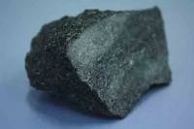 | 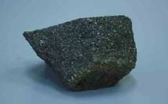 | 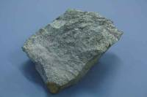
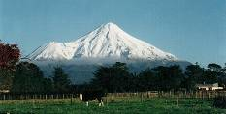 | 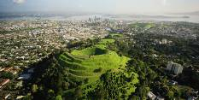 | 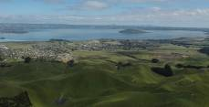

Completed chart

Rhyolite | Andesite | Basalt
Thick gluggy magma (very viscous) | Medium magma, not thick, not runny | Thin runny magma (not very viscous)
High silica content (rocks look white) | Medium silica content | Low silica content (rock looks dark)
Low iron content (rock looks white) | Medium iron content | High iron content (rocks look dark)
Low magnesium content (rock looks white) | Medium magnesium content | High magnesium content (rocks look dark)
Caldera volcano | Cone volcano | Shield volcano

