ACTIVITY: Home disaster kit

Activity idea

In this activity, students select items to include in a home disaster kit in case of emergency and calculate how much food and water they will need to include in a disaster kit for their family.

By the end of this activity, students should understand:
- that everyone faces danger from natural disasters
- that we can help reduce the impact of a disaster by being prepared
- the contents of a basic emergency kit
- what sort of items should not be included in an emergency kit and why
- where to find out information about emergencies and being prepared.

Introduction/background notes
What you need
What to do
Discussion questions
Extension activities
Disaster kit items
Basic emergency kit
Large emergency kit
Calculating food and water
Costs of disaster kit items

Introduction/background

Volcanoes are just one of the potential hazards faced in New Zealand. Others include earthquakes, tsunamis and floods. Civil Defence advises that all homes should have an emergency kit that will help families survive for 3 days. Crucial items include food and water to sustain the family until co-ordinated help is available.

While it can be scary to consider some of the possible risks, being prepared is the best way for people to cope. We can't prevent disasters, but we can all take simple steps to reduce the impact and be better prepared to recover quickly.

What you need

- Photos of disaster kit items
- Photos of basic emergency kit and large emergency kit
- Copies of calculating food and water worksheet
- Copies of costs of disaster kit items and calculators (for extension activity)

What to do

- Ask students to use the photos of disaster kit items provided to assemble their own emergency kit. What are you going to include, what are you going to leave out? (Asking students to compile a kit from the range of photos may stimulate some debate, as some items may be useful but are not necessarily part of the basic kit.) Students could look at the back of the Yellow Pages or Civil Defence website (www.civildefence.govt.nz) for more information.

- Hand out photos of the basic emergency kit and large emergency kit and discuss:
- How does your kit compare to these pictures?
- Can you identify what extra items have been included in the larger kit?
- Why have each of the extra items been included?
- What could you use each of these items for? For example, what could you use the heavy duty plastic sheet for?
- Why is water included? Could you substitute fizzy drink? Why or why not?
- Some items in the kit may already be found around the house. What items could be used instead of buying things shown in the photos?
- Tinned food is recommended, instead of dried or dehydrated food. Why might this be?

- Civil Defence recommends that each household has enough supplies to last for 3 days. Why would you need to be self-sufficient for this period of time? Hand out copies of the calculating food and water worksheet and ask students to complete it.

Discussion questions

- Where can you find out more about what should be in your disaster kit?
- Apart from a disaster kit what else could your family do to prepare for an emergency?

Extension activities

An extension costs of disaster kit items worksheet is provided, which shows the cost of each item. Students could calculate the cost of their kit, or you could give students a budget (suggested $170 for a basic kit for a family of 4) and ask them to build their kit – extra items will mean that can’t afford essential items.
Disaster kit items

Antibacterial wipes  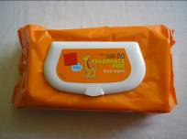 | Boot polish  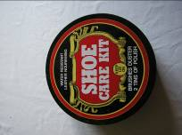 | Canned food  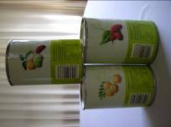
Batteries  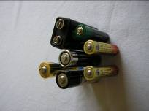 | Can opener  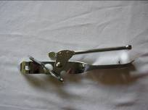 | Cheese  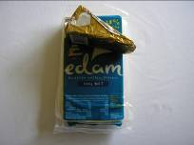
Bleach  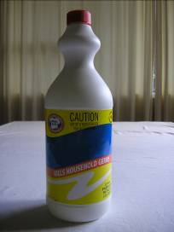 | Candles  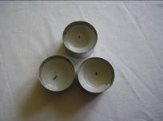 | Disposable face mask  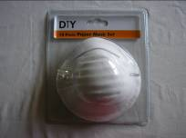

Duct tape  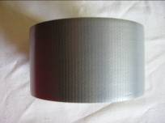 | Fresh fruit  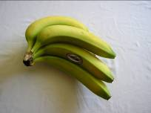 | Hand sanitiser  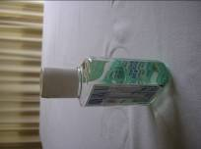
Emergency stove  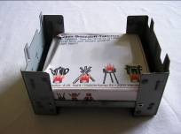 | Frozen food  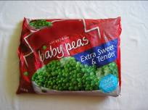 | Light stick  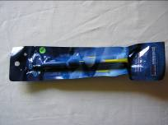
First aid kit  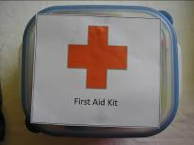 | Gloves  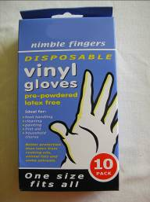 | Mask and snorkel  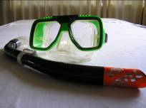

Matches  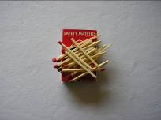 | Toilet paper  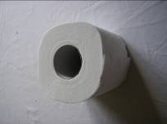 | Waterproof matches  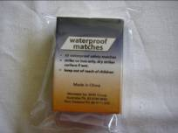
Rubbish bag  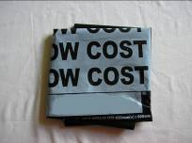 | Tough plastic sheet  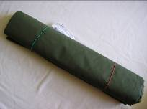 | Wind-up torch and radio  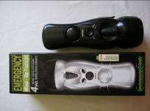
Thermal blanket  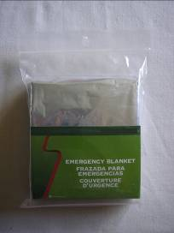 | Water  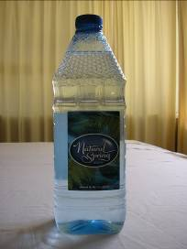

Basic emergency kit

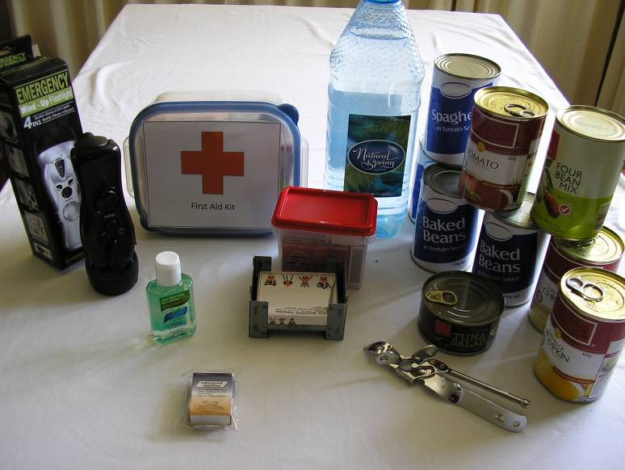
Large emergency kit

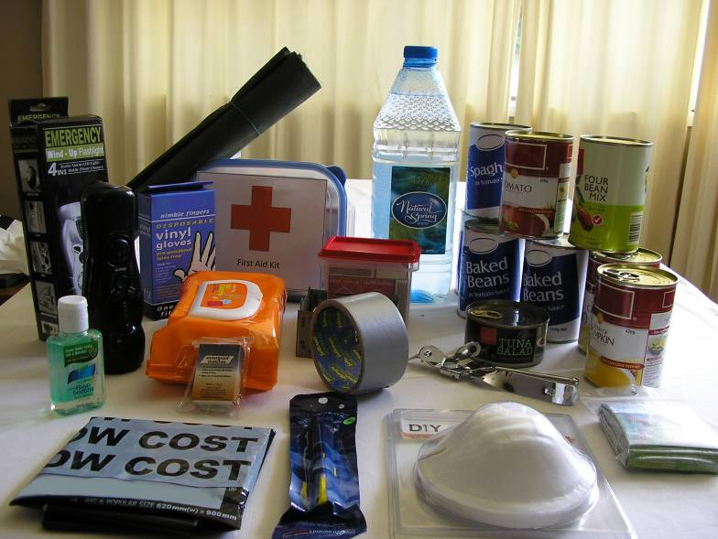

Calculating food and water

Civil Defence recommends that you include enough food and water in your kit for your family to survive for three days after an emergency. How much do you need to include in your kit?

How many people live at your home address? You, Mum, Dad, sisters,
brothers, grandparents? What is the total number of people at home? _____________

Food

Each person will need half a can of food for each meal. How many cans of
food will each person need in total per day? (0.5 cans x 3 meals) _____________

How many cans of food will you need to feed everyone in your family
for 3 days? (number of cans per person x the number of people x 3 days) _____________

Water

Each person needs 3 litres of water per day. How much water will you need
to include in your kit? (3 litres x the number of people x 3 days) _____________

Do you have any pets?

DELETE ONE:

No, I don’t have any pets at home OR Yes, I have a ____________________________

If you have pets, how many cans of food do they eat per week? _____________

So how much do they eat per day? (number of cans per week divided by 7) _____________

How many cans of food will you need in your kit to feed your pet(s) for
3 days? (number of cans per pet x the number of pets x 3 days) _____________

Costs of disaster kit items

Item | Cost
Antibacterial wipes | $2.50 per packet
Batteries (radio) | $6.50 per pack of 4
Batteries (torch) | $6.50 per pack of 2
Battery-powered radio (needs 4 radio batteries, not included) | $30.00 each
Battery-powered torch (needs 2 torch batteries, not included) | $15.00 each
Bleach | $2.00 per bottle
Boot polish | $5.50 per packet
Candles | $3.50 per pack of 6
Canned food | $0.95 per can
Can opener | $1.75 each
Cheese | $6.00 per 750g block
Duct tape | $3.75 per roll
Emergency stove and fuel | $13.50 for stove and 1 block of fuel
Extra stove fuel | $5.00 per block
Face mask | $4.00 per pack of 10
First aid kit | $35.00 each
Fresh fruit | $0.50 per fruit item
Frozen food | $3.00 per packet
Gloves | $2.50 per pack of 20
Hand sanitiser | $4.00 per 125ml bottle
Light stick | $2.00 each
Mask and snorkel | $25.00 per set
Pet food | $3.50 per can
Rubbish bags | $5.00 per pack of 10
Thermal blanket | $8.00 each
Tough plastic sheet | $5.00 each
Toilet paper | $4.50 per pack of 4
Waterproof matches | $3.00 per packet
Water | $5.00 per 3 litres
Wind-up torch and radio (does not need batteries) | $40.00 each

