ACTIVITY: Volcano hunt

Activity idea

In this computer-based activity, students work in pairs or threes to find New Zealand volcanoes using a map and Google Earth. Google Earth gives impressive 3D aerial photography that can be viewed in great detail by scrolling with a mouse. Volcanoes in New Zealand are clearly evident.

By the end of this activity, students should be able to:
- appreciate the topography of New Zealand
- recognise some volcanoes on aerial/satellite photographs
- use a map to find volcanoes in aerial/satellite photographs
- to explain latitude and longitude
- use latitude and longitude to record the location of volcanoes.

Introduction/background
What you need
What to do
Discussion questions
Map of major volcanoes in New Zealand
Map of volcanoes in Auckland
Recording sheet

Introduction/background

New Zealand is a very active geological environment. Since it sits on the boundary of the Pacific and Indo-Australian tectonic plates, it is not surprising that volcanoes are such a characteristic part of New Zealand’s landscape. No wonder Sir Peter Jackson thought it was an ideal setting for his The Lord of the Rings trilogy.

It would appear that the South Island no longer has any active volcanoes, but like the North Island, it has numerous volcanic vents. In the North Island, you can follow a trail of hot springs almost from the top of the North Island to the bottom. The biggest eruption in the world in the last 5,000 years was in New Zealand – this eruption formed Lake Taupō. Auckland, the country’s largest city and home to more than 1.3 million people, is built on an active volcanic field.

Your students may have driven past volcanoes many times and not recognised them as volcanoes. What do these volcanoes look like? Where are they? Are there any close to where we live?

This activity uses Google Earth to give impressive visual imagery of New Zealand’s volcanoes. It would be ideal in a computer suite with 1–3 students per computer. Alternatively, it could be set up on a classroom computer or used as a homework activity.

Latitude and longitude

The Earth is a sphere, so how do we describe where a point is on its surface? Using latitude and longitude lets us locate places on the Earth very exactly, to within a few centimetres.

The equator (an imaginary line equidistant from the North and South Poles) is the line of latitude 0. Latitude is measured from the equator, with positive values north of the equator and negative values south. Latitude values indicate the angular distance between the equator and points north or south of it on the surface of the Earth. A line connecting all the points with the same latitude value is called a line of latitude. All lines of latitude are parallel to the equator, and they are sometimes also referred to as parallels.

Lines of longitude, or meridians, are perpendicular to the lines of latitude. They pass through both the North and the South Pole. By international agreement, longitude 0 (the prime meridian) passes through Greenwich, England. Longitude values are the angular distance between the prime meridian and points east or west of it on the surface of the Earth.

Latitude and longitude are measured in degrees. Degrees can be further subdivided into minutes and seconds – there are 60 minutes (’) per degree and 60 seconds (”) per minute. A co-ordinate might be written 65° 32’ 15” or it might be written as a decimal.

What you need

- Access to computers with the Google Earth program (download is free). Google Earth has a comprehensive and easy to follow user guide if you have not used it before.
- Copies of the map of major volcanoes in New Zealand, map of volcanoes in Auckland and recording sheet for each student/group.

What to do

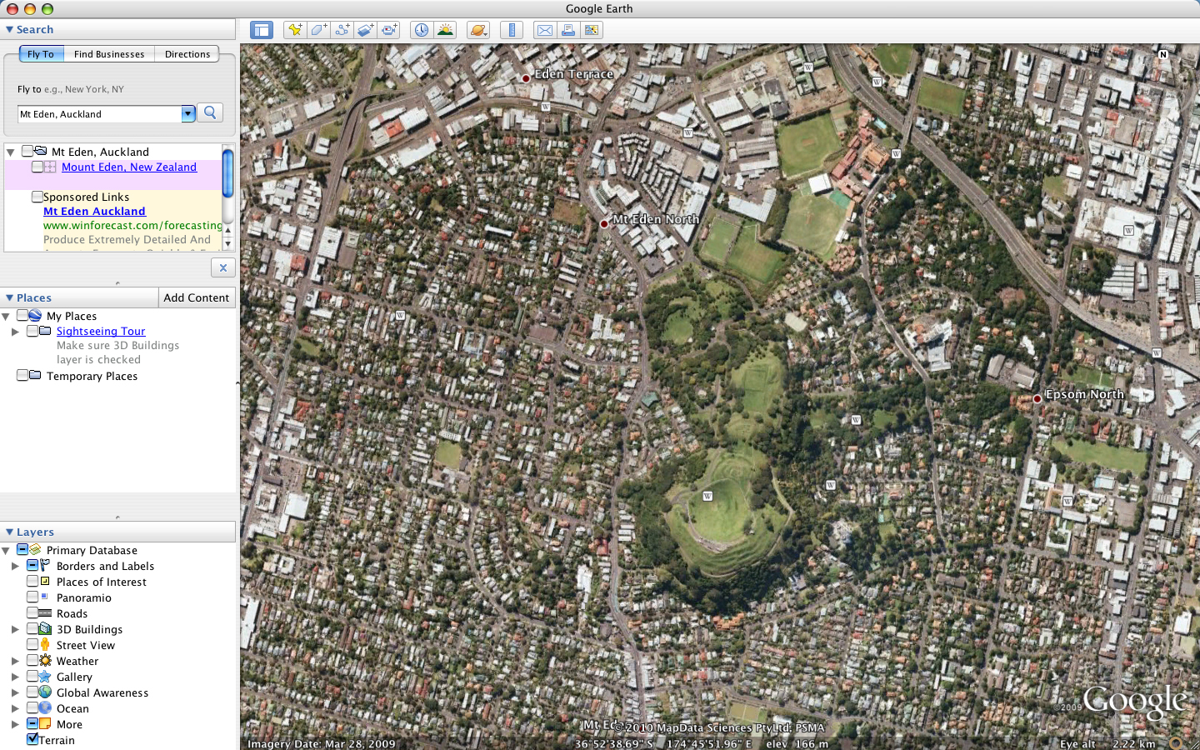

- Introduce students to the concept of latitude and longitude (see Introduction/background).

- Hand out the maps and recording sheet to each group/student, and explain that they are to use their maps and Google Earth to locate as many volcanoes as they can and record the latitude, longitude and height of each volcano they find.

- Use a volcano such as Mt Eden to demonstrate how to use Google Earth to find the information required:
- You can find some of the volcanoes easily just by typing the name of the volcano (for example, Mt Eden) in the ‘Fly to’ search tool on the left-hand side.
- You can also use navigation controls on the right-hand side of the image to set north, look from a vantage point, move from one place to another or zoom in and out.
- Show students the status bar across the bottom of the screen. This shows the latitude, longitude and height of each volcano they find.

Discussion questions

- Who found the highest volcano?
- Did you know we were surrounded by so many volcanoes?
- What did the volcanoes look like and why?
- We live in a very active country geologically. Should this influence the research that scientists do?
- Is there anything we should do as individuals or in our families since we live in such a volcanic country?
Map of major volcanoes in New Zealand

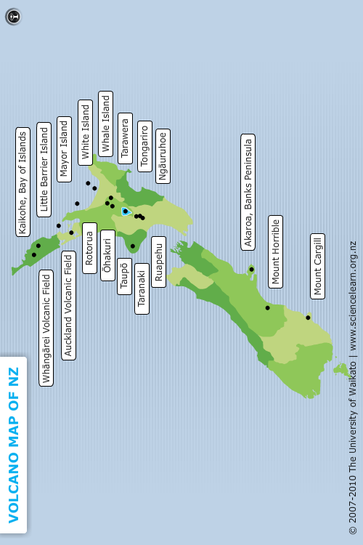
Map of volcanoes in Auckland

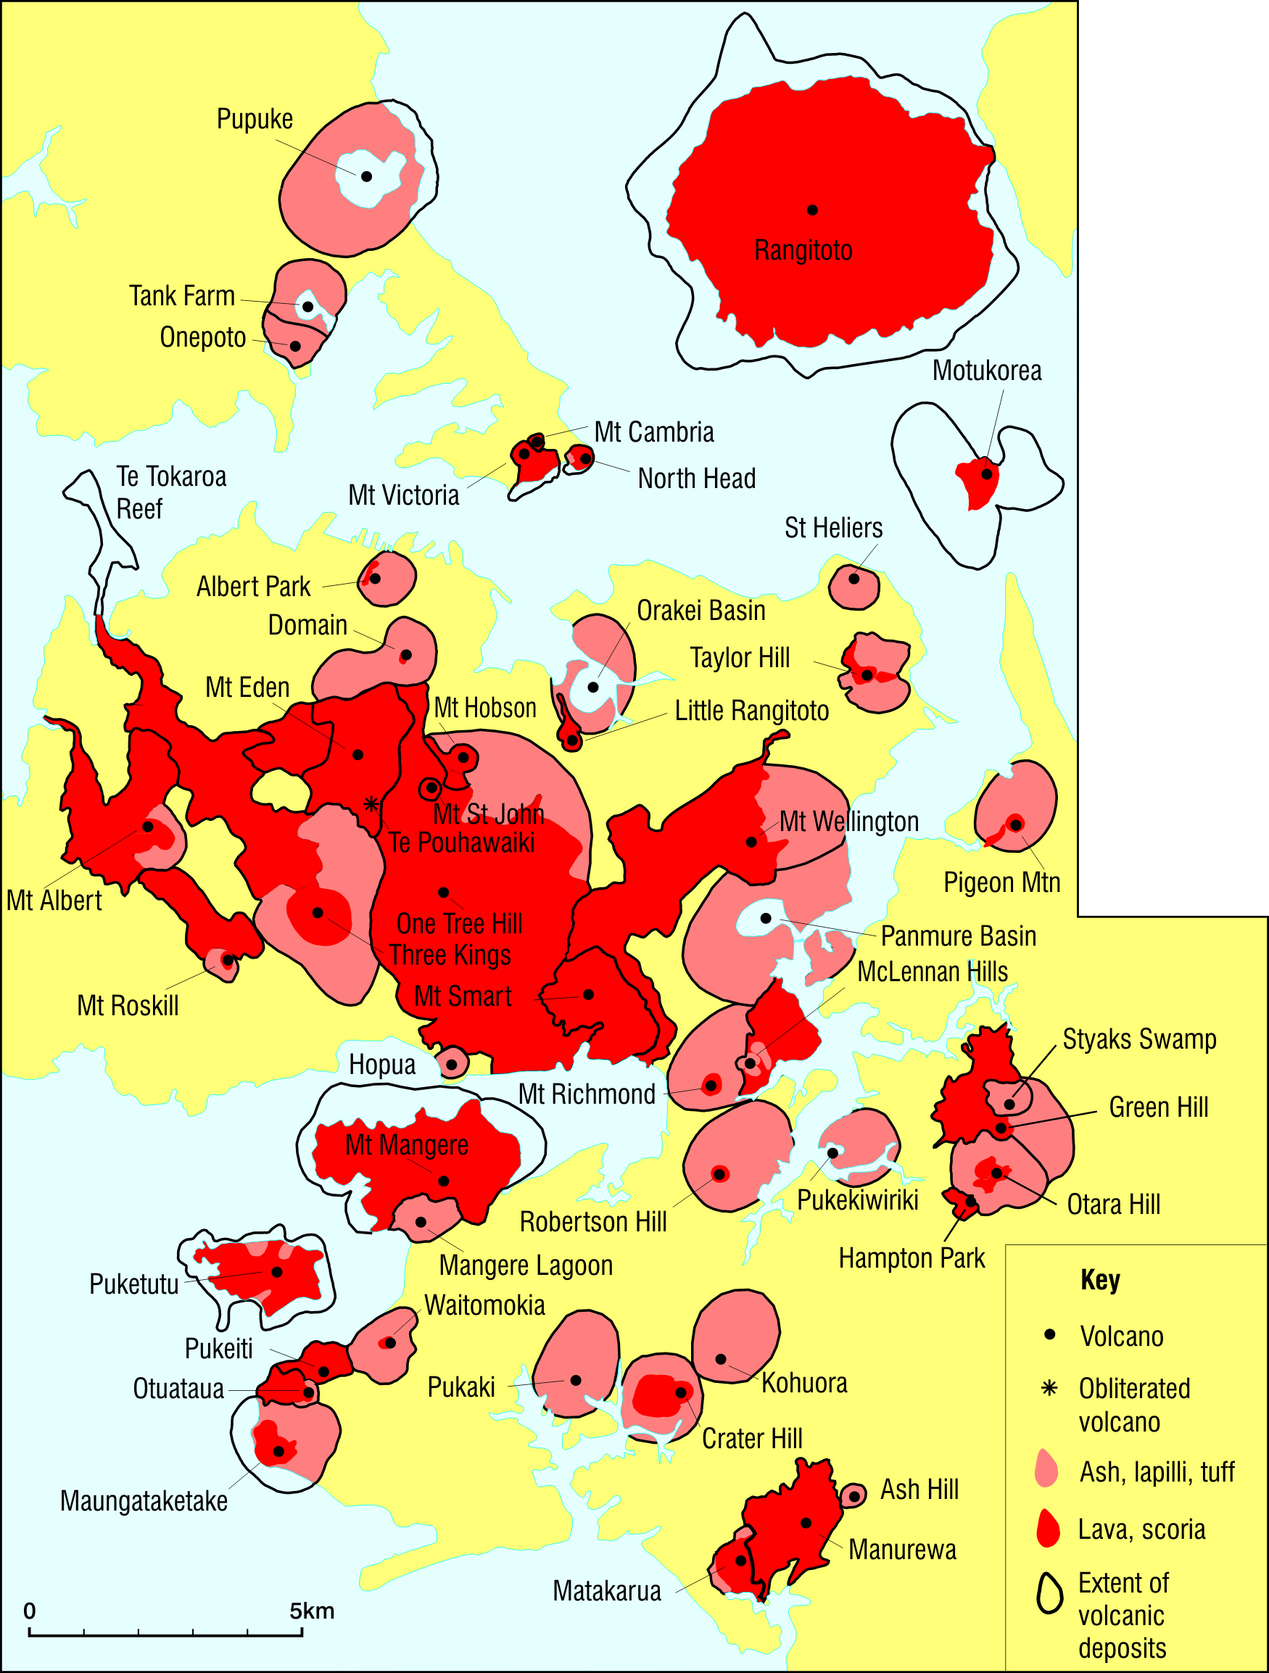
Map courtesy of GNS Science, Les Kermode.
Recording sheet

Name(s): ___________________________________________________________________

Use this table to record the name, the latitude and longitude, and the height of each of the volcanoes you find on your volcano hunt.

Name of volcano | Latitude and longitude  (Go to the centre of the volcano and record in whole degrees.) | Height  (At the highest point you can find on the volcano.)
Mt Eden | 36˚S 174˚E | 189m

