ACTIVITY: Navigating by the stars

Activity idea

In this activity, students learn the cardinal points of the compass. They also learn how to use the Sun and star constellations – the Southern Cross and the Pointers – to identify the cardinal compass points.

By the end of this activity, students should be able to:
- recall the cardinal compass points
- explain how the compass points relate to the South and North Poles
- use the rising or setting Sun to determine east and west (and therefore north and south)
- locate the Southern Cross
- use the Southern Cross and the Pointers to locate the Southern Celestial Pole (SCP)
- use the Southern Cross to determine compass points and therefore direction.

Introduction/background notes
What you need
What to do
Student handout: Navigating using the Southern Cross

Introduction/background

The cardinal compass points are the four main compass points that give the directions north, south, east and west. East and west are at right angles to north and south, with east being in the clockwise direction of rotation from north. There are 12 intermediate points between the four cardinal directions that form the additional points of the compass – NW, NE, SE, SW, NNW, NNE, ENE, ESE, SSE, SSW, WSW and WNW. This activity introduces the cardinal points but could be extended to include intermediate points as well.

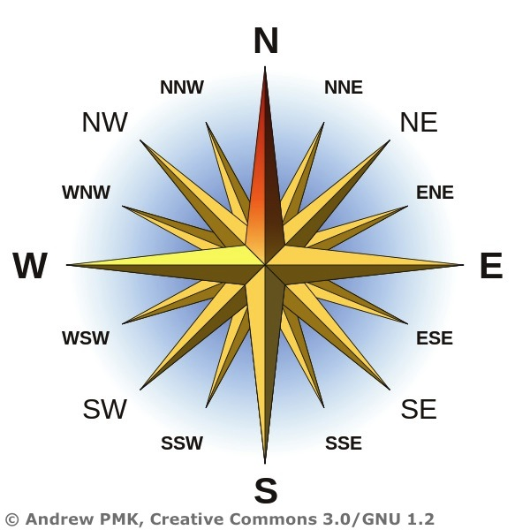

Once the students understand the points of direction (and that they line up with the North and South Poles), they can think about how they could use the celestial sphere to find these compass points. The Sun is a very simple way to work out direction, because it rises in the east and sets in the west. It should be noted, though, that the rising and setting of the Sun shifts in the course of the year. In the spring and autumn, it rises due east and sets due west. In the summer, it rises at ESE and sets at WSW. In the winter, it rises at ENE and sets at WNW. (See Navigating with Sun, Moon and planets for an explanation of this.)

At night, wayfinders use the stars to find their compass points. In this activity, students are shown how to recognise the Southern Cross and to use the Southern Cross and the Pointers to the left of it to find due (directly) south. Due south lines up with the South Pole. Once the students can identify this direction, they use their compass point knowledge to find north, west and east. Landmarks on the horizon at each of these cardinal points can help them fix these points.

Students could practise using the Sun and night stars (the Southern Cross) to get their bearings and identify locations that are north, south, east and west of the school or their homes.

Note: Although navigational compass points on maps refer to true north (the geographical North Pole), a magnetic compass does not point to true north. A hand-held or magnetic compass functions as a pointer to ‘magnetic north’ because the magnetised needle at its heart aligns itself with the lines of the Earth’s magnetic field. Magnetic north is near true north but is not the same location. We say a compass points to ‘magnetic north’ – not true north.

What you need

- Chalk to mark space for compass points game if boundaries not already defined
- Globe
- Southern Cross image (and data projector)
- Copies of the student handout Navigating using the Southern Cross

What to do

- Check students understand compass points. If they imagine the points on a cross, south (S) is opposite to north (N) and the word ‘WE’ can be used to place west (W) and east (E) opposite each other with N situated clockwise from W. Explain that due north and due south line up with the North and South Poles of the Earth. You might like to point these out on a globe.

- A game is helpful for those just learning about cardinal compass points. You need a good-sized rectangular or square space to run around either inside or outside with defining boundaries. The class begins in the middle. Call N, S, W or E. On each call, the class runs in that direction. Whoever is last to cross the boundary line is ‘out’ and sits down outside the square. The winner is the last one left. (Once the class is familiar with the compass points, you could switch to the game ‘Hit the deck’ to teach boat positions – http://youthgroupgamesetc.blogspot.co.nz/2007/01/58-port-and-starboard-akahit-deck.html.)

- Discuss why compass directions are helpful. When might you use them? How might you work out where north is? Students might discuss the Sun rising in the east or setting in the west to work out other compass points. Ask students to get up early enough to see where the Sun comes up over the horizon (or alternatively to see where on the horizon it sets). Students could note that point (E or W) by identifying a landmark where the Sun came up or went down. They could then work out where south and north are (by making an imaginary line from east to west or west to east (180°) and then by dividing the horizon into quarters to get north and south. These compass points are very general. If you want to be more specific (with older students) about where the Sun rises and sets, see Navigating with Sun, Moon and planets.

- Ask students how they might find out where north is at night (when there is no Sun). Some students may have ideas about using the stars in the night sky.

- Using a data projector, show the image of the Southern Cross. Discuss how the Southern Cross can be identified in the sky with the help of the two Pointers (to the left).

- Hand out copies of the student handout Navigating using the Southern Cross, and explain to students how they can use the Southern Cross to find south. Have them do this for homework. Once they have found south, they can use their compass knowledge to find north, west and east.

- Students share experiences back in school. If unsuccessful, try again on another clear night.
Student handout: Navigating using the Southern Cross

If you are ever unfortunate enough to be lost at night and your phone battery is dead, all is not lost. Here is a way of locating the points of the compass using the Southern Cross if it’s not a cloudy night. Of course, you would need to know whether you needed to be going north, south, east or west to get home.

- Locate the Southern Cross. The Southern Cross is not very big and is often mistaken for the Vela constellation. The best way to confirm that the kite formation of four stars that you are looking at is in fact the Southern Cross is to look for the two bright stars (Alpha Centauri and Beta Centauri) that are called the Pointers. These appear to the left of the Southern Cross and are used with the Southern Cross to find south.

- Locate the South Celestial Pole (SCP). This is the point in the sky directly above the South Pole. All of the stars in the southern sky rotate around this point. Unfortunately, the SCP is just a blank piece of sky (no stars to identify its position), so we need to use constellations to get our bearings south.

- Draw an imaginary line (in your mind) between the two Pointers. Halfway along this line draw another line at right angles and extend it until it intersects the imaginary line that runs through the Southern Cross (through the spine of the cross). This intersection is the SCP. Drop a vertical line to the horizon. This is due south.

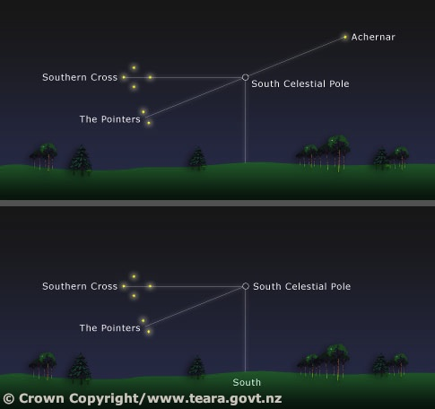

- Note any major landmarks that are due south, due north, due west and due east from your position. Record to share with the class.

- Name some things you might come across if you were to travel due east (and then due west) from where you are.

- If you were in the middle of your nearest town, which compass direction would you need to follow to get home?

