ACTIVITY: Investigating bubbles

Activity idea

In this activity, students learn about the surface tension of water by experimenting with bubbles.

By the end of this activity, students should be able to:
- demonstrate the effect of soap on surface tension
- demonstrate whether the shape of a bubble wand affects the shape of bubbles
- discuss one or more ways in which they worked as scientists to complete this activity.

Introduction/background notes
What you need
What to do
Extension idea
Student handout: Observing bubbles
Student handout: Bubble blowers

Introduction/background

Water has the greatest surface tension of any common liquid. Surface tension has many roles in the natural world and many applications in the commercial world. In a young person’s world, surface tension can provide an ideal mix of experimentation and enjoyment.

This activity uses an inquiry approach in which the students become scientists to conduct research. The first part of the activity explores surface tension in ordinary water. Bubbles form in water but they quickly burst because tension pulls the water molecules surrounding the air back into the main body of water. The bubbles cannot remain intact under this pressure so they quickly pop. Soap lowers the surface tension of water by about a third, so bubbles formed in soapy water are under less pressure and last longer.

The second part of the activity explores the spherical shape of bubbles. The surface tension in soapy water captures air and pulls the soapy water around it into the shape of a sphere. Bubbles naturally form a sphere because this shape has the smallest surface area for a particular amount of trapped air. The shape of the bubble blower does not affect the outcome. Unless they pop first, bubbles turn into spheres. Very large bubbles can be misshaped by the wind.

To learn more about surface tension, read the article Observing bubbles and the introductory comments in the activity Observing water’s thin ‘skin’.

What you need

- Bubble solution (water, dishwashing liquid, glycerine or sugar – see recipes below) in a 2 L milk container
- Water in a 2 L milk container
- Plastic cups (ideally 2 per student, but they can share)
- 2 drinking straws per student
- 2 pipe cleaners (chenille sticks) per student
- Cookie cutters, geometric maths shapes or similar templates (optional)
- Copies of the student handouts Observing bubbles and Bubble blowers

What to do

- Make the bubble solution. Both recipes work well. The second recipe uses sugar instead of glycerine:
- Glycerine recipe: Mix 1 cup of dishwashing liquid, 6 cups of water and 2 tablespoons of glycerine. (You can find glycerine in the supermarket pharmacy aisle or at the chemist. The price is about $4.00 for 100 ml.) Mix the liquids together. For best results, leave it to sit overnight.
- Sugar recipe: Dissolve 1 cup of sugar in 1 cup of boiling water. Add 2 cups of green dishwashing liquid. Mix the liquids together. For best results, leave it to sit overnight.

- Dilute the bubble solution – mix 1 cup bubble liquid to 6 cups of water in a milk container.

Exploring surface tension

- Set the scene by asking the students to put on their imaginary lab coats and enter into a virtual science lab. Discuss the terms ‘research’, ‘investigate’ and ‘observe’. It will be their job as scientists to do some research by investigating two different liquids. As the scientists carry out their research, ask them to observe the liquid in each cup and later what happens to the liquids. Mention observations like:
- the amount of liquid in each cup
- the colour of the liquid in each cup
- noting if the liquids have the same smell
- what happens when air is blown into each liquid
- what happens when the liquids are left to sit for a few seconds after blowing air into them.

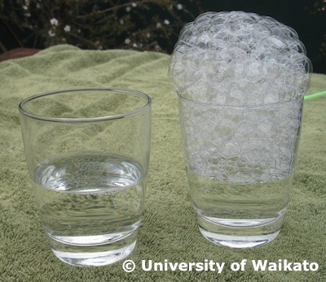
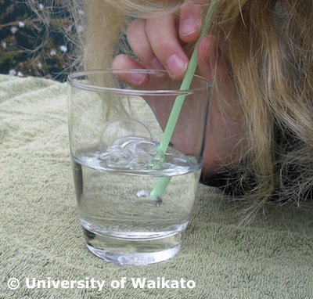
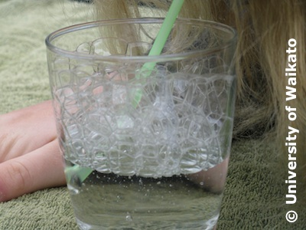
- Provide each student with their scientific equipment – two drinking straws. Explain that scientists use their equipment appropriately and accurately – these are for blowing and not for sucking. (Practise this with younger students to ensure they do not accidentally drink the liquids.) Practise blowing through the straw with small, consistent breaths to keep the test conditions similar for each liquid.

- If possible, move to an outdoor ‘lab’ setting. Give students two cups – one with a small amount of water, the other with an equal amount of bubble solution. Remind students to observe the liquids before, during and after blowing air into them.

- Give students time to blow air into each container.

- After experimenting, gather the scientists to record their observations:
- What was similar about each liquid?
- What was different?
- How did the bubbles in the water behave?
- Did they form in the liquid or on its surface?
- Did they remain in the cup or quickly disappear?

- Briefly explain how surface tension quickly pops bubbles in ordinary water. (Blowing air into tap water creates bubbles that last for a very short time. Surface tension creates a strong force that makes it difficult for bubbles to remain intact so they quickly burst. Once someone stops blowing air into water, the bubbles quickly disappear.)

- Compare it to soapy water with its reduced surface tension. (Adding soap to water lowers the surface tension. These bubbles are more stable and last much longer.) At this stage, it’s only necessary for students to understand that surface tension is an important property of water rather than understand how it actually works.

- Record the students’ observations for a wall story. Include photos if possible. Compare it to how scientists publish their work or share it at conferences.

- Use the student handout Observing bubbles to record individual responses. Younger students can use the wall story for guidance, record ideas as a group or have an adult record their ideas for them.

Exploring bubble shape

- Ask students to put on their lab coats again, this time to investigate bubble wand size and shape and its influence on bubbles.

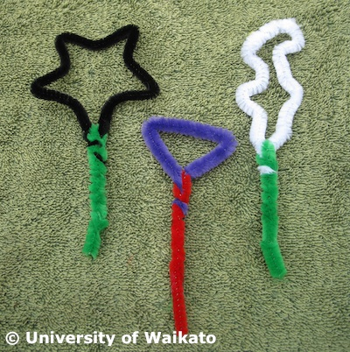
- Give each student two pipe cleaners. (Pipe cleaners make very good bubble wands. They are easy to shape and the furry coating provides an even layer of bubble liquid.) One is to be twisted into any shape the student chooses. The second is to use as a handle. Model the construction of a bubble wand, emphasising that the wand must have a closed loop regardless of its size or shape. Younger students may also require a demonstration on how to twist the ends of the pipe cleaner to tighten them. Twist the second pipe cleaner around the shape to make a handle.

- If available, offer the use of cookie cutters or other templates for students to use. Encourage different design shapes and sizes.

- Look at the different designs and predict what shape the bubbles will be. Do triangular wands make triangular bubbles? Do small wands only make small bubbles?

- Once completed, take the bubble wands outside and test them out. Ask students to observe the shape of the bubbles that come from the wands. (It may help to wave the wands rather than blow on them. Bubbles can be difficult for younger students to blow.)

- Use the student handout Bubble blowers to record individual responses Discuss the observations/results and record as suggested above.

Extension idea
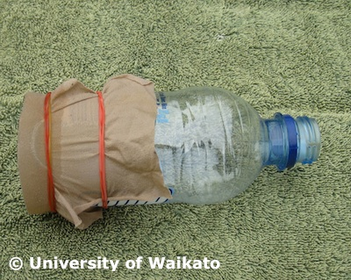
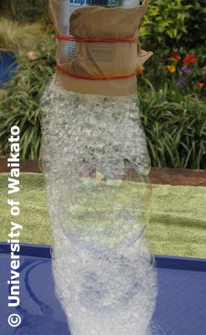
Foam is a mass of bubbles formed in or on a liquid. When students use a straw to blow air into the soapy water, they are making foam. An effective way to make very long foam ‘snakes’ is to cut the end off of a water or soft drink bottle. Stretch a layer of nylon stocking over the cut end. Dip into bubble liquid and blow through the lip or mouth of the bottle.

Student handout: Observing bubbles
Write about your observations with bubbles.
Blowing bubbles in water | Blowing bubbles in soapy water | After blowing bubbles
Word bank
water liquid bubbles straw cup research same different observe investigate surface tension disappear colour smell air blow soap before after pop

Student handout: Bubble blowers

This is the shape of my bubble blower. | This is what I discovered when I used it to blow bubbles.

