ACTIVITY: Observing water’s thin ‘skin’

Activity idea

In this activity, students conduct a few simple activities to learn more about surface tension – a liquid’s thin ‘skin’.

By the end of this activity, students should be able to:
- talk about water molecules and the way in which they are attracted to each other
- talk about how the various activities demonstrate surface tension
- use equipment in a consistent manner.

Introduction/background notes
What you need
What to do
Student handout: Exploring surface tension

Introduction/background

Water has the greatest surface tension of any common liquid. Surface tension is often described as a thin, elastic layer or the ‘skin’ on water’s surface. These descriptions help us visualise surface tension, but as with most things in nature, it is much more complex than that!

A scientist would explain that surface tension is the cohesive force that attracts and holds liquid molecules together. Liquid molecules on the surface do not have other liquid molecules above them so they have stronger attractive forces with the molecules on and below the surface. This force causes the surface molecules to contract and resist an external force. Surface tension allows small objects like insects to rest on the water’s surface as long as the objects do not break through and separate the liquid molecules. Surface tension has other roles in life science – such as the rise of sap in plants – and in many commercial products ranging from tyres to milk powder to mascara.

Surface tension can be explained a little differently from a young person’s point of view. Water molecules like to hold onto their water molecule friends. Those at the surface hold hands a little tighter so other things can’t easily break through. But just as there are ways to get friends to lessen their grip or stop holding hands, there are also ways reduce surface tension.

This resource includes a number of simple, visual activities to teach students about surface tension. You can choose to do one or several of the different activities.

What you need

- Small, clear plastic cup
- Paper clips
- Water
- Pipettes (eye droppers) – enough for students to work in pairs
- 10 cent coins – enough for students to work in pairs
- Plastic cups – enough for students to work in pairs
- Paper towels or newspaper to cover the tables
- Plastic plates – for use with small groups
- Pepper
- Milk (higher fat content works best)
- Liquid food colours
- Dishwashing liquid
- Copies of the student handout: Exploring surface tension

What to do

Demonstrating surface tension

- Introduce surface tension by doing a demonstration activity. Fill a small, clear plastic cup with water. Gather students around the cup, ensuring they are close enough to see what is happening but not so close so that they can bump the table holding the cup.
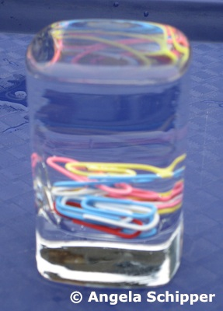
- Top up the cup with water so it is full to the brim. Ask students what will happen if you drop in a paper clip. Discuss their ideas. Continue to add the paper clips one at a time. Watch as the water rises above the cup to form a small dome. Continue adding paper clips until the surface tension breaks and water spills from the cup.

- Explain the concept of surface tension – both from a child’s and a scientist’s point of view. There are many applications of surface tension in the scientific world, but for young students, keep it simple and discuss the ability of some insects to walk on water or the ability of tent materials to repel water (until someone touches the tent and breaks the surface tension, allowing water to enter the finely woven fabric).

Student investigation

- Hand out copies of the student handout Exploring surface tension and have students investigate surface tension in pairs. First, demonstrate how to hold a pipette to ensure uniform drops. Hold the pipette vertically and squeeze gently. Release a line of water drops to demonstrate their uniformity. Then create a second line of water drops by holding the pipette at a 45° or 90° angle. Discuss any differences. Explain that scientists require accurate data so they need to use their equipment accurately and consistently. Ask students to practise holding the pipettes vertically and squeezing water drops onto paper towels until they have consistently sized drops.

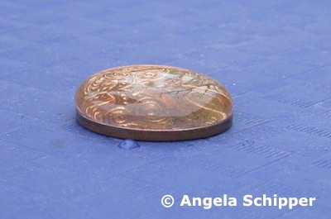
- Pass out the 10 cent pieces and ask students to count how many drops they can slowly place on the coin, building up a dome of water. One student uses the pipette while the other counts. Record the number then reverse the roles. Students can repeat the experiment to see if they get the same numbers the second time around. Compare the numbers with those around them. Discuss why there might be differences (handling of the pipette, how fast or how high the drops are released).

- Finish the activity by discussing how it demonstrates surface tension. Discuss whether children have seen similar beads of water, for example, on waxy plant leaves or on impervious surfaces like kitchen benches or car bonnets.

Reducing surface tension – part 1

- Soaps and detergents reduce surface tension. This is one of the reasons why soap is so much more effective in removing dirt and grease than plain water alone. Pour water onto a plate. Allow it to settle then sprinkle a layer of black pepper over the water. The pepper is light so it does not break through the surface tension and sink. Add a drop of dishwashing liquid to the middle of the plate. The dishwashing liquid reduces the surface tension. The tension or cohesive forces between the other water molecules ‘pull’ the pepper away from the soap.

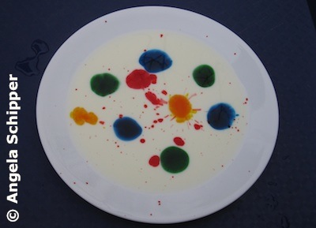
Reducing surface tension – part 2

- Pour milk onto a plate. Use the pipettes to add a few drops of food colouring.

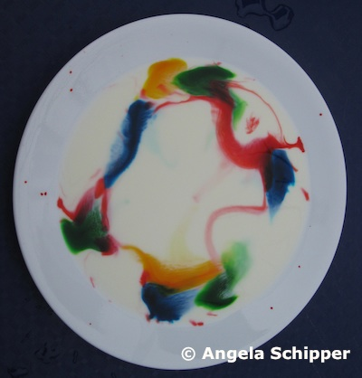
- Add a drop of dishwashing liquid to the middle of the plate. Watch as the soap reduces the surface tension. Again, the cohesive forces between the liquid molecules cause movement and the colours begin to swirl. (Remind students to be patient and watch what happens in the milk. Younger students are often tempted to stir the milk themselves.) Once the movement has stopped, add a drop of detergent in another part of the milk to begin the swirls once again.

Student handout: Exploring surface tension

Surface tension and water drops | Surface tension and soap
Water has strong surface tension.  Water molecules hold on tight to each other. They form a dome on the coin.  Too many drops cause the surface tension to break.  How many water drops can you fit onto the coin?  First try __________  Second try __________  Third try __________ | Soap breaks surface tension.  The molecules pull away from each other.  The soap also breaks up the fat in milk.  Draw a picture of the milk and food colours before you add the soap.  Draw a picture of the milk and food colours after you add the soap.

