ACTIVITY: Hearing sounds under water

Activity idea

In this activity, students listen to sounds made in a swimming pool while being under water themselves.

By the end of this activity, students should be able to:
- recognise how difficult it is to identify the direction of a source of underwater sound
- describe how well various sounds travel under water.

Introduction/background
What you need
What to do
Discussion questions
Extension ideas

Introduction/background

This is a practical activity where students are doing the listening under water themselves. Also, in listening for the particular sounds described in the activity, students will become more aware of the other common sounds heard in a swimming pool – the splashes on the water’s surface, the lapping of water at the edges of the pool and the noises generated as other swimmers move water aside as they move around the pool.

What you need

- 2 small plastic resealable zipper storage bags
- An old or cheap cell phone or a mechanical or electronic alarm clock
- 2–3m of string
- 2 or 3 weights – lead sinkers used in fishing would be ideal
- A block of wood approximately 75 x 50 x 1000mm
- A number of long nails and a hammer
- A thick wooden skewer
- A rubber bung
- A swimming pool

What to do

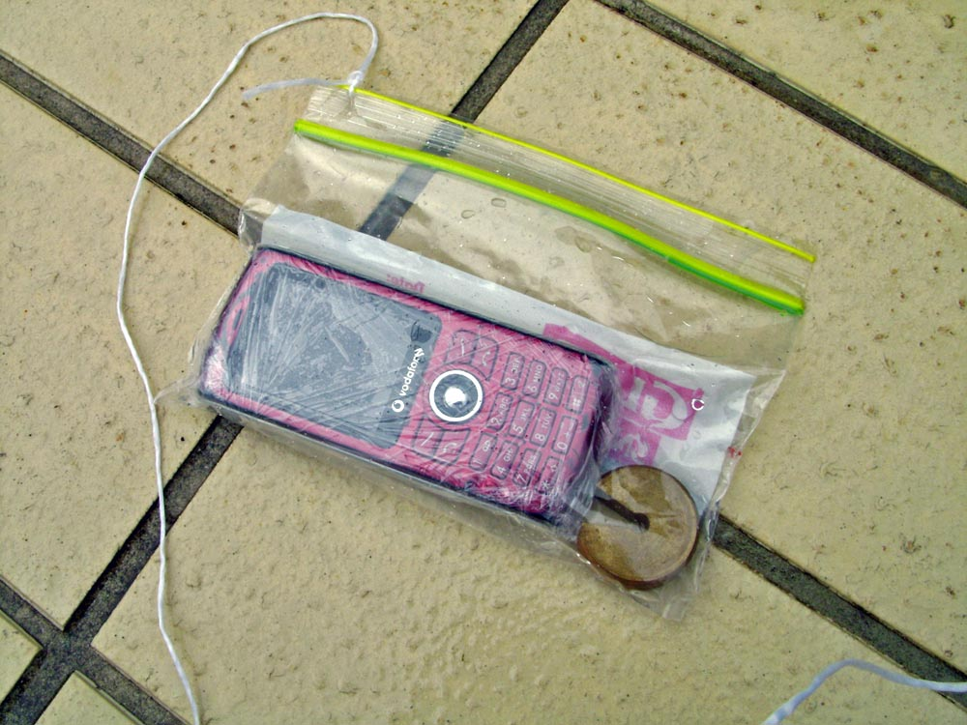
- Put an old or cheap cell phone into a plastic zipper bag. Squeeze as much air out of it before sealing.

- Put that bag and 2 or 3 weights into another identical bag, squeezing the air out as you seal it. Double-bagging the cell phone improves the waterproofing. (Note: only one bag is used with the cell phone in the picture, and you can see, a small amount of water has seeped in!)

- Make a hole in one corner of the bag by the non-sealed part of the zipper and tie the string to the bag as shown.

- Have someone lower the bagged cell phone into the water and have another person make a phone call to the cell phone when you are listening under water. (The same can be done for an electronic or mechanical alarm clock so that the alarm sounds when you are listening under water.)

- Another sound source can be made by hammering some long nails to varying depths into one end of a block of wood. Dip the other end of the wood into the water and tap the tips of the nails side-on with a rubber hammer to make them vibrate sideways. (A rubber hammer can be made from a rubber bung pushed on to the end of a thick skewer.)

- Generate these sounds from different points around the sides of the swimming pool. You should move about the pool and make observations about how each sound’s loudness varies with distance from the source. Also see how easy it is to judge the direction that the sound is coming from.

Discussion questions

- Which sounds are most easily heard in the swimming pool?
- How does a sound’s loudness vary with distance from the source?
- How easy it is to judge the direction that the sound is coming from?

Extension ideas

If it is too cold for swimming in the pool, the hydrophone and amplifier combination used in Make and use a hydrophone could be used instead to listen to the underwater sounds that are produced.

You could watch the interactive How sound travels under water and use information from it to suggest reasons why it can be difficult to estimate the direction of a sound source under water.

