ACTIVITY: Sound on an oscilloscope

Activity idea

In this activity, students play different kinds of sounds near a computer’s microphone and watch the resulting visual display created by oscilloscope software.

By the end of this activity, students should be able to:
- relate the visual display to each sound played
- appreciate the complexity of amplitudes and frequencies within real sounds.

Introduction/background
What you need
What to do
Discussion questions
Extension ideas

Introduction/background

Sound waves cause pressure variations in the substance they travel through. The microphone in a computer or smart phone converts pressure variations in the air around it to corresponding variations in electrical voltage. A computer oscilloscope program gives a visual display of those voltage variations. The program displays a graph of voltage vertically and time horizontally, redrawing this many times a second. The pattern produced on the graph is called a ‘trace’. Traces that repeat themselves regularly are often called ‘waveforms’.
Some oscilloscope programs can have a number of features that are used to manipulate the way in which the trace is displayed. The most important ones are the ability to change the vertical voltage scale – sometimes called the amplitude – and the horizontal time base scale. You should familiarise yourself with the software and use any tutorial and help features.

The oscilloscope trace shows how the pressure variations in the air are varying with time at the microphone. This is not the same as what the sound waves physically look like as they reach the microphone. However, the oscilloscope software can be used to measure frequency and loudness of the sound waves. Some of the free oscilloscope programs listed under What you need are able to measure one or both of these.

These are sample screen images taken when using the Soundcard Scope software on a PC netbook. Note that, in image 1, the amplitude is set at 0.01 and the time base at 5 milliseconds, while the amplitude is 0.02 and the time base is 50 milliseconds in image 2.  Image 1 shows an oscilloscope trace for a sustained tone of frequency 1000Hz. The pureness of the sound is shown by the regular sine-shaped curve.  Image 2 shows the noise produced by a single hand clap. Even though the clap is short and sharp, the oscilloscope trace shows it is still made of about 30 waves that take about 30 milliseconds (ms) to die away from the initial loud sound.  30 waves in 30 ms means that, on average, each wave takes 1ms, which, in turn, means the average frequency of the waves in this particular clap is 1000Hz. | 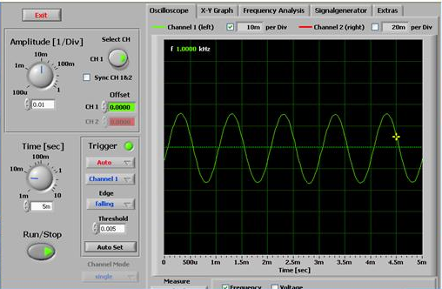
 | 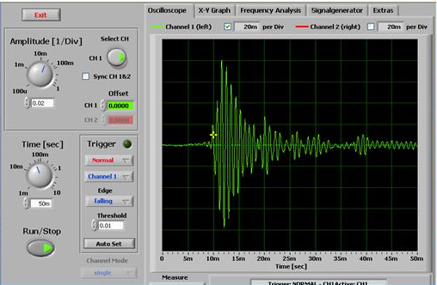

What you need

- Any one of the following provided it has a microphone input: a computer (either desk-top or laptop or netbook), iPad, iPhone, iTouch, Android-based smart phone
- Download and install a freeware oscilloscope software program suitable for the computer or hand-held device chosen from the above list – suitable software programs are:
- for PC – Soundcard Scope 1.32 (www.zeitnitz.de/Christian/scope_en)
- for Apple – MacCRO X (0.1.3) (http://mac.softpedia.com/get/Audio/MacCRO-X.shtml)
- for Apple – Wavewindow (https://www.macupdate.com/app/mac/16454/wavewindow-au)
- for iPhone, iTouch and iPad – oScope Lite or FreqCounter (available from the iTunes App Store)
- for Android-based smart phones – Oscilloscope Pro US$7.99 (not freeware) (www.appbrain.com/app/oscilloscope-pro/com.nfx.noscpro)
- For Android-based smart phones – Oscilloscope (free) (https://play.google.com/store/apps/details?id=com.xyz.scope&hl=en)
- Various items that produce a range of musical sounds and noise, for example, tuning fork, mechanical music box, musical instruments, a small bell, radio, mp3 player, rattle, electronic alarm

What to do

- Play each sound in front of the microphone in the computer and look at the shape of the oscilloscope trace displayed.

- Look especially at the maximum height (the amplitude) of the trace and relate that to how loud the sound is or how close the sound source is to the computer microphone.

- Look at how close together the variations in the trace are horizontally and relate that to the pitch (frequency) of the sound that is heard.

- Speak into the microphone and see the resulting trace. It is easier to see patterns on the oscilloscope when the sounds are sustained. Slowly say the five vowels and then other sounds such as a hiss and a gentle whistle.

Discussion questions

- How does the display change when a sound is made louder?
- How does the display change when sounds of a higher frequency are played?
- What differences are there between the traces of the spoken sounds ‘ahh’ and ‘shh’?
- How common are pure sounds in what we hear in our daily lives?

Extension ideas

Change to the ‘frequency analysis’ part of the oscilloscope program (where available). This method of displaying sound information gives something called a ‘frequency spectrum’. It shows both the frequencies that are present in a complex sound and which of them are the prominent ones. Play the same sounds as before and now look at which frequencies appear as prominent components of the sounds.

The hydrophone and amplifier combination used in Make and use a hydrophone could be placed near the computer microphone input. In this way, the oscilloscope software can display the underwater sounds visually.

Obtain a dog whistle that produces ultrasonic sound. Blow the whistle near the computer microphone. Is the whistle’s sound able to be detected and displayed?

