ACTIVITY: Make and use a hydrophone

Activity idea

In this activity, students make a hydrophone and use it to listen to underwater sounds.

By the end of this activity, students should be able to:
- understand how to modify an electret microphone to be used underwater
- describe differences in how sounds are heard underwater and above water in the air

Introduction/background
What you need
What to do
Discussion questions
Extension ideas

Introduction/background

Water is a different substance to air. Water is much denser and does not compress as easily as air. Conventional microphones that work in air will not work in water unless they are modified. Hydrophones are microphones designed for use in water.

Amongst his other research, Ernest Rutherford led early research into hydrophones made from piezoelectric crystals. The only patent he ever took out was a design for a hydrophone. Today, most professional hydrophones continue to use piezoelectric material.

This activity involves waterproofing a cheap, commercially available piezoelectric microphone, called an electret microphone, so that it can be used under water as a hydrophone. The waterproofing material needs to be flexible, however, so that the underwater sound waves can travel through the material and reach the microphone.

The electret microphone cannot be connected to any amplifier directly. A special preamplifier circuit is needed that both provides power to the electret and boosts the tiny signal from it ready for connection to a main amplifier. Jaycar Electronics (www.jaycar.co.nz) sells a suitable preamplifier as a kitset.

Safety
As the hydrophone and the preamplifier are operated in and around water, the main amplifier (speaker) should not be mains operated. To be absolutely safe from electrocution, you should use a battery-operated amplifier. A battery-operated speaker that can be plugged directly into a cell phone will serve well as the main amplifier.

What you need

For constructing the hydrophone and pre-amplifier
- One electret microphone insert, Cat# AM4010 or AM4011
- Audio connecting cable 2–3 metres long, Cat# WB1500
- Flexible silicone sealant, such as Selleys Wet Area Silicone, 75g tube
- One Pre-Champ Versatile Preamplifier Kit, Cat# KC5166
- One 3.5 mm enclosed socket, Cat# PS0122
- One 9 volt battery snap connector, Cat# PH9230
- One 9 volt battery
- Solder, soldering iron and tools to construct the preamplifier
- Main amplifier (battery-operated speaker or similar)

The input of the main amplifier needs to be able to connect to the 3.5 output socket of the preamplifier. If the amplifier does not have a suitable lead, you will need an audio lead with plugs at both ends. Jaycar sells a 1.5 metre long lead 3.5mm stereo plug to 3.5mm stereo plug, Cat# WA7008.

For making sounds
- Drinking straws
- A small bottle
- Hand-operated egg beater
- 10 litre plastic bucket or a small aquarium
- Mechanical music box or tuning fork
- Block of wood approximately 75 x 50 x 500mm

What to do

Construct the hydrophone  - Solder the two leads at one end of the audio cable to the electret microphone. The picture shows that the ‘gnd’ (ground) connection on the microphone is the one with small metal connections to the outside of the case. Make a note of which colour lead is soldered to the ‘gnd’ connection and which colour lead to the ‘input’ connection.  - Cover the microphone and end of the audio lead with flexible sealant as shown in the picture. Allow the sealant to set.  - Construct the preamplifier following the instructions that accompany the kit.  - Solder the gnd lead of the microphone audio cable to the gnd of the preamplifier and similarly for the input lead to the input of the preamplifier.  - Solder the battery snap leads and the 3.5mm socket connections to the preamplifier as shown in the picture. The picture also shows a short length of wire is needed to be soldered between the side connection of the 3.5mm socket and the gnd connection because the side connection cannot reach. For this, use an off-cut of wire taken from one of the components soldered earlier in the preamplifier circuit. Note that the centre connection of the 3.5mm socket is not used.  - Connect the main amplifier to the preamplifier using a 3.5mm audio lead. The picture shows the complete set up. | 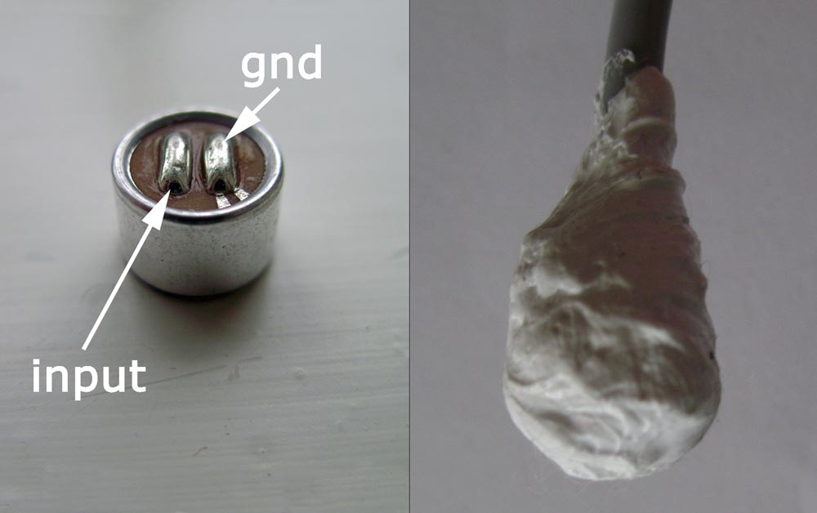  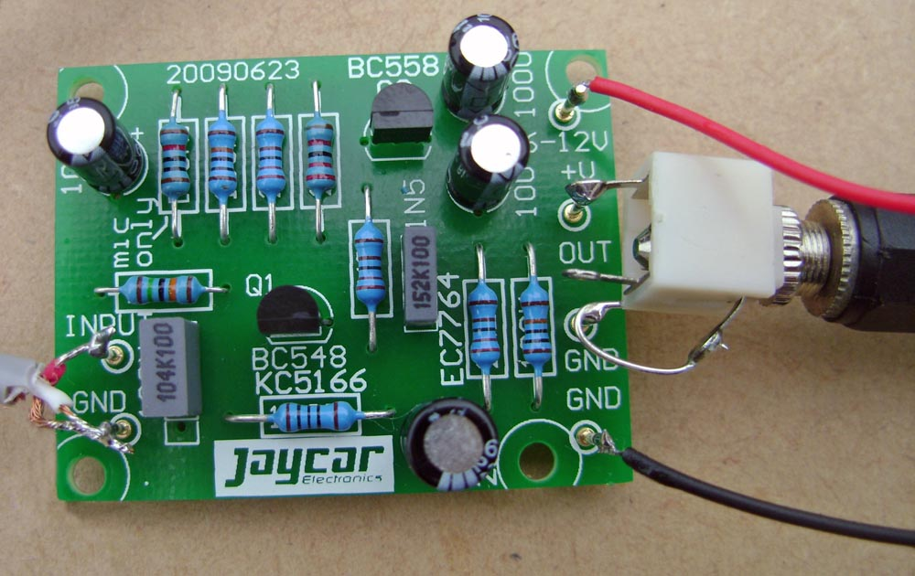  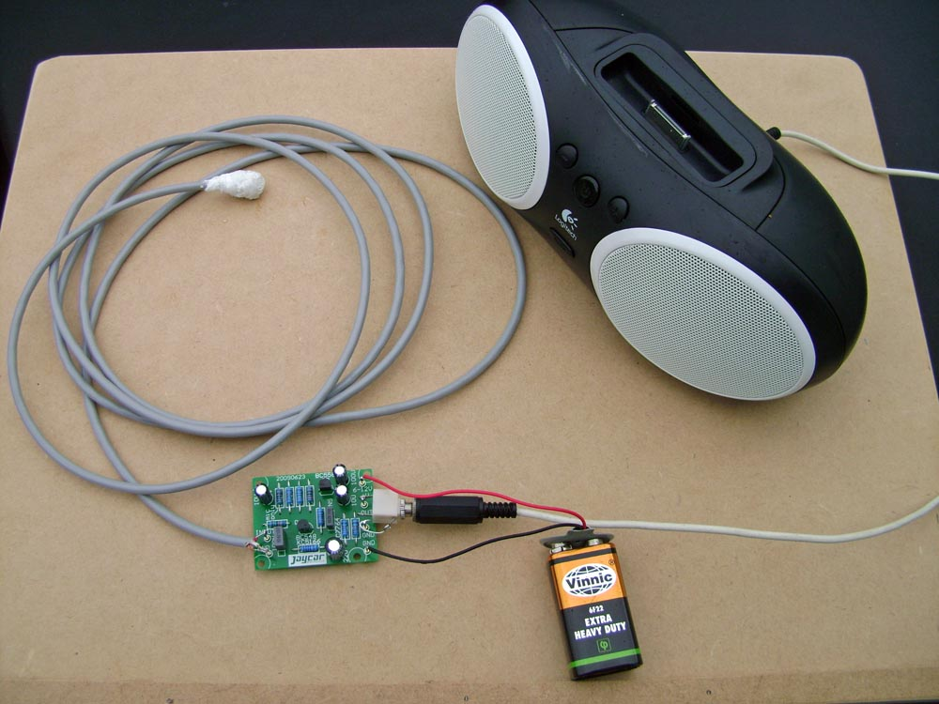

Listen to sounds
- Place the hydrophone in a bucket of water or in a small aquarium and use it to listen to a range of sounds made first in the air above and then under water. Here are different sounds you can try:
- Make splashes on the surface of the water in the bucket or aquarium.
- Using a straw, blow bubbles in a small bottle of water then remove the straw and blow bubbles with the straw on the surface of the water in the bucket or aquarium.
- Tap and scrape the side of a wooden block, then do the same to the bucket or aquarium.
- Turn the handle of a hand-operated egg beater in air then dip the beater into the water and turn the handle.
- Place a hand-operated or wind-up music box on the block of wood near one end and make it play. As it plays, slowly dip the other end of the block into the water.
- Tap a metal tuning fork and hold the tuning fork handle on one end of the block of wood. As it plays, slowly dip the other end of the block into the water.

Discussion questions

- How would you describe each of the sounds that you heard?
- How do the various sounds change when they are made first in air and then under water? Does their loudness change? Does their pitch change?
- What does this tell you about how sound travels in water?

Extension ideas

The hydrophone and amplifier combination could be taken to a school swimming pool or to the sea and used to listen to sounds generated under water and by surface waves and splashes. The larger size of a swimming pool allows you to make an underwater sound and investigate how the sound volume changes with distance away from the source of sound.

You could use the hydrophone to listen to a cell phone as it rings under water (see Sounds in the school pool).

You could use a computer oscilloscope programme to display visually the sounds that are detected by the hydrophone (see Sound on an oscilloscope).

