ACTIVITY: Catching worms using ground sounds

Activity idea

In this activity, students investigate whether there is any evidence that earthworms can respond to vibrations in the ground.

By the end of this activity, students should be able to:
- justify their opinion about a strategy for catching worms and provide evidence for this opinion
- state the evidence that has been collected and analysed to substantiate their position
- link vibration production to worm numbers and worm behaviour.

Introduction/background notes
What you need
What to do
Discussion questions
Extension ideas

Introduction/background

In the 1960s, Dutch scientist Nikolaas Tinbergen, who studied bird behaviour, reported seeing seagulls ‘paddling’ or stamping and noted that this behaviour brought earthworms to the surface. Much earlier in 1881, the famous evolutionary scientist Charles Darwin wrote about earthworms coming to the surface in response to vibrations.

There are people in the South Western United States who catch worms for a living and sell them to fishers for bait. They are called ‘grunters’. They go to a recently cleared forest area and drive a stake about 30cm into the ground. Then they rub the top of the stake with a long piece of metal (11 x 7cm) and wait for the worms to emerge.

Scientists have tested to see if worm ‘grunting’ entices worms out of the ground. They were able to measure the best frequency for getting worms to surface and found that sound below 500Hz made the worms react. At these frequencies, worms started to emerge after 1–2 minutes.

But why do earthworms come to the surface? One hypothesis is that they move to the surface when their burrows are flooded, but scientists have shown that earthworms can cope with high levels of flooding. Darwin suggested that earthworms were escaping moles whose main source of food are earthworms – moles are noisy animals and make grunting sounds. Recent research has shown that earthworms do crawl away from moles and the best place to escape is the surface where moles don’t go. We don’t have moles in New Zealand and it would be interesting to see if our worms carry this memory of a ‘predator’ and respond by leaving the ground.

There are still unanswered questions about earthworms and sound in the ground. Scientists may have found out that worms can respond to sound but they don’t know how. Scientists presume that they ‘hear’ the vibrations through their skin – just the way some deaf people can hear sounds through their skin surface. (There is a famous timpanist called Dame Evelyn Glennie who plays drums in the English National Orchestra. She is totally deaf but is able to use her body to listen to the orchestra playing.)

You are not going to play an orchestra when you do your experiment but instead produce some simple sounds that might make earthworms respond.

What you need

- Garden fork
- An area where worms may be living

What to do
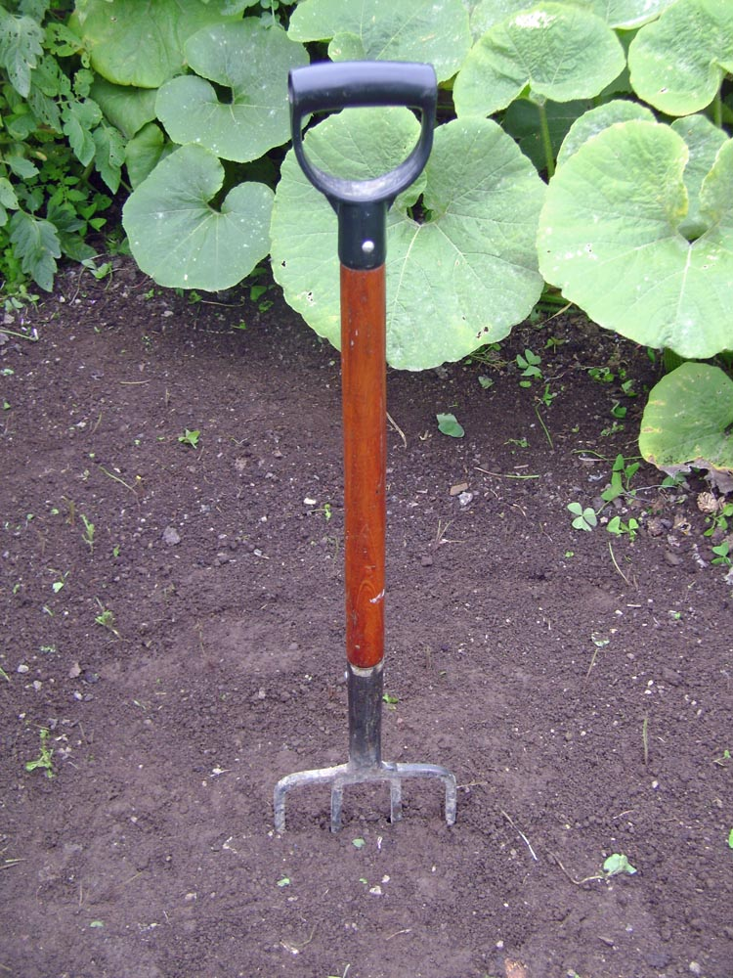
- Use the introduction/background notes to introduce the idea of earthworms responding to vibrations in the ground.

- Choose a place where worms may be living and set up your own ‘grunter’/vibrator by digging a garden fork into the ground.

- Vibrate the garden fork and wait for the worms to emerge.

Discussion questions

- What measurements should we record when carrying out this experiment? (How quickly we are vibrating the fork and for how long. What time of day we carry out the ‘grunting’ activity.)
- What information about the worms will we record? (How long it took for worms to appear. How many worms. Where worms have appeared. What they are doing. Whether they all look the same or behave the same.)
- What are the best places to collect worms using this method?

Extension ideas

Students may decide they would rather carry out some foot stomping.
- How many people make a good foot stomping team?
- How many stomps per minute are needed?

Some students may decide to go bird watching and keep an eye out for seagulls doing some foot paddling.
- What kinds of birds are foot paddlers?
- How do you know they are catching worms?

Some other questions to investigate:
- Do our native worms respond to ground sound?
- What type of vibration makes earthworms surface?
- Does the wetness of the soil have any influence on their surfacing response?
- What do earthworms do once they have surfaced and the vibrations have stopped?
- What birds carry out foot paddling/foot stomping? Where do they do it? What time of the day does this happen? Is it true that the early bird catches the worm?

