ACTIVITY: Modelling waves with slinkies

Activity idea

In this activity, students model how sound travels by sending waves along two stretched plastic slinkies tied together.

By the end of this activity, students should be able to:
- understand that sound is a longitudinal wave where particles in the medium vibrate back and forth along the same direction as the wave travels
- see that a wave travels along as a series of compressions and expansions in the medium.

Introduction/background
What you need
What to do
Discussion questions
Extension ideas

Introduction/background

Sound travels invisibly as longitudinal waves through media. This is because particle motion in each medium is too tiny or too rapid or the particles are themselves too tiny to see (as in air). This activity helps to visualise the microscopic motion of particles as they carry sound waves by using a simple model where the rungs of a slinky represent particles in a medium. There are some useful videos for students to watch in the article Waves and energy – wave basics.

What you need

- 2 inexpensive plastic slinkies – these can be purchased cheaply from a $2 Shop or toy shop
- 2 solid points between which the slinkies can be stretched – bricks are used in the image shown
- Twist-ties and/or string to attach the slinkies
- A smooth flat surface on which to lay the slinkies, not carpet – tables or a lino or wooden floor are ideal

What to do

- Use twist-ties or string to attach one end of each slinky together.
- Attach the other end of each slinky to a brick (or other solid point).
- Move the bricks apart until the slinkies are stretched but are not too taut (as shown in the image).
- Place a flat hand between the slinky rungs a little way from one end and rapidly move your hand backwards and forwards rhythmically. This will send waves down the length of the slinkies.
- Observe how the waves die away progressively as friction between the rungs and the floor or table takes the energy of motion away. This means that very little of the waves are reflected back from the far end, which would interfere with a clear vision of the waves as they travel along. (Note: Two plastic slinkies are used since using only one slinky does not give enough distance to see the waves travel and suffers from considerable interference from reflected waves.)

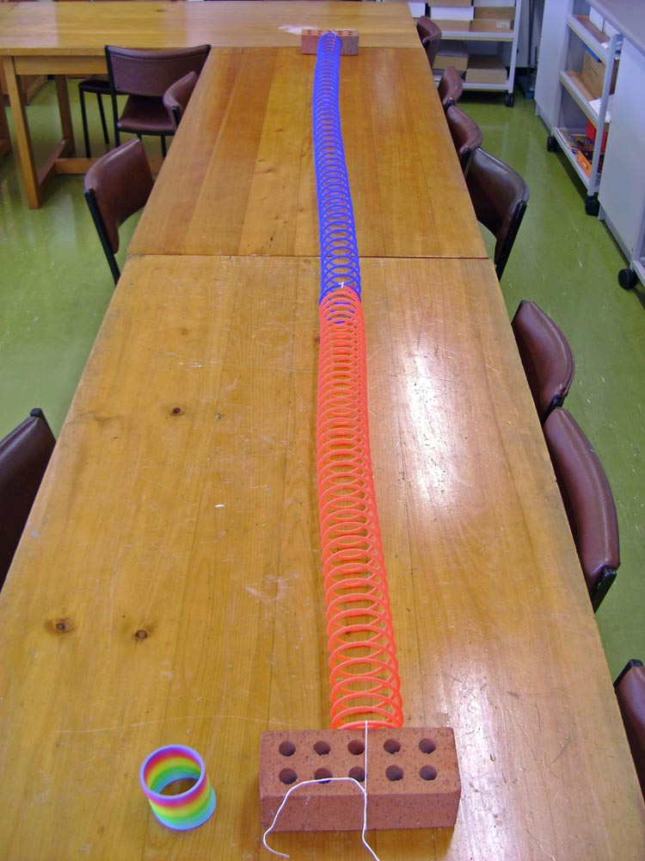

Discussion questions

- How would you describe the waves that you see travelling along the slinkies? Can you see where the slinky rungs are compressed and where they are expanded?
- How do the waves along the slinkies change if you change from moving your hand back and forth slowly to moving it rapidly?
- This activity models the motion of particles in a medium when sound waves pass through it. What parts of the stretched slinkies represent the particles in a medium? What represents the source of the sound?

Extension ideas

- You could video the waves moving along the slinkies and play it back in slow motion to make it easier to see the places where the rungs are compressed and where they are expanded.
- You could mark one point on a rung near the centre of the stretched slinkies in some way (say with a loop of string or a small sticky-taped piece of paper), then watch the motion of that particular part of the slinky as waves pass through it. You should observe that the marked point on the rung vibrates backwards and forwards in the same way as the hand causing the waves (but with a smaller motion, since the waves are dying away).

