Proteins

It has been estimated that about 18% of the human body is made up of protein. Like carbohydrates and fats, proteins are made up of the elements carbon (C), hydrogen (H) and (O) but they also contain nitrogen (N).

Amino acids

Proteins are very big molecules made up of smaller units known as ‘amino acids’. There are about 20 different naturally occurring amino acids that combine to form proteins.

This is the basic structure of amino acids:

‘R’ varies from one amino acid to another.
The NH₂ part is the amino group and COOH the acid group.

The simplest amino acid is glycine, where ‘R’ is a hydrogen atom. In alanine, ‘R’ is CH₃, known as the methyl group.

Peptide bond

Amino acids can link together to form chains of variable length. To do this, the acid group of one amino acid interacts with the amino group of an adjacent amino acid. The linkage formed is known as a peptide bond.

This dipeptide (two amino acids linked together) is known as glycylalanine and is represented as Gly-Ala using the three-letter amino acid coding system.

Peptides and proteins

Chains with fewer than 50 amino acids are called peptides, while the term protein is reserved for longer chains which, unlike peptides, take up a definite shape.

Insulin is a protein hormone that is involved in maintaining blood sugar levels. It consists of 51 amino acids organised into two chains that link into a 3D structure.

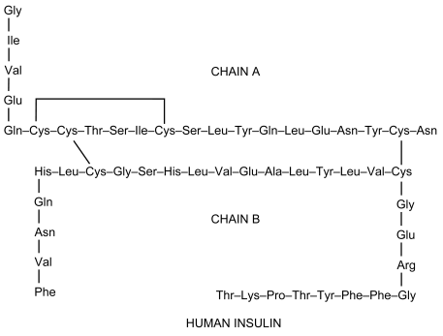

Types of protein

Proteins can be classified according to their three dimensional shape:
- Fibrous – consisting of polypeptide chains arranged side by side.
- Globular – consisting of coiled polypeptide chains that form compact roughly spherical shapes.

Insulin is a globular protein with a roughly spherical shape that is soluble in water.

Keratin is a protein found in hair and skin. It is a fibrous protein and has a coiled structure similar to that of a telephone cord. The structure is described as an alpha helix. This confers on it properties such as toughness, rigidity, and water insolubility.
A human hair strand is made up of many alpha helices. As the diagram below shows, three alpha helices are interwoven to make a protofibril. Eleven protofibrils are bonded and coiled together to make a microfibril.

Hundreds of these microfibrils are combined together into an irregular bundle called a macrofibril. These, in turn, are mixed with dead and living cells to make a complete strand of hair.

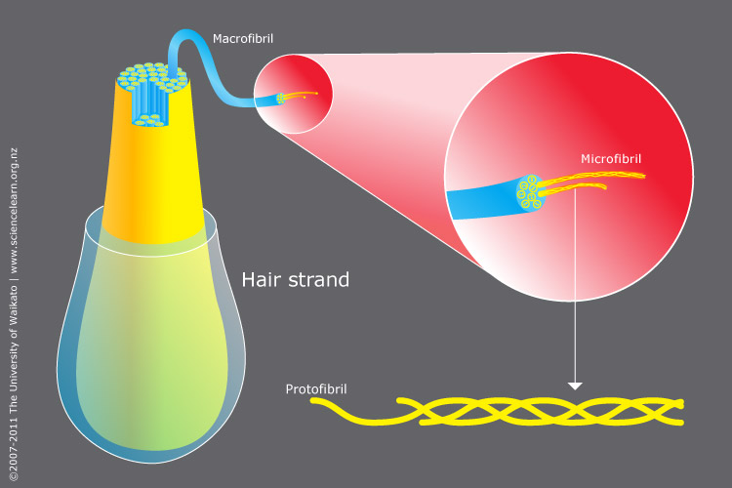

Fibroin is a fibrous protein found in silk. It has a pleated sheet structure in which polypeptide chains line up in a parallel arrangement and are held together by hydrogen bonds.

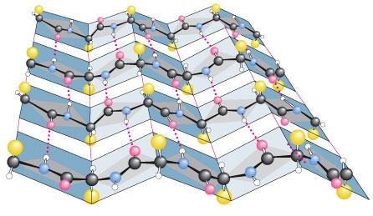
Diagram by Irvine Geis, courtesy of the Howard Hughes Medical Institute

