Lipids

Lipids are an extremely important group of chemicals that play a major role in living things. A characteristic feature is their limited solubility in water.

There are two main classes of lipid:
- Fats, oils and waxes containing ester linkages.
- Sterols like cholesterol

Fats and oils

Fats and oils are the fatty acid esters of glycerol and are an important source of energy in the diet. They are also referred to as triglycerides.

A triglyceride molecule if formed by reacting a molecule of glycerol (an alcohol) with long chain fatty acids such as stearic acid (C₁₇H₃₅COOH).

Stearic acid has only single carbon–carbon bonds present in the molecule. It is described as being saturated. The fat associated with beefsteak has a high glyceryl stearate content and is referred to as saturated fat.

If carbon–carbon double bonds are present in the fatty acid, it is said to be unsaturated. For example, olive oil contains a mixture of glyceryl fatty acid esters, which, on digestion, yield unsaturated fatty acids such as oleic, linoleic and linolenic. Oleic acid is very similar in structure to stearic acid – the only difference being the presence of one carbon-carbon double bond in the chain. It is a monounsaturated fatty acid.

The double bond is 9 carbons in from the terminal CH₃ or methyl group. This acid in called an ϕ 9 (omega nine) monounsaturated fatty acid.

Linoleic and linolenic fatty acids, since they have more than one carbon–carbon double bond present, are known as polyunsaturated. The position of the double bond is also important. Linoleic’s near-terminal double bond is at ϕ 6 (omega 6) whereas linolenic’s is at ϕ 3 (omega 3).

Fats and oils are important dietary components. Although the body is capable of synthesising saturated and monounsaturated fatty acids, it cannot produce the essential fatty acids such as ϕ 3 (omega 3) and ϕ 6 (omega 6). These acids are required for the construction of cell membranes and as precursors for the production of hormones.

It has been discovered that eating a relatively low fat diet in which much of the fat comes from polyunsaturated sources such as olive oil and oily fish has definite health benefits. Keeping the ratio of omega 3:omega 6 in unsaturated fats to less than 1:10 is also recommended.

Trans fatty acids

The food industry uses fats and oils in the production of margarines, baked goods, sauces and chocolates. In addition to using naturally occurring lipids, fats and oils that have been altered in a process called hydrogenation are also used. In this process, some of the double bonds present in the polyunsaturated fatty acids are removed. The resulting product has a higher melting point and, when used in manufactured foods, give extra texture and body.

Unfortunately the process also changes the configuration of the remaining double bonds from the naturally occurring ‘cis’ configuration into a ‘trans’ configuration. The effect of this is that the ’trans’ fatty acids behave biologically like saturated fatty acids.

Overconsumption of manufactured foods that use hydrogenated oils in their production can alter the balance of saturated to unsaturated fatty acids and this in turn can have a negative health effect.

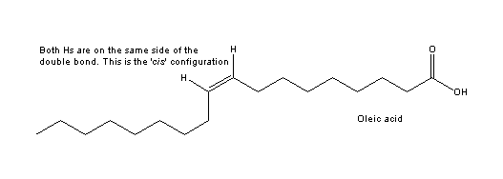

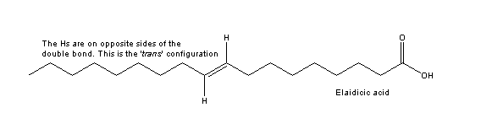

Cholesterol

Sterols are another type of lipid where the atoms of carbon, hydrogen and oxygen are arranged in a series of four fused rings with a range of side chains. Cholesterol is the main sterol found in foods we eat that are of animal origin.

Cholesterol plays an important structural role in cell membranes and is used by the body in the production of bile acids, steroid hormones and vitamin D.

Cholesterol in food often has a fatty acid attached to it so it is a cholesterol ester.

The liver makes over half of the cholesterol needed by the body, and the rest comes via the diet.

Molecules called lipoproteins transport cholesterol around the bloodstream. These carrier lipoproteins come either as low-density lipoprotein (LDL) or as high-density lipoprotein (HDL).

LDL is the major carrier of cholesterol from the liver to the rest of the body. When cholesterol levels are excessive, LDL deposits cholesterol onto the arteries, causing a build-up of material called plaque.

In contrast to this HDL mops up cholesterol from the bloodstream and takes it back to the liver, lessening the chance of it being deposited in the arteries. The higher the ratio of HDL to LDL, the lower is the risk of artery disease.

Eating a lot of saturated fat tends to elevate the levels of LDL, which could lead to deposition of cholesterol in the coronary arteries.

Lowering overall fat intake and replacing saturated fats with unsaturated fats tends to increase the levels of HDL. This reduces the risk of artery disease.

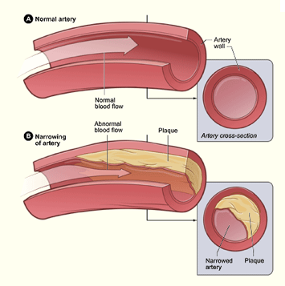
Image kindly supplied by National Heart, Lung, and Blood Institute, National Institutes of Health, U.S. Department of Health and Human Services

