ACTIVITY: Modelling DNA

Activity idea

In this activity, students use lollies to construct a DNA model in order to model a point mutation.

By the end of this activity, students should be able to:
- make a model that helps to explain DNA
- use the model to show and describe a point mutation.

Introduction/background notes
What you need
What to do
Student handout: Make a DNA model

Introduction/background

DNA molecules are hard to visualise. They are extremely small and cannot be seen with the eye. Scientists often use models to visualise what can’t be easily seen.

You can make a DNA model out of lollies, toothpicks and florist wire. Make a little change (mutation) in your model to show a point mutation (where a single base pair is altered). Point mutations are frequently the result of mistakes made during DNA replication.
What you need

- Lollies
- Toothpicks
- Florist wire
- Copies of the article Mistakes in DNA
- Access to the video clip UV and melanoma
- Copies of the student handout Make a DNA model

What to do

- As a class, read Mistakes in DNA and watch the video clip UV and melanoma.

- Demonstrate to students how to make a DNA model using lollies, toothpicks and wire.

- Hand out copies of the student handout Make a DNA model and assist students to gather the materials they need, working in small groups. Discuss the results.

Student handout: Make a DNA model

- Decide in your group which lollies will be the bases (remember there are four sorts of these), the phosphate groups and the sugar. The base sequence for your DNA molecule will be:
ATGATTACAAG
TACTAATGTTC

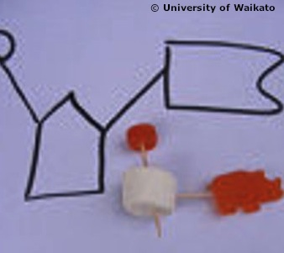
- Use the toothpicks and florist wire as bonds to hold parts together, just like in the real DNA molecule. A DNA molecule has two strands – how will you join the strands?

- Can you twist your molecule into the double helix shape?

- A mutation is a change in the DNA sequence. Make just a little mutation in your model – this is a point mutation where only one base has been changed. Find the mutation in the sequence below then make this molecule.
ATGAATACAAG
TACTAATGTTC

When you have made your model of a DNA molecule, sketch it into your books or use your phone or tablet to photograph it.

