ACTIVITY: Ferns under the microscope

Activity idea

In this activity, students see how increasing the power of magnification leads to much greater detail. They view the reproductive structures of ferns, moving from the naked eye to light microscopes to electron microscopes.

By the end of this activity, students should be able to:
- use a light microscope to view fern reproductive structures
- identify some of the fern reproductive structures (sori, sporangia, indusium, spores)
- discuss the differing amounts of detail they are able to see with the naked eye and with increased powers of magnification.

Introduction/background notes
What you need
What to do
Image cards
Student handout: Looking at ferns under the microscope

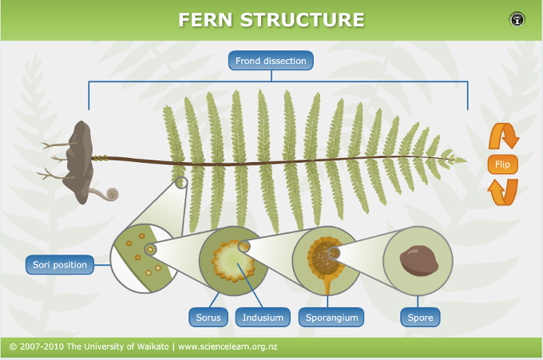
Introduction/background

Ferns are common plants around New Zealand. This ubiquitousness and their unusual reproductive structures make them ideal subjects when it comes to microscopy.

In this activity, students use ferns to explore the increased power of magnification and progress from viewing ferns with the naked eye to using hand lenses and light microscopes to finding images produced by electron microscopes.

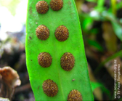
The Fern structure interactive provides an ideal start to the activity, giving participants an introduction to the various parts of ferns and the associated terms.

Turn over a fertile fern frond, and it’s possible to see reproductive structures with the naked eye. Sori are clusters of sporangia. They can be round, oval, oblong or considerably elongated. Sori may run along the veins of the pinna (leaflet) or be grouped around the edges.

With a 10x lens or microscope, it’s possible to see that the sori are composed of numerous small, round bodies known as sporangia. With a 20x (or greater) magnification, it is possible to see the indusium or flap of tissue that protects the sori in some ferns. When spores are mature and ready for release, the indusia usually shrivel or bend backwards to expose the sporangia.

Most ferns produce 64 spores in each sporangium. Spores are single cells. Scientists use scanning electron microscopes to look at the shape and characteristics of fern spores in great detail. Microscopic examination and molecular analysis are two techniques botanists utilise when classifying ferns.

Various fern species produce spores at different times of the year. Use a magnifying glass to look at the sori. Ripe sporangia look like shiny round balls or clusters. Fronds in which a few of the sporangia have burst open while others remain intact are ideal for this activity as they are ready to release spores. However, unripe or newly formed sori or sori in which the indusia have split and released their spores work just as well.

What you need

- Fertile fern fronds (those with sori on the underside)
- Several sheets of white A4 paper
- Magnifying glasses
- Light microscopes
- Access to the article Molecular analysis of ferns
- Access to the Fern structure interactive
- Access to YouTube clip showing fern spores being catapulted from sporangia
- Access to the online Australasian Pollen and Spore Atlas
- Copies of the fern image cards
- Copies of the student handout Looking at ferns under the microscope

What to do

Preparation before the activity

- Collect a variety of fertile fern fronds. Various fern species become fertile at different times of the year. Identify fertile fronds by turning over individual fronds to see if the underside is covered in sori. These reproductive structures are clearly visible and easy to spot. If the fern fronds are large, simply collect a number of the leaflets (pinnae). If possible, try to collect several different species. Alternatively, students can bring fertile fern fronds from home on the day of the activity.
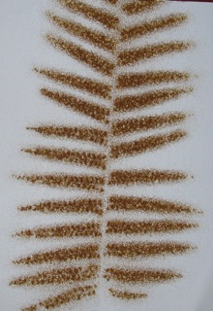
- Lay the ferns on sheets of white A4 paper. Label each fern with its species name if known. Cover with a second sheet of paper, a heavy book and press overnight. This flattens the leaflets, making them easier to use. It also identifies which ferns are ready to drop their spores. Ferns that contain ripe sporangia will leave a spore print on the paper. Gather any spores left on the paper. If there is no print or it is very faint, the sporangia are either too early in their development or have released their spores. (If the spores have been released, you can often see the split indusium under the microscope.)

During the activity

- Introduce the activity with the article Molecular analysis of ferns. Briefly discuss how technology has changed the way in which organisms are classified – from using observable features like reproductive structures to using a scanning electron microscope.

- Give students time to work through the Fern structure interactive. Discuss the related vocabulary and the relationships between the various reproductive structures of sorus, indusium, sporangium and spore.

- View the YouTube clip by Martin Microscope Company showing fern spores being catapulted from the sporangium. The video was filmed using a stereomicroscope. (An extended version of the clip displays several sori patterns and discusses the indusium.)

- Look at the image cards. Discuss the sori position. (Along the veins or grouped around the edges.) Discuss the sori shape. (Round, oval, oblong or elongated.)

- Pass out the individual fern pinnae and give students time to view them with the naked eye, hand lenses and light microscopes at various magnifications. Distribute copies of the two-page student handout Looking at ferns under the microscope and ask students to complete it as they work their way through the fern species.

- Students can use a light microscope to view fern spores. However, given that most spores are around 20 microns in length, to get any useable characteristics may require more powerful microscopes than those found in most schools. An internet search may reveal individual spore images. The Australasian Pollen and Spore Atlas has a New Zealand section with a few photos.
Image cards
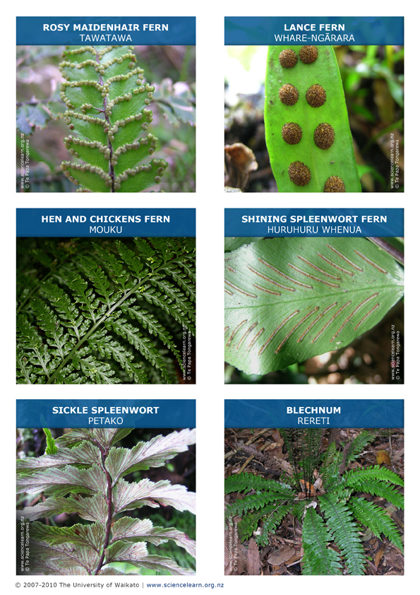
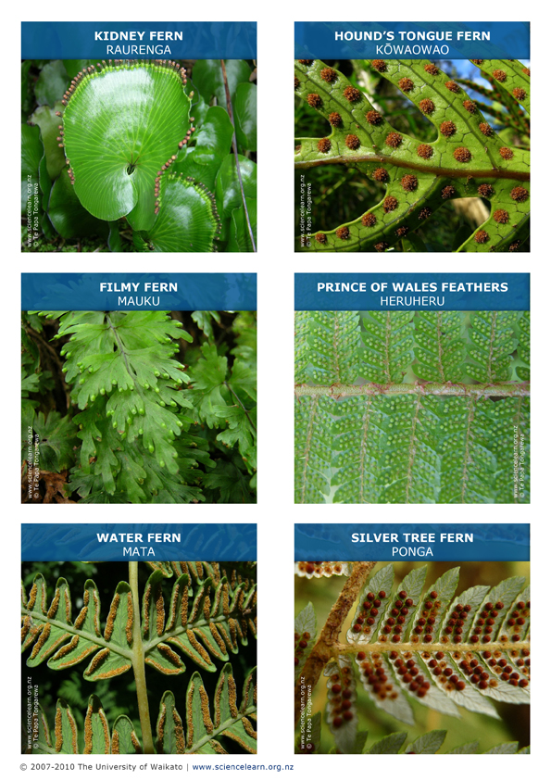

Student handout: Looking at ferns under the microscope

How much extra detail can you see as you move through the powers of magnification?

Tick the reproductive structures you can clearly see with the various tools. Extra points for adding a drawing or description.

 | Sori position  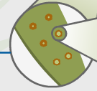 | Sori shape  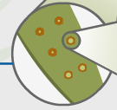 | Indusium  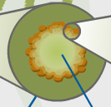 | Sporangium  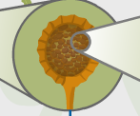 | Spore
Eyes

Magnifying glass

Light microscope

Fill in this table as you use both your eyes and a light microscope to examine each fern species. Use the internet to find spore images.

Fern species  (Use common name or attach the leaflet) | What is the  sori position? | What is the  sori shape? | Indusium  (Tick) |  |  |  | Sporangium  (Tick) |  | Spores
 |  |  |  |  |  |  |  |  | From the fern?  (Tick) |  | Internet image?  (Tick)
 |  |  | Yes | No | Intact | Burst | Intact | Burst | Yes | No | Yes | No

