ACTIVITY: Fresco painting chemistry

Activity idea

In this activity, students will prepare a tile of lime plaster and then paint it in the fresco style. The chemistry that lies behind this technique will then be explored.

By the end of this activity, students should be able to:
- describe how lime is made from limestone
- define the term ‘slaked lime’
- prepare a lime mortar by mixing slaked lime with sand
- better understand the chemistry behind the drying and hardening of the lime mortar
- describe how frescos are made.

Introduction/background notes
What you need
What to do
Student handout: Fresco chemistry
Design templates
Fresco chemistry answers

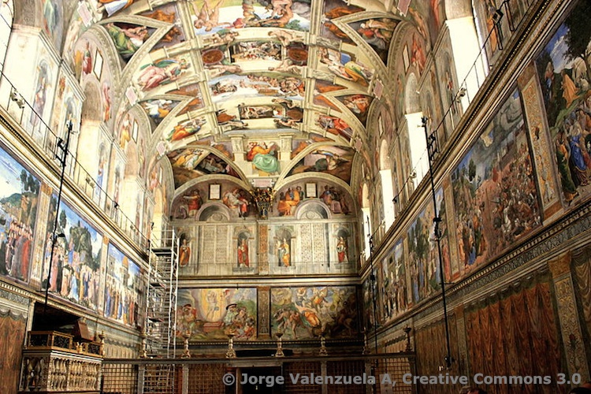
Introduction/background

One of the oldest and most durable art forms is the technique of fresco. Fresco is an Italian word meaning ‘fresh’, and the technique involves applying pigment to a fresh surface of lime plaster.

This technique was extensively used by Renaissance painters in 15th and 16th centuries, and some of the works created such as Michelangelo’s painting of the Sistine Chapel ceiling are marvelled at by a continuous stream of visitors to the Vatican each year.

Of all the painting techniques, fresco painting involves the greatest number of chemical reactions – the starting point of which is limestone rock.

When heated to a high temperature, limestone decomposes into lime with a release of carbon dioxide gas.

CaCO₃(s) + heat → | CaO (s) + | CO₂(g)
limestone | lime | carbon dioxide

Adding water to the lime ‘slakes’ it. Considerable heat is released in this reaction.

CaO(s) + H₂O(l) → Ca(OH)₂(s) + heat

The lime plaster is a mix of slaked lime and sand. After initial drying in which excess moisture evaporates, the slaked lime starts to react with carbon dioxide present in the air. This reaction produces calcium carbonate crystals that lock the sand grains in the plaster together, creating a hard, white material.

Ca(OH)₂(s) + | CO₂(g) → | CaCO₃(s)
slaked lime | carbon dioxide | calcium carbonate solid

Painting pigment onto the wet plaster results in the pigment being incorporated into the plaster structure. Provided the atmospheric conditions are relatively warm, dry and free of pollutant gases, the painted plaster or fresco can survive the ravages of time.

Calcium carbonate is present at the beginning of this process and is also the end product.
limestone
slaked lime
lime
lime plaster
carbonation
calcination
mixing with sand
slaking

Safety
Slaked lime is alkaline and can cause damage to exposed skin. Care needs to be taken when handling this material.

What you need

- Copies of the student handout Fresco chemistry
- Small pottery tile (150 x 150 mm) with an unglazed back
- Slaked lime
- Fine sand
- 250 ml plastic container
- Spatula for spreading the lime plaster onto the tile
- Selection of mineral pigments such as barium chromate (yellow), chromium oxide (green), zinc oxide (white), cobalt blue, cadmium red
- Spatula for pigment grinding
- Small glass plate for pigment preparation
- Small paintbrush to apply pigment to the plaster
- Lightweight tracing paper
- Satay stick
- Plastic gloves

For supplies of slaked lime and water-soluble colour pigments, the school art department may be able to help. Local art and pottery stores normally hold supplies of the materials needed.

What to do

- Hand out copies of the student handout Fresco chemistry and discuss.

- Assist students to gather the materials they need and paint their tiles.

- Discuss responses to the questions on the handout.
Student handout: Fresco chemistry

Plaster the tile with a base layer
- Measure out 50 mL of sand and 25 mL of slaked lime. Place in a 250 mL plastic container and mix thoroughly. This is the lime plaster base.

- Wet the back of the tile and place a thin (3 mm) even layer of the lime plaster on it.

- Leave in a safe place for 2 days or longer to allow conversion of the plaster to calcium carbonate (carbonation).

Prepare a suitable picture
- Sketch your picture on a piece of tracing paper (see templates on next page).

- Plan a suitable colour scheme from the available pigments.

Plaster the tile with the top layer
- Measure out 50 mL of sand and 50 mL of slaked lime. Place in a 250 mL plastic beaker and mix thoroughly. This is the lime plaster to be painted on.

- Wet the base layer applied earlier and place a thin (2 mm) even layer of the lime plaster on it. Leave aside for 10 minutes to partially dry.

Paint the tile
- Transfer the outline of your picture onto the plaster surface by gently dotting an outline with the satay stick through the tracing paper.

- Prepare your selected pigments by grinding a small amount in water with a spatula on a glass plate.

- Apply the paint to your selected areas.

- Place the tile in a safe place and leave to slowly dry for several days.

Questions
- Lime plaster is a mixture of sand and slaked lime. How is slaked lime made?

- Why is it necessary to wear protective gloves when handling lime plaster?

- The hardening of lime plaster involves a chemical reaction between the slaked lime and carbon dioxide in the air. Write a word equation for this reaction.

- Explain the relationship between calcination and carbonation.

- Fresco artworks deteriorate rapidly if placed in polluted atmospheres rich in acidic gases. Give a reason for this.

Design templates

Fresco chemistry answers

- Lime plaster is a mixture of sand and slaked lime. How is slaked lime made?
The addition of water to lime (calcium oxide) converts it to slaked lime (calcium hydroxide).

- Why is it necessary to wear protective gloves when handling lime plaster?
Slaked lime is a strongly alkaline material. If handled without adequate protection, it can damage the skin.

- The hardening of lime plaster involves a chemical reaction between the slaked lime and carbon dioxide in the air. Write a word equation for this reaction.
slaked lime (calcium hydroxide) + carbon dioxide → calcium carbonate

- Explain the relationship between calcination and carbonation.
Calcination removes carbon dioxide from limestone in a thermal decomposition reaction, whereas carbonation adds carbon dioxide to slaked lime in an acid/base reaction.

- Fresco artworks deteriorate rapidly if placed in polluted atmospheres rich in acidic gases. Give a reason for this.
Hardened lime plaster contains calcium carbonate. In moist, damp atmospheres contaminated with pollutant gases like sulfur dioxide, a thin layer of acidic moisture can develop over the surface of the fresco. This slowly corrodes the surface of the fresco.

