STUDENT ACTIVITY: River connections

Activity idea

In this activity, students make connections between the river environment and the species in and around it, learning about their relationships. The activity helps them visualise the interdependence within an environment.

By the end of this activity, students should be able to:
- describe the interdependence between some of the species in a river environment and between these species and the river environment
- be able to justify some of these connections by describing the relationship between them
- explain with some understanding how Waikato-Tainui iwi view their connectedness to the river.

Introduction/background notes
What you need
What to do
River cards
Catchment background

Introduction/background

“Ko au te awa, ko te awa ko au – I am the river, the river is me.” This whakatauki (Maori proverb) is used by Waikato-Tainui about the Waikato River and its relationship with the people. It conveys the connectivity between the people, the river and the environment.

This activity helps students consider the relationships within an environment. Students are given a selection of cards including the focus card, which is the river. The cards are spread out, and the students use string to connect them based on a direct relationship such as habitat dependence, food source or some other use they can justify.

Working in small groups will enable students to discuss as they work. How are these organisms and physical features related? Are they directly related? Why does one need the other? How does one affect another? They should be directly related, for example, the black mudfish should have a string connecting it to wetland because it lives there. It would not be connected to the river. However, the wetland should be connected by string to the river because water from the wetland flows into the river and this is important for the river – it cleanses the water. During flooding, water from the river flows into the wetland – bringing with it food for species in the wetland and/or enabling river species to reach food in the wetlands.

Students should be able to see direct and indirect connections. For example, they will see the river connected to the wetland, which is connected to the mudfish. Indirect relationships are also important, for example, if the river is affected by excess nutrients (because of neighbouring farmland), this nutrient-rich water will come into the wetland, causing algal growth and depleted oxygen and making it an impossible habitat for the black mudfish.

The students will end up with many pieces of string criss-crossing between the various items. This will help them to appreciate the interrelatedness of the organisms and the physical features. Tell the students that these are only a few of the possible interactions. In fact, there are thousands more – all connected in this way, many depending on another or affected by another (interdependence).

The students explore the articles and videos first to learn about the relationships. They could do this by individually researching different areas of the river so that they become the ‘expert’ to present back to their group. As a group, they discuss the relationships between the organisms/features as they make stringlines between them. The discussion and explanations made within the groups – about the connections made – are an important part of this activity.
An option is for student groups to use a catchment area background to place their cards on (making the river card redundant). It could be:
- a catchment (river mouth, river, hills with a stream coming from them into the river, wetland and lake) drawn with a piece of chalk on the concrete outside
- the catchment background printed out on an A3 piece of paper.

As an alternative, the cards could be loaded onto an interactive whiteboard, and students can draw lines to show the connections.

There are many relationships – here are a few to get them going:

Connection |  | Why?
river | (tuna) eels | Habitat for tuna (eels).
river | native grasses | Riverbank habitat for the native grasses.
river | power station | Power station uses the water.
river | iwi | People live there, eat from the river, enjoy the river with each other, can use it for transport using waka.
river | wetlands | Wetlands clean the water for the river.
waka | iwi | Iwi use waka to socialise, for transport and for cultural reasons on the river.
wetlands | fernbird | Habitat for the fernbird.
wetlands | black mudfish | Habitat for the mudfish.
mudfish | kingfisher | Food for the kingfisher.
koi carp | tuna (eels) | Koi carp eat juvenile eels – older eels eat small koi carp.
native grasses | whitebait | Spawning ground for whitebait.
sweet reed grass | native grasses | Sweet reed grasses use the same resources as native grasses and takes over their space on the riverbank.
sweet reed grass | whitebait | Whitebait avoid this cutty grass, limiting its spawning ground.

What you need

- Access to these articles: River ecosystems, Human impact on rivers, Kaitiakitanga and mana whakahaere, Te mana o te awa, Trapping koi carp, An introduced species – koi carp, Tuna – working with glass eels, Longfin eels, Wetlands – the river’s kidneys, Whitebait, Huntly Power Station, Human impacts on the Waikato River, Whitebaiting
- Access to these video clips: Whakapapa and biodiversity, Awa and iwi, Koi carp – a pest fish, The Lake Waahi project, Glass eel research, The life cycle of eels, The importance of wetlands, Wetland research, Maurea Islands, Pest plants, Īnanga and other whitebait, Reconnecting, Living with the power station
- River cards (one set colour printed and laminated per group)
- A brightly coloured ball of string (per group)
- A reusable adhesive such as Blu-Tack
- Optional: Catchment background (print to A3)
- Optional: Chalk

What to do

- As a class, read River ecosystems. Discuss ecosystems and how things are connected. Read Human impact on rivers and discuss how humans can impact an ecosystem.

- Read Kaitiakitanga and mana whakahaere and Te mana o te awa. Watch the video clips Whakapapa and biodiversity and Awa and iwi. Discuss interdependence with the river from a Māori (Tainui iwi) point of view.

- Form groups of 5 and number students in the group 1 to 5.
- All the 1s research koi carp – read/watch Trapping koi carp, An introduced species – koi carp, Koi carp – a pest fish, The Lake Waahi project.
- All the 2s research tuna (eels) – read/watch Tuna – working with glass eels, Longfin eels, Glass eel research, The life cycle of eels.
- All the 3s research river islands and wetlands – read/watch River islands, Wetlands – the river’s kidneys, The importance of wetlands, Wetland research, Maurea Islands, Pest plants.
- All the 4s research whitebait – read/watch Whitebaiting, Whitebait, Īnanga and other whitebait.
- All the 5s research Huntly Power Station and human impacts – read/watch Huntly Power Station, Human impacts on the Waikato River, Reconnecting, Living with the Power Station.
Students could research individually or form groups (for example, all the 1s together) to do this research.

- The original groups of 5 sit on the floor. Divide the 20 cards up between the students. The student with the river card places it on the floor. (Alternatively spread out the catchment background printed on A3 paper for students to work on or use chalk to draw a catchment area for each group on concrete outside.)

- The next student places their card either around the river or a bit further away – if not directly connected (e.g. in the wetland if using a catchment background). After the card has been placed on the floor, the group needs to discuss what relationship this card has to the river (or not). If there is a direct relationship, cut off a piece of string and connect it between the river and the next item. Use a little Blu-Tack to hold it in place.

- Continue with the next card – now students need to consider the relationships between the new item and not only the river card but also the previous card placed. If there is a direct relationship place string between those two cards as well.

- Continue in this manner considering relationships with each new card and all of the cards already placed on the floor. Each time a connection is made, it must be justified by a group member. Several people may contribute – there may be more than one reason for a connection. Remember, there will be a group member who is an ‘expert’ for some of the items, and they should share what they have learned about the relationships.

- Students look at their ‘web’. They should appreciate the complex relationships between all the organisms/features – these are a very small number compared to what is really connected to the river.

- Optional: Students take a snapshot of their river connections. Paste electronically to a word document or print and paste onto A4 paper (or in a book). Write a report called ‘River connections’ about the relatedness of the river and the species in it and around it using the card items in the connected picture as examples.

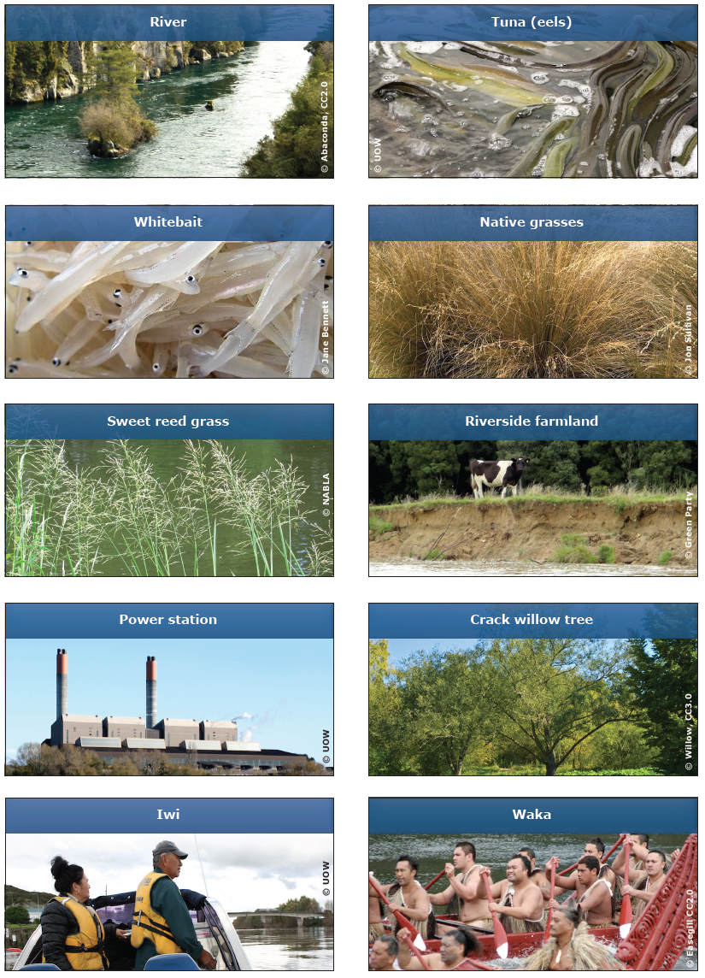
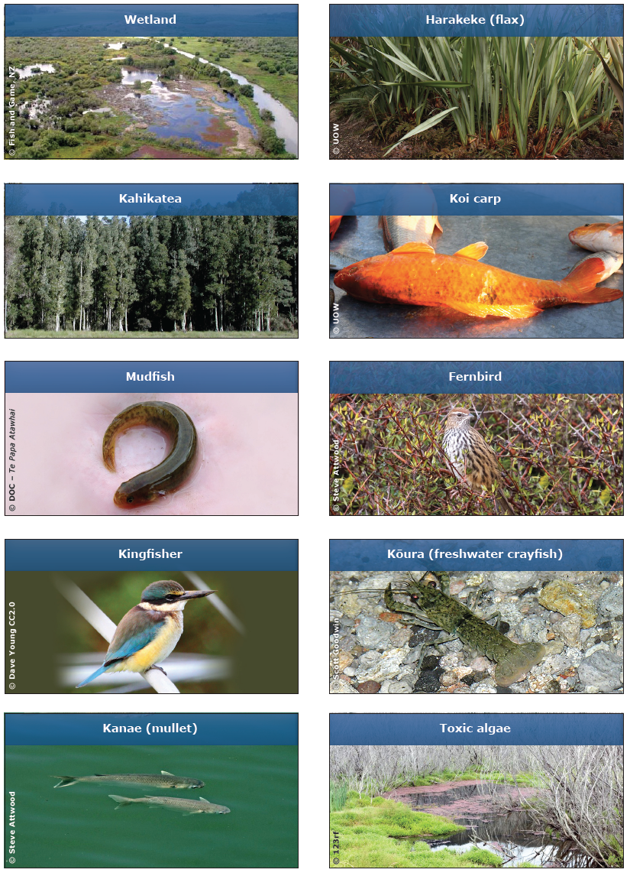

Catchment background (print to A3)

