ACTIVITY: Communicating in science

Activity idea

In this activity, students look at SMS text language to gain a deeper understanding of communicating in science.

By the end of this activity, students should be able to:
- write messages using SMS text language
- explain the usefulness of SMS text language in communication via mobile devices
- explain the similarities between SMS text language and the specialised vocabulary, numeric and symbolic systems and conventions of science communication.

Introduction/background notes
What you need
What to do
Extension ideas
Mobile phone
Some txt speak

Introduction/background

Just as SMS texting has its own language, so does science. SMS text language is invaluable for sending messages on mobile phones. A whole specialised vocabulary has developed. This is a useful analogy to introduce the importance of and the reasons for the specialised language of science.

Scientific language is critical for science. Scientific knowledge is communicated through its text, its associated symbols, diagrams, graphs and equations. This specialised language of science makes it possible for scientists to communicate ideas and explanations in a way that would not be possible with everyday language.

This specialised language is particularly important in three areas:
- For collaboration among scientists – particularly since scientists generally work as part of a wider scientific community rather than the stereotypical view of a scientist working alone in a laboratory or in the field.
- In the presentation of science at conferences or in publications.
- To actually help a scientist shape their ideas. Language is needed to construct scientific understandings and explanations. Thinking cannot be clear until it has had expression. We must write or speak or act our thoughts or they will remain half-formed.

For more information on communicating in science, see the article The ‘Communicating in science’ strand.

Adapt this activity to best suit the age and dynamics of your students.

What you need

- An A4 size copy of the Mobile phone per pair of students
- A copy of Some txt speak for each pair
- Large sheets of paper and pens for group brainstorming

What to do

- As a class, establish parameters for this activity (e.g. no hurtful or offensive messages).

- Have students pair up and give each pair a copy of the Mobile phone and Some txt speak.

- Have each pair spend 5 minutes having a text-based conversation with their partner by taking turns to write messages on their phone. The students need to include as many abbreviations in their messages as possible.

- Then in groups of 4–6, have students brainstorm as many scientific words or symbols as they can. Set a time limit.

- Share back their best two with the class.

- Lead a class discussion on the similarities and differences between text messages and scientific language. (Refer to Introduction/background for key ideas.)

- As a class, pairs or individuals, construct a Venn diagram to show the differences and similarities.

Extension ideas

Discuss the confusion that can arise in communication when words in daily use have a different meaning than the same word used in a scientific context, for example, energy, work, force, hypothesis, theory, law and gas.

Have the students construct an on-going graffiti wall to which they can keep adding words they know or come across that have a different everyday and scientific meaning.

Mobile phone

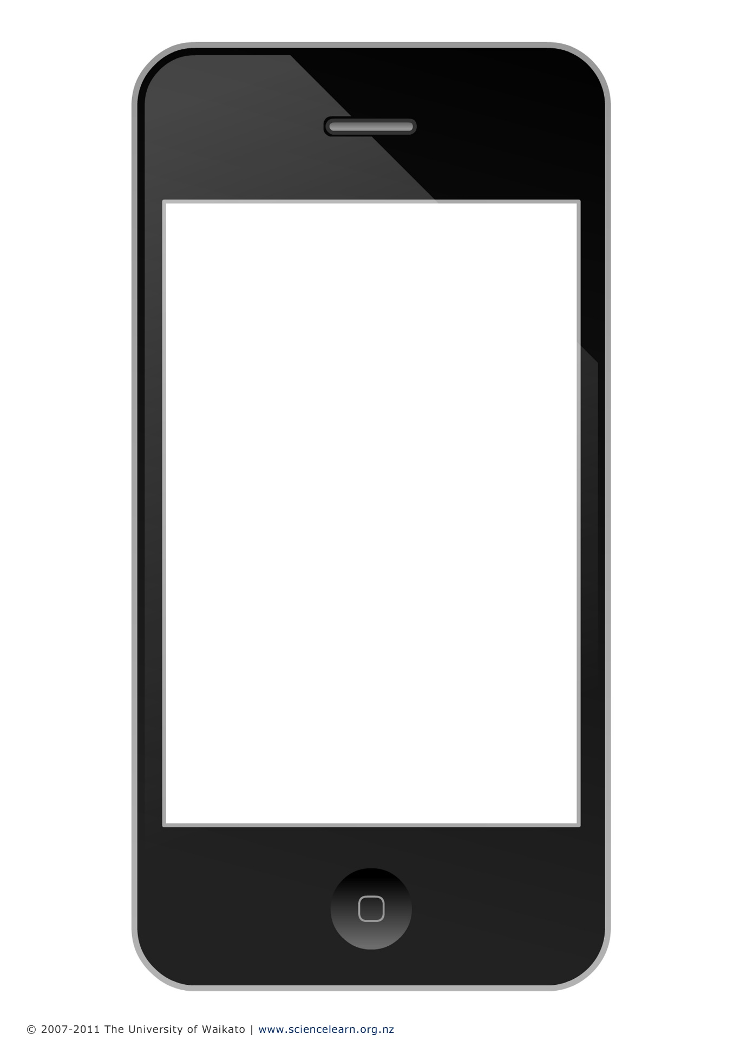

Some txt speak

2NITE tonight
2MORO tomorrow
AYS are you serious
B4N bye for now
BCNU be seeing you
BF boyfriend
BFF best friends forever
BRB be right back
BTW by the way
COS because
FYI for your information
GF girlfriend
GR8 great
GTG got to go
IDK I don’t know
JK just kidding
L8R later
LOL laugh out loud
LTG like to go
LTK like to come
NP no problem, nosy parents
NVM never mind
OIC oh, I see
OXOX hugs and kisses
PLMK please let me know
ROFL rolling on floor laughing
TMB text me back
TTYL talk to you later
TYVM thank you very much
WWYC write when you can
WYWH wish you were here
Y2K you are too kind
ZZZ sleeping or bored

Source: www.snaphow.com/list-of-sms-abbreviations-meaning-of-texting-words-symbols

