ACTIVITY: Investigating rocket motion

Activity idea

In this activity, students investigate the motion of a rocket using a spreadsheet with graphs of motion included. They adjust variables and investigate how height and speed are affected.

By the end of this activity, students should be able to:
- investigate at least one variable that affects the height reached by a rocket
- gradually change that variable and describe how motion is affected by that change
- interpret graphs to describe what is happening to the height and speed of a rocket during each stage of its flight.

Introduction/background
What you need
What to do
Student record sheet: Analysing rocket motion

Introduction/background

Rocket scientists use models and computer calculations to predict how a rocket will perform. It is much cheaper and faster to simulate launches rather than to build a new rocket each time to test ideas.

In this activity, students investigate the height and speed of a rocket using a spreadsheet and graphs of motion. They change variables such as thrust, mass, duration of thrust and drag (air resistance). They are also able to vary the diameter of the rocket and the percentage of mass lost as propellant is ejected.

The spreadsheet Rocket graphs of motion provides students with results for maximum height reached, time to reach maximum height, maximum speed and total time of flight. It also provides graphs of motion for height, speed and acceleration versus time. Adventurous students may wish to investigate how the diameter of the rocket affects motion due to its affect on drag.

For more in-depth analysis, there is also a table of results that show how theses values change over time. Changing air density and gravitational field strength at various heights can also be considered. Further graphs are provided of forces acting versus time.

What you need

- Access to the spreadsheet Rocket graphs of motion
- Copies of the student record sheet Analysing rocket motion

What to do

- Introduce the challenge: to investigate variables that affect the height and speed reached by a rocket using the spreadsheet Rocket graphs of motion.

- Discuss what variables may affect the height reached by a rocket.

- Discuss that this simulation allows students to investigate an ideal world without drag (by leaving drag set to off). It is then useful to compare this with the real world where drag makes a great difference.

- Hand out copies of the student record sheet Analysing rocket motion and ask students to work through it.
Analysing rocket motion

Introduction

This activity allows you to enter variables for a rocket ready to launch.

Which of the following variables do you think might affect the height reached by your rocket?

Mass of rocket (measured in kilograms)

Thrust (force of rocket engine)

Duration of thrust (How long the rocket engine produces thrust)

Drag (Whether there is air resistance opposing the rocket motion)

Diameter of rocket

Changing mass (How much propellant is ejected from the rocket)

Shape of rocket

Your challenge is to choose one of the above to investigate. Change this variable gradually to see how the height and speed reached by your rocket is affected. All other variables should be kept the same.

Your investigation:

How does __________________________ affect the height reached by a rocket?

Your prediction:

I think that as ___________ increases, the height reached by a rocket will _____________
because __________________________________________________________________
_________________________________________________________________________

Activity 1 – Interpreting the tables and graphs

Set rocket to 5.0 kg, 200 N, 5.0 s, off, off, 8 cm, 0.4, 10%, on, on.

Use the tables and graphs to answer the following:

Maximum height reached: _____

At what time does the rocket reach its maximum height? _____

What is the speed of the rocket at this time? _____

At what time does the rocket reach its maximum speed? _____

What is happening to the speed of the rocket during the first 5 seconds?
_________________________________________________________________________

What is happening to the speed of the rocket after the first 5 seconds?
_________________________________________________________________________
Activity 2 – How does each variable affect height and speed?

Keep all variables the same apart from the one you are changing. For each result, check to see the difference with drag switched on.

- Changing total mass of rocket
Set rocket to 5.0 kg, 200 N, 5.0 s, off, off, 8 cm, 0.4, 10%, on, on.

Launch settings | Launch results  Drag ‘off’ |  | Launch results  Drag ‘on’
Mass (kg) | Height reached (m) | Maximum speed (m/s) | Height reached (m) | Maximum speed (m/s)
5.0
6.0
7.0
8.0
9.0
10.0

Observation: _________________________________________________________________

- Changing thrust
Set rocket to 5.0 kg, 200 N, 5.0 s, off, off, 8 cm, 0.4, 10%, on, on.

Launch settings | Launch results  Drag ‘off’ |  | Launch results  Drag ‘on’
Thrust (N) | Height reached (m) | Maximum speed (m/s) | Height reached (m) | Maximum speed (m/s)
200
400
600
800
1000
2000

Observation: _________________________________________________________________

- Changing duration of thrust
Set rocket to 5.0 kg, 200 N, 5.0 s, off, off, 8 cm, 0.4, 10%, on, on.

Launch settings | Launch results  Drag ‘off’ |  | Launch results  Drag ‘on’
Duration of Thrust (s) | Height reached (m) | Maximum speed (m/s) | Height reached (m) | Maximum speed (m/s)
5
10
15
20
25
30

Observation: _________________________________________________________________
Activity 3 – How drag affects motion

- Canterbury University students Malcolm Snowden and Avinash Rao built a rocket and launched it in 2011.

The goal of this launch was to control the roll.

Their rocket had a mass of 2.5 kg and a diameter of 8 cm. If they used a motor that produced a thrust of 245 N for 1.7 s, how high would their rocket travel? (Set drag on, mass decrease on, Cd = 0.4, propellant mass 10%, on, on)

Launch settings | Launch results  Drag ‘off’ |  | Launch results  Drag ‘on’
 | Height reached (m) | Maximum speed (m/s) | Height reached (m) | Maximum speed (m/s)
2.5 kg, 245 N, 1.7 s, on, on, 8 cm, 0.4, 10%, on, on

(The actual height measured by altimeter sensors was 904 m.)

How high would their rocket go if its diameter was doubled? ______ m

- 2.0 kg rocket with a thrust of 50 N and duration of thrust of 10.0 s.

Launch settings | Launch results  Drag ‘off’ |  | Launch results  Drag ‘on’
 | Height reached (m) | Maximum speed (m/s) | Height reached (m) | Maximum speed (m/s)
2.0 kg, 50 N, 10.0 s, off, off, 8 cm, 0.4, 10%, on, on

- 1.0 kg rocket with a thrust of 100 N and duration of thrust of 20.0 s.

Launch settings | Launch results  Drag ‘off’ |  | Launch results  Drag ‘on’
 | Height reached (m) | Maximum speed (m/s) | Height reached (m) | Maximum speed (m/s)
2.0 kg, 100 N, 10.0 s, off, off, 15 cm, 0.4, 10%, on, on

- The Ātea-1 rocket had a mass of 65 kg. Rocket Lab designed this suborbital rocket to reach space (over 100 km altitude).

For a rocket of 65 kg, a burn time of 20 s, a diameter of 15 cm and a propellant mass of 80%, what thrust would take the rocket to a height of 136.9 km? _______ N

Launch settings | Launch results  Drag ‘off’ |  | Launch results  Drag ‘on’
 | Height reached | Maximum speed | Height reached | Maximum speed
65 kg, _____ N, 20.0 s, on, on, 15 cm, 0.4, 80%, on, on |  |  | 136.9 km

Activity 4 – Looking closer at graphs

- For a 1.0 kg rocket with launch settings 1.0 kg, 20 N, 10.0 s, off, off, 20 cm, 0.4, 10%, on, on, complete the graphs of speed versus time below.

No drag With drag

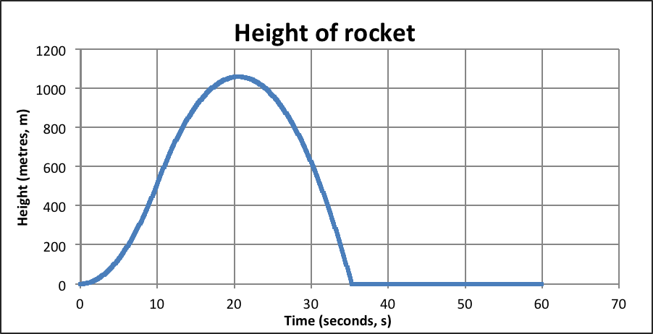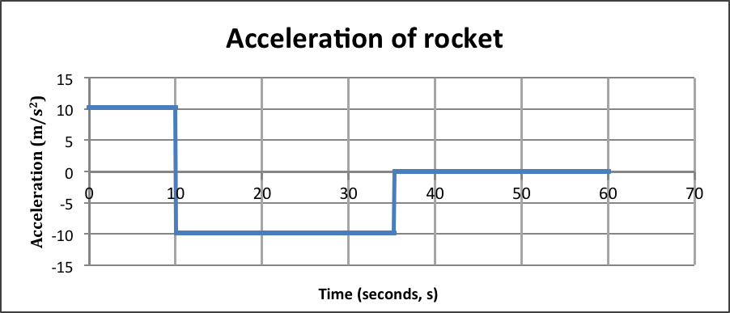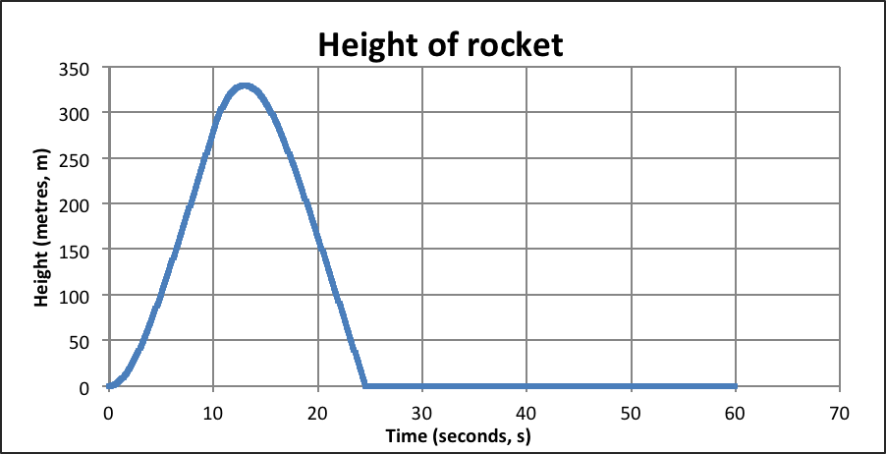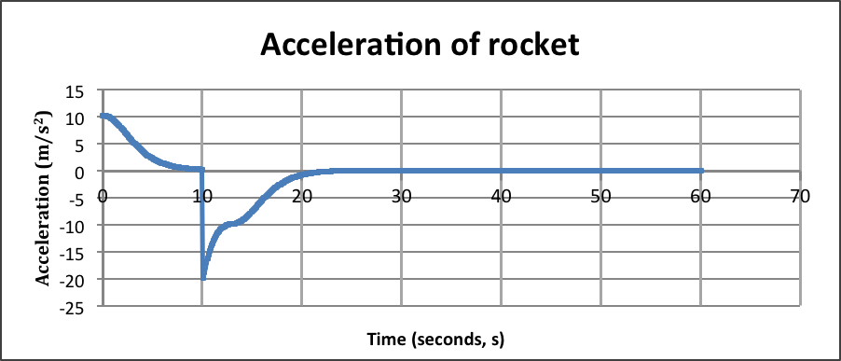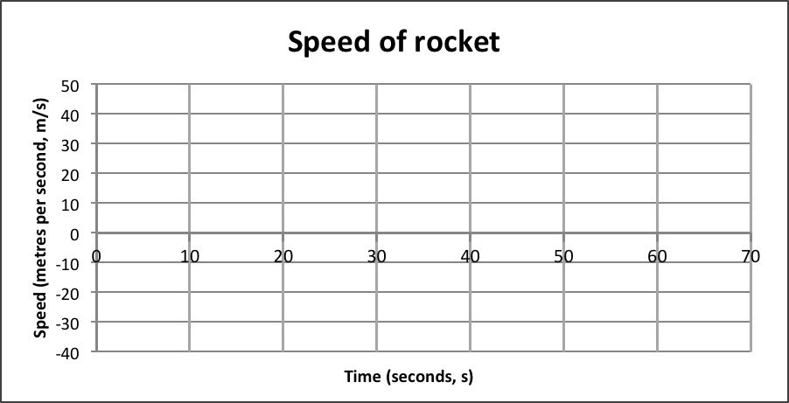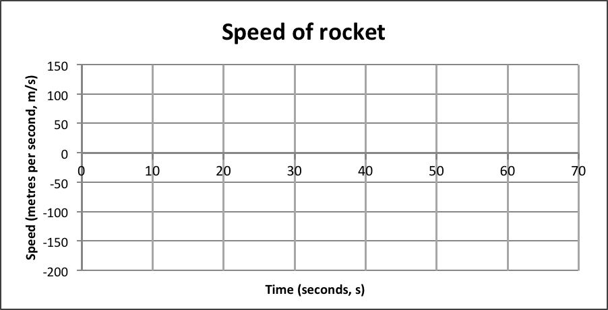

- Why does the rocket acceleration decrease during the first 10 seconds?
_________________________________________________________________________
_________________________________________________________________________

- Check the table of results and graphs of force by clicking on the ‘DATA’ tab at the bottom of the spreadsheet. What is happening to the resultant force as the time gets close to 10 s?
_________________________________________________________________________

- Increase the thrust to 200 N for the above rocket. How much difference does drag make to the height reached?
_________________________________________________________________________

- With drag ‘on’, the rocket does not appear to reach a constant speed while thrust is still acting. It does appear to reach a steady speed (terminal velocity) as it falls back down. Check the table of results and graphs of force and suggest a reason why drag plus weight never balance out thrust on the way up.
_________________________________________________________________________
_________________________________________________________________________
Activity 5 – Is less mass always best?

Any rocket such as a water rocket will speed up faster if it has less mass with the same amount of thrust. Investigate whether lighter is always better.

Launch settings: 1.0 kg, 100 N, 1.0 s, on, off, 8 cm, 0.4, 10%, on, on.

Mass  (kg) | Height reached  (m) | Maximum speed  (m/s) | Height at end of thrust (m)
1.0
0.9
0.8
0.7
0.6
0.5
0.4
0.3
0.2
0.1

The optimal mass of the rocket to make it travel the highest is _______ kg.

The rocket with a lower mass will reach a faster/slower speed.

A rocket with less mass will be more/less affected by drag (air resistance), so it will slow down more/less quickly.

There is an optimal amount of mass to make sure that the rocket reaches as fast a speed as possible but yet still has enough mass so that it is not too affected by drag once the thrust has finished.

Activity 6 – Finding the best mass for a water rocket

Design and build a water rocket. See Water bottle rockets.

Investigate to determine the volume of water that makes the rocket travel the greatest distance. Ensure you use the same air pressure for each launch.

Ideal volume of water: ______ mL

Once that volume of water has been determined, investigate how adding slightly more or less mass to the nose cone (e.g. using modelling clay) affects the distance travelled.

Optimal amount of mass to add to the nose cone: ____

Once you have found the optimal mass for the nose cone, you may need to investigate further to determine if the optimal volume of water has changed.

Your findings:
_________________________________________________________________________
_________________________________________________________________________
_________________________________________________________________________

