ACTIVITY: Effervescent canister rockets

Activity idea

In this activity, students make an effervescent canister rocket using baking soda and vinegar. They develop their understanding of rocket propulsion and investigate the amount of vinegar that will make the rocket go the highest.

By the end of this activity, students should be able to:
- explain how rocket propulsion works in terms of gases being pushed out one end so that a force is exerted on the rocket in the opposite direction
- carry out a fair test to find the amount of vinegar that makes the rocket go the highest
- explain that pressure needs to build up inside the effervescent canister for a successful launch
- explain how the speed of the rocket changes as it goes up and comes back down and how these changes are related to the forces acting on it.

This activity is ideally done after the teaching and learning activity Introduction to rockets and space.

Introduction/background
What you need
What to do
Discussion questions
Extension ideas
Student handout: Make and launch an effervescent canister rocket

Introduction/background
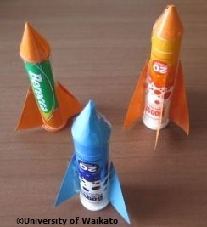
The chemical reaction between baking soda and vinegar produces carbon dioxide gas. When the lid of the effervescent (or film) canister is sealed, pressure builds up inside the canister until the lid pops off and the rocket is launched upwards.

Newton’s third law
This law states that, for every action, there is an equal but opposite reaction. The action is that gases are pushed out the bottom of the effervescent canister rocket. The reaction is that the rocket is pushed upwards. If a larger pressure is able to build up inside the canister before the lid pops off, the gases will be pushed out faster so the rocket will be pushed upwards faster and will reach a greater height.

Momentum and gravity
Once the lid has come off the rocket and the rocket is moving upwards, its momentum will keep it moving upwards. The force of gravity acts on the rocket and pulls it back towards the Earth. This force remains the same throughout the flight and makes the rocket slow down, momentarily stop and then keep speeding up as it falls back down.

Fair testing
A variable is anything that might affect the results. The main variables that might affect the height reached by the effervescent canister include the amount of vinegar, amount of baking soda, nose cone and fins (number, size and layout). Students will keep all variables the same except the amount of vinegar. They will experiment to find out the amount of vinegar that produces the greatest height before having a class competition with their chosen amount of vinegar.

Safety first
Students should be warned not to put their face over a effervescent canister that is taking a long time to launch. They may carefully come in from the side and give it an extra quick shake and put it back down to speed things up.

What you need

- Copies of the student handout: Make and launch an effervescent canister rocket
- An effervescent canister for each pair of students (e.g. Berocca, Boost). The hollow in the lid of some effervescent canisters is filled with silica gel that is held in place by a cardboard seal. You need to remove the seal and tip out the silica gel. You may also use white film canisters, but note that the lids need to snap closed on the inside of the canister – the black ones that close over the outside do not work in this activity. White film canisters can be obtained from photo shops, although they are becoming scarcer, so hang on to your supply for future years!
- 250 g baking soda in a plastic container (Carefully mix the baking soda with a little water to make it a little damper than the consistency of snow – 4 parts baking soda mixed with 1 part water is quite good. The baking soda needs to be damp enough to stay in the lid when it is tipped upside down.)
- 1 litre of white vinegar in a sipper bottle for easy pouring
- Coloured card
- Tape
- Spoons
- Prizes for the highest, nicest flight, best design (Oddfellows mints representing the Moon work well)

What to do

- Discuss what makes a rocket go up. (Pressure inside the rocket pushes gases out one end really fast, which pushes the rocket in the other direction.)

- Explain the challenge: to make an effervescent canister into a rocket and to find out how to make it fly as high as possible – a well made rocket will fly about twice as high as the classroom. Explain that there will be a competition to see which rocket flies the highest, which has the nicest flight and which is the best looking.

- Discuss how we could build up pressure inside the effervescent canister rocket. (Students may suggest hydrogen gas or kerosene – explain that they will use a method without flames: vinegar reacting with baking soda.)

- Discuss what things might affect how high the rocket will go. Explain that something that might affect the results is called a variable, and to work like scientists, they should only change one variable and keep all the others the same:
- Things to keep the same – nose cone, fins and amount of baking soda placed in the lid.
- The one variable to change – amount of vinegar.
- The one thing to measure as a result – height reached by the effervescent canister.

- Hand out copies of the student handout Make and launch an effervescent canister rocket, and working in pairs, have students make their rockets.

- When all the rockets are ready, proceed to a designated testing area outside – a clearly marked section of level flat concrete on a path or court works well. Emphasise safety. Make sure students stay well away from the launch zone when not launching.

- Describe the testing procedure. Ask the students for a show of hands for which amount of vinegar (1, 2, 3 or 4 cm) they think will make the rocket go the highest. Ask for reasons.

- Have students undertake their testing and complete the ‘Recording sheet’ section of the student handout as they go. Height could be recorded as a comparison with other objects such as twice the height of the classroom or half the height of the netball hoop or estimated in metres. If there is time, students may like to try half-centimetre amounts.

- After 30 minutes of building and testing, announce the competition and give students 5 minutes to get their rockets ready filled with the amount of vinegar they think will make their rocket go the highest.

- For the class competition, have one student from each pair lined up along a line ready to launch. The other students should be off to the side to help with judging. You may also like to give prizes for the highest rocket, nicest flight and prettiest rocket.

- Have students complete the ‘Thinking about science ideas’ section of the student handout and discuss the results.

Discussion questions

- Who was expecting that more vinegar would make it go higher?
- What amount of vinegar worked best?
- Why do you think that amount worked best?

Extension ideas

- What effect does the nose cone have? Try different designs or no nose cone at all.
- What effect do the fins have? Try different sizes, shapes and number of fins. Make sure all variables remain the same apart from the one thing that is being changed. Try attaching the fins at an angle so that they make the rocket spin.
Student handout: Make and launch an effervescent canister rocket

Challenge: To make an effervescent canister rocket go as high as possible.

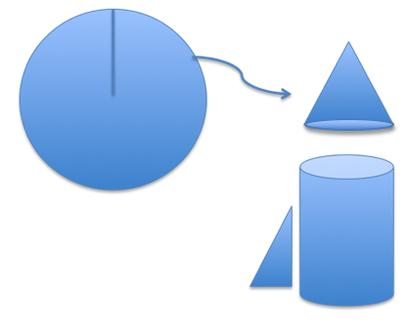
Making your rocket
- To build the nose cone, draw a circle about twice the diameter of the effervescent canister onto a piece of coloured card. Cut to the exact centre and then curve the card around on itself to make a cone. Tape this to the closed end of the canister.

- To make fins, cut 3 or 4 equal sized triangles from the coloured card. Tape them evenly spaced to the open end of the effervescent canister. (For four fins, use the 3, 6, 9 and 12 o’clock positions. For three fins, use 4, 8 and 12 o’clock positions.) Make sure tape and fins still allow the lid to seal properly.
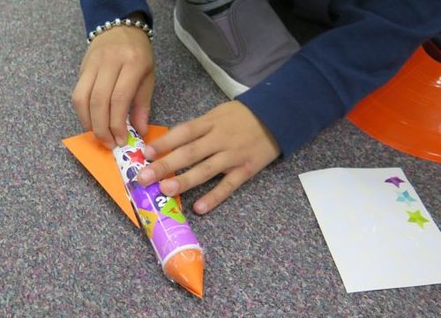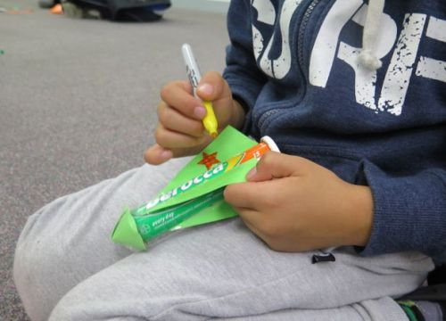

- Draw marks at 1 cm intervals on the outside of the canister measuring from the closed end. (These are the guides for filling with vinegar for each trial.)

Launching your rocket
- Fill the hollow in the lid with baking soda – level it off with a spoon or finger so there is the same amount used for each launch. Make sure the edges of the lid and the canister are wiped clean so there are no leaks at launch time. (The hollow in the lid of some effervescent canisters is filled with silica gel held in place by a cardboard seal. You need to remove these.)
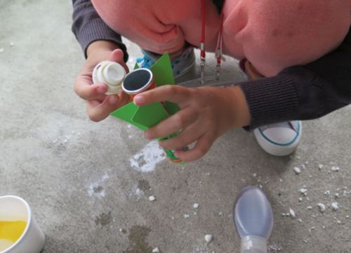
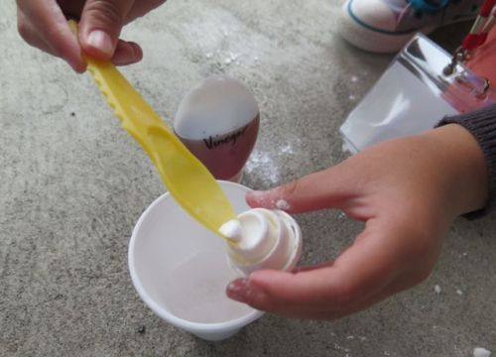
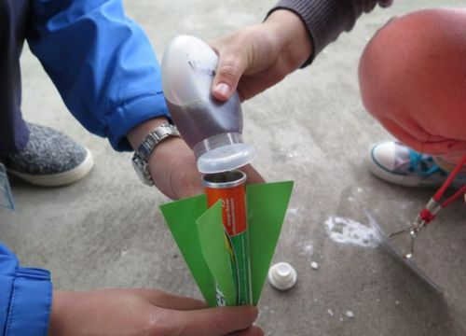
- Start with 1 cm of vinegar in the canister. Once at the launch site, hold the canister firmly in one hand and use the palm of your other hand to snap the lid closed, being careful to keep holding the rocket vertically upside down so that the vinegar and baking soda don’t mix.

- Turn the rocket over, give it a brief shake, place it on the ground and step well back. If the rocket does not launch after about 20 seconds, carefully approach from a low side-on stance and give it another quick shake. If you can see bubbles and liquid escaping from the canister, it is possible that the lid was not cleaned well enough to seal or that it is broken.

Rinse out the rocket and repeat for 2, 3 and 4 cm of vinegar. Clean the edges of the lid well between launches.
Recording sheet

- Draw and label your rocket:

- What amount of vinegar do you think will make the rocket go the highest? Give a reason for your answer.

- Record your results for each amount of vinegar as you do it. Clean your rocket well between trials.

Amount of vinegar | Height (estimate metres or relate it to the height of a nearby object, e.g. 1.5 times the height of the classroom)
1 cm
2 cm
3 cm
4 cm

- What amount of vinegar did you use for the class competition? ____ cm of vinegar

- How high did your rocket go?

- How much vinegar did the winning rocket have?

- How high did the winning rocket go?

- What is your conclusion about what makes an effervescent canister go the highest?

- What else might you try to make your effervescent canister go even higher?

- What difference do you think a nose cone makes? Give a reason.

- What difference do you think the fins make? Give a reason.

Thinking about science ideas

- What is pushing on an effervescent canister rocket to make it start going up?

- Why does the rocket keep moving upwards once the lid has already come off?

- What makes the rocket slow down and then come back to the ground?

- Look at the diagram at the bottom of the page. Describe what is happening to the speed of an effervescent canister rocket at each stage of its motion:

Stage of motion | What is happening to the speed? (e.g. getting faster, staying the same, slowing down)  The effervescent canister rocket is…
A. While the lid is being pushed off
B. Just after the lid has been pushed off
C. Nearly at the top
D. At the top
E. On its way back down
F. Nearly all the way down

- On the diagram below, use a ruler to draw an arrow to show the size and direction of the speed for each of the rocket images. Use a smaller arrow if it is travelling more slowly. Label each of these arrows with ‘speed’.

- On the diagram below, use a ruler and a different colour to draw an arrow to show the size and direction of any force that is acting on the rocket for each of the rocket images above. (A force is something that is pushing or pulling on the rocket.) Use a smaller arrow if the force is less. Label each of these arrows with ‘force’.

