ACTIVITY: Having a go at chromatography

Activity idea

In this hands-on activity, students use paper chromatography to separate the dye pigments in coloured sweets. This introduces students to chromatography and helps them to understand how scientists find toxins in substances.

By the end of this activity, students should be able to:
- explain chromatography in simple terms
- demonstrate how chromatography works using paper chromatography.

Introduction/background notes
What you need
What to do
Extension ideas
Student handout: Separating dye pigments

Introduction/background

The scientists at Cawthron Institute used chromatography to identify the toxin tetrodotoxin (see Solving the dog death mystery).

They also use chromatography to detect and identify toxins in shellfish (see Measuring toxicity and Monitoring shellfish).

The scientists at Cawthron have a special instrument that uses liquid chromatography (LC) combined with another process called mass spectrometry (MS). The instrument is called a liquid chromatography-mass spectrometer (LC-MS). The first part of the process is chromatography using liquid. The second part of the process determines the mass of pure substances.

This is a hands-on activity introducing students to the first part of the process – chromatography.

Chromatography
Many substances are mixtures of different things. For example, milk looks like one substance but it is actually a mixture of many solids and liquids such as water, fat, carbohydrate (lactose), proteins (casein and whey), vitamins and minerals. Chromatography is a technique that is used to separate mixtures.

In Monitoring shellfish, chromatography is used to separate an extract (mixture) of shellfish. The separation process will isolate a toxin if there is one.

Likewise, in Solving the dog death mystery, chromatography was used to separate the sea slug extract into pure substances. This led to the identification of the toxin tetrodotoxin.

In this activity, students use paper chromatography to separate the dye pigments in coloured sweets (M&Ms). In this way, they can see how many pigments go into one dye. Brown is a good colour to use because it is made up of a number of colours.

Each colour becomes clearly visible on the paper. It also shows how different substances travel different distances before they stick. In this case, the more soluble colours move the furthest distance on the paper.

Safety note
In New Zealand school science laboratories, the consumption of food and drink is not permitted.

What you need

For each group:
- Copies of the student handout Separating dye pigments
- Coffee filter papers (e.g. Faggs, size 4)
- Pencil
- M&Ms (or other sweets such as Pebbles/Smarties)
- Eye dropper or teaspoon
- Aluminium foil
- Toothpicks
- 2-litre container
- ⅛ teaspoon of salt
- 3 cups of water
- Tape
- Chopstick
- Tall glass container (500 ml glass jug works well)
- Food dyes and felt pens for extension

What to do

- Hand out copies of the student handout Separating dye pigments and discuss. Assist students to get into small groups, gather the required materials and follow the instructions.

- Discuss the findings:
- Which colours contained the same dyes?
- Which colours moved the furthest along the paper?
- Which M&Ms contained multiple dyes?
- Can you match any of the colours with the names of the dyes listed on the ingredients for the M&Ms?

Extension ideas

Students could try the activity again using food dyes and/or felt pen markers.
Separating dye pigments

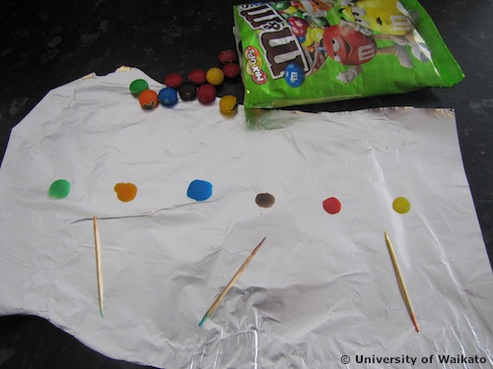
- Cut a coffee filter paper into a square or rectangle that will fit into a tall glass container (9 x 7.5 cm fits nicely into a 500 ml glass jug). Draw a pencil line 1 cm from the edge of one side of the paper (the shorter end if it’s a rectangle).

- Make 6 pencil dots across the line about 1 cm apart. Underneath each dot, label the colour of the M&M you are going to use at that dot. (You won’t have much space, so B for blue, Br for brown, G for green etc. would be an easy way to label.)

- Place 6 drops of water at an equal distance on aluminium foil. Use a dropper or the edge of a teaspoon to make the drops. Position one M&M of each colour on the drops. Wait 1–2 minutes. Remove M&Ms and discard.

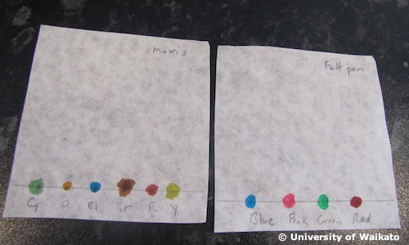
- Dip a toothpick into a colour and dab the colour onto a pencil dot. Do this for each colour with a clean toothpick. Try to keep the colour dot small.

- After doing it once for each colour, leave to dry and then reapply the colours to the dots. Leave to dry and do it again a third time to get a good amount of pigment in a small space. Leave to dry.

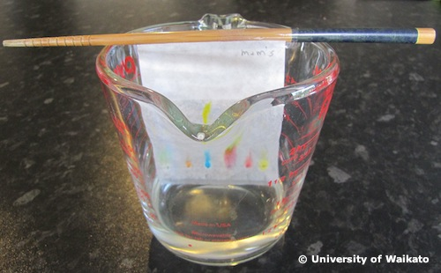
- Prepare a 1% salt solution – mix ⅛ of a teaspoon of salt and 3 cups of water in a clean container. Stir or shake until dissolved.

- Tape the top end (from the dots) of the filter paper to a chopstick (or something similar) and sit the chopstick across the top of a clean glass container (e.g. 500 ml glass jug). The filter paper should hang down into the container, finishing about 1–2 cm from the bottom.

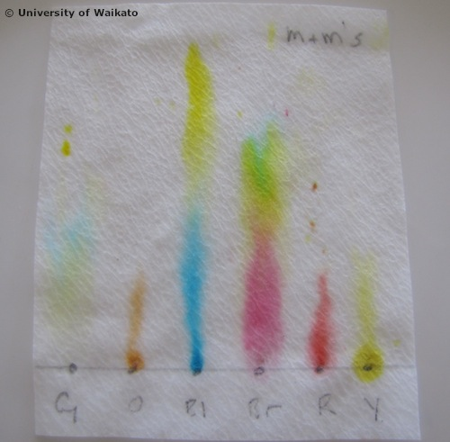
- Very carefully pour the salt solution into the container without touching or getting the solution onto the filter paper. The solution should just come up to and be in contact with the bottom edge of the paper. The solution should not cover the dots. You may wish to pour the solution in first and then lower the filter paper into the liquid. Check first though that it won’t cover the colour dots.

- Capillary action will draw the solution up the paper. As it passes through the dots, it will begin to separate out the dyes if there is more than one dye in a colour. The dyes separate out because, while some dyes will stick to the paper, others are more soluble and will travel further up the paper before sticking.

- When the solution is about ½ cm from the top of the paper, remove it from the glass container and place it on a clean flat surface to dry.

