ACTIVITY: Finding out about chemicals

Activity idea

This activity is designed to help students become aware that all substances are made of chemicals and that chemicals are made up of a combination of elements.

By the end of this activity, students should be able to:
- explain that all substances are made up of chemicals
- explain that chemicals can be synthetic or natural
- explain that chemicals are made up of a composition of elements

Introduction/background notes
What you need
What to do
Extension ideas
Student handout: Chemical cards
Student handout: Periodic table of elements

Introduction/background

Toxins are chemicals that cause harm to living organisms, so to understand toxins, students need to understand chemicals. Simply put, a chemical is any substance that has a defined atomic composition – which is everything relating to matter (not something like energy). Read the article Chemicals everywhere.

Students often have alternative conceptions about chemicals. When asked to define chemicals, they tend to give a list of poisons or synthetic (man-made) chemicals. They will list such items as pesticides or fire-retardant chemicals. When asked to name things made with chemicals, students often refer to shampoo, detergent, washing powders and sweeteners (such as aspartame). They will also see chemicals as pollutants and ‘bad’ things that damage our environment.

This lesson is intended to help students realise that everything is made up of chemicals – both synthetic and natural. Students are referred to the periodic table of elements so that they are made aware that everything is made up of a few basic elements.

They will need to know that an element is the pure substance. The chemical formula of a substance shows the elements that are in that substance.

The activity with the periodic table will help them see which elements go together to make chemical compounds. For example, sugar (C₁₂H₂₂O₁₁) is a combination of the elements carbon (C), hydrogen (H) and oxygen (O).

What you need

- Sets of chemical cards – one set for 2–3 students
- For each group, 6 small cards labelled:
- Made of chemicals
- Not made of chemicals
- Synthetic
- Natural
- Toxic
- Non-toxic
- Access to the article Chemicals everywhere
- Copies of the periodic table of elements

What to do

- Before doing any teaching on chemicals, give out the sets of chemical cards to groups of 2–3 students. Ask students to put into piles those made of chemicals and those not made of chemicals. Use the ‘made of chemicals’ and ‘not made of chemicals’ labels to head each pile. Students need to discuss with each other the choices they are making – why they think they are/are not chemicals. Allow about 5 minutes.

- As a class, discuss choices students have made. Allow students to say why they have made their choices.

- Ask students to redivide their cards into new groups using the heading cards ‘synthetic’ (made by people) and ‘natural’ (naturally occurring). Can a natural substance be made of chemicals? Can a synthetic substance be made of chemicals?

- Have students reorganise cards into groups using the headings ‘toxic’ and ‘non-toxic’. Is a natural substance always non-toxic? Is a synthetic substance always toxic?

- After the students have progressed through grouping the cards and discussion, ask them to define what a chemical is. Allow time for discussion.

- As a class or in small groups, read and discuss the article Chemicals everywhere (or present in a more simple way if appropriate). Check that students are clear that everything is made of chemicals – that a chemical is a substance made of a combination of specific elements (refer to the periodic table of elements) – so the only item in the chemical cards that is not made of chemicals is the dreams, which have no substance.

- In view of everything being made of chemicals, ask these questions again: Can a natural substance be made of chemicals? Can a synthetic substance be made of chemicals?

- Give out copies of the periodic table of elements. Ask students to consider these substances (chemicals) – water, sugar, salt, chalk and caffeine. They are all made up of elements from the periodic table. The elements that make up these substances are shown in their chemical formulae as follows:
- Water - H₂O
- Table sugar – C₁₂H₂₂O₁₁
- Salt – NaCl
- Chalk – CaCO₃
- Caffeine – C₈H₁₀N₄O₅

- Have students use a colouring pencil to colour all the different elements in water, and four different colouring pencils to colour all the different elements in sugar, then salt, then chalk and then caffeine. Are some of the same elements in different substances? (It is amazing to think that everything is made of different combinations of these few elements. There are only 90 naturally occurring elements – the others have been produced by people.)

- Have students colour in the elements found in a human – H, Be, Na, Mg, K, Ca, Fe, Cu, Zn, B, C, N, O, F, Al, P, S, Cl and I. Explain that the main elements found in all living things are carbon, hydrogen, oxygen, nitrogen, phosphorus and sulfur – six of them!

Extension ideas

What do the numbers mean in a chemical formula such as H₂O? (Students should know that atoms combine together to form chemical compounds. The number of atoms that combine to produce a particular substance are shown by the small number beside the symbol of the element. For example, two atoms of the element hydrogen can combine with one atom of the element oxygen to form a molecule of the substance called water.)
Student handout: Chemical cards

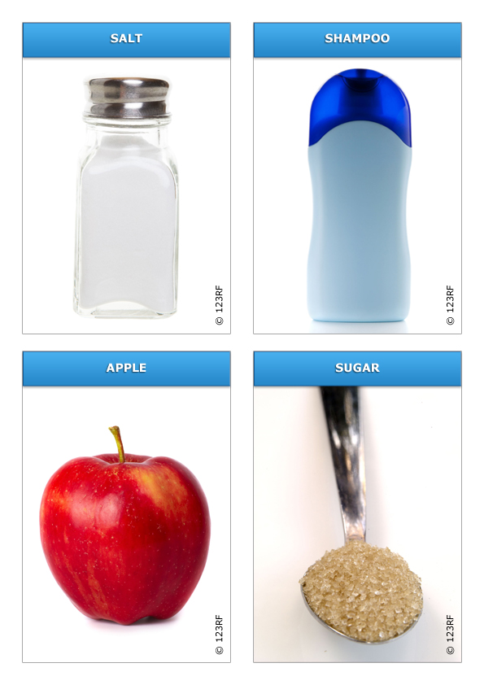

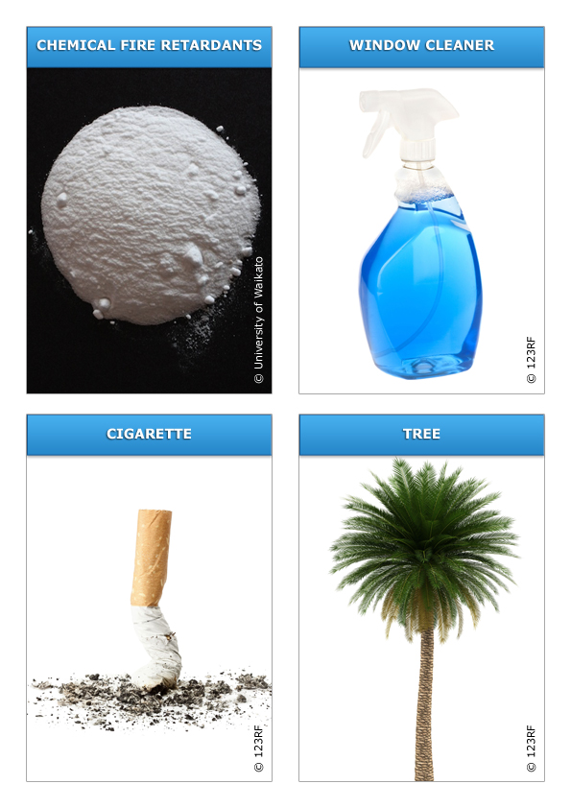

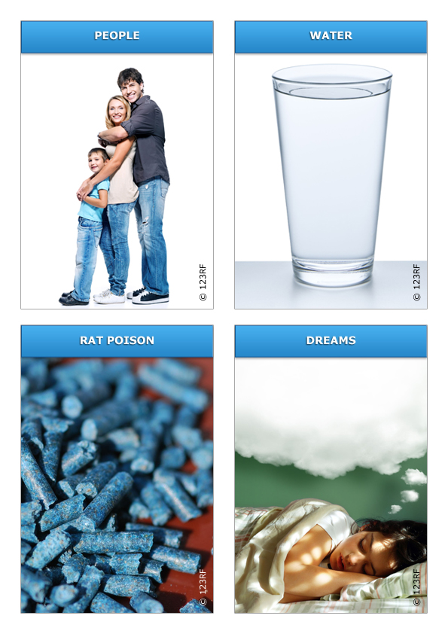

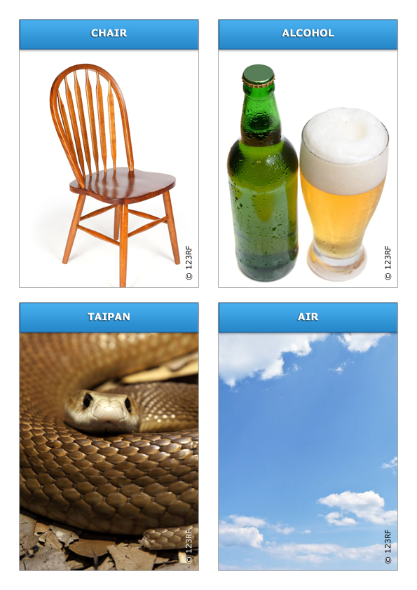

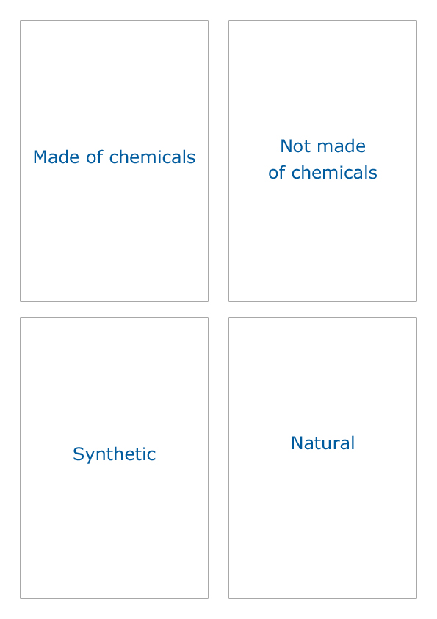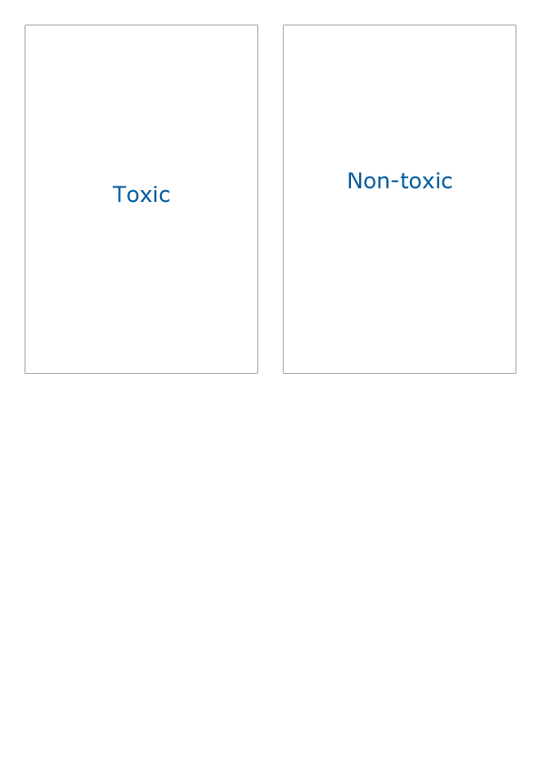
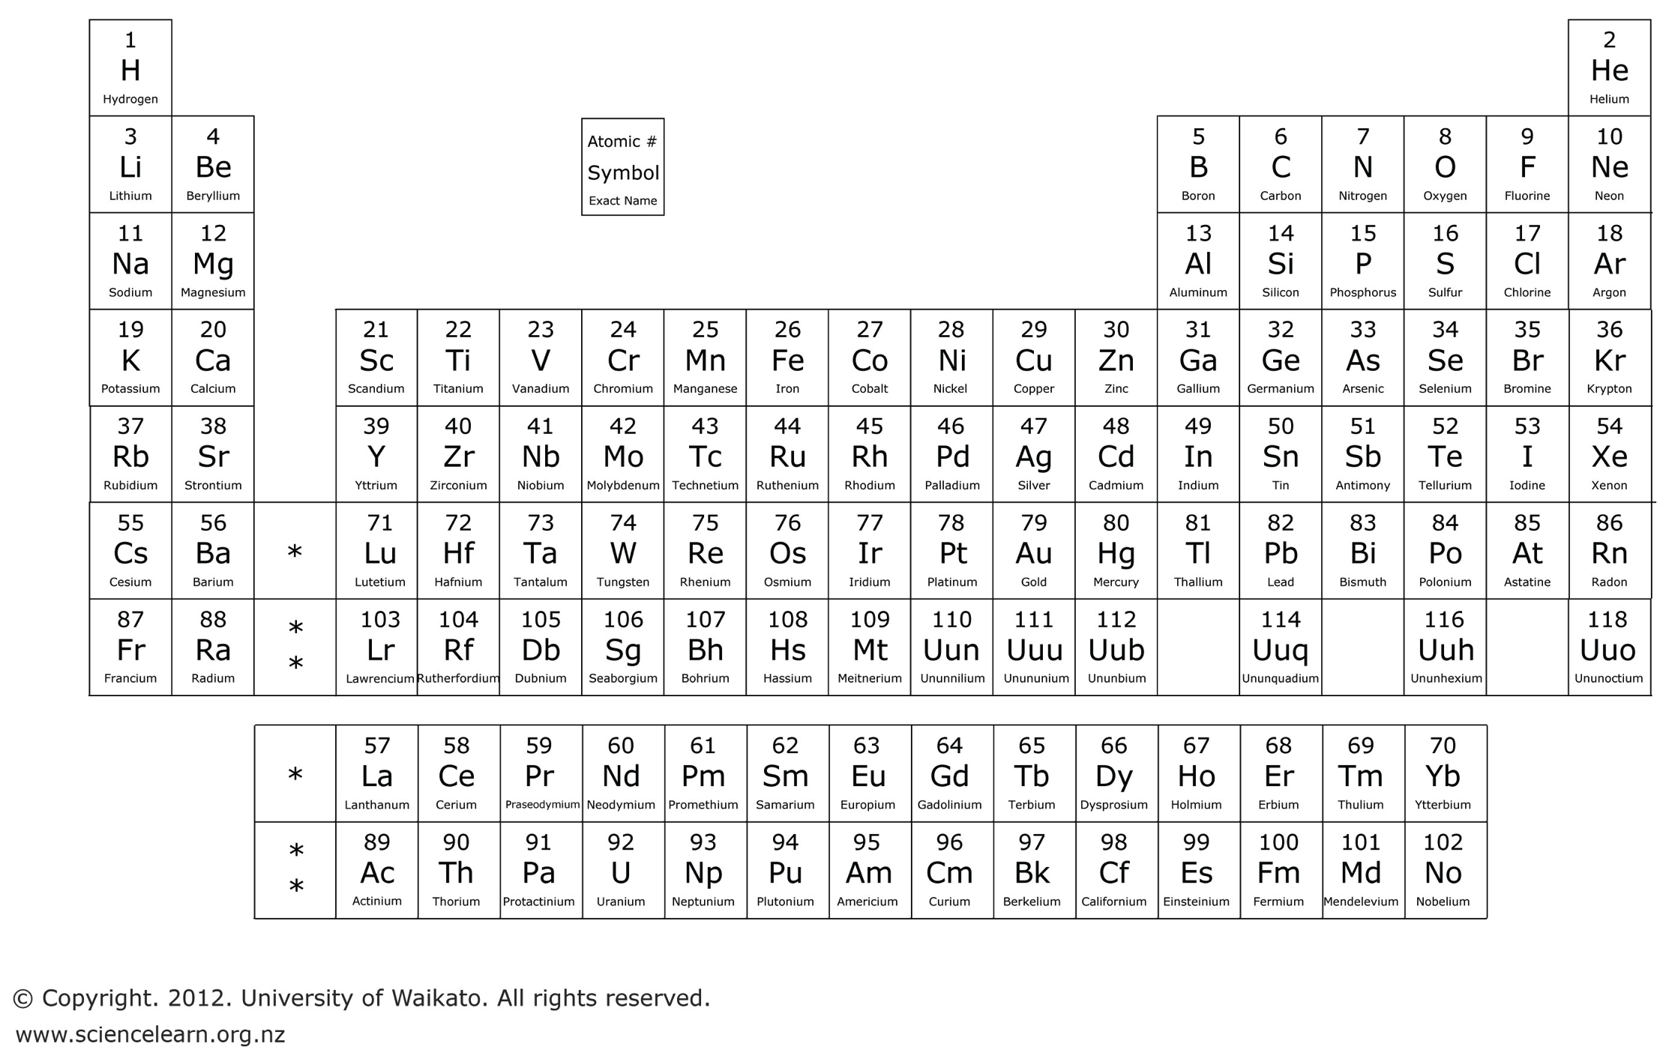
Student handout: Periodic table of elements

