ACTIVITY: Something creepy is happening

Activity idea

In this activity, students explore tectonic movements called slow slips. They plot and interpret a graph using data from an actual event in New Zealand.

By the end of this activity, students should be able to:
- understand the difference between earthquakes and slow slips
- plot and interpret data on a line graph
- explain a scientific application of GPS technology.

Introduction/background
What you need
What to do
Discussion questions
Student handout: A slow slip near Kapiti
A slow slip near Kapiti – answers

Introduction/background

Slow slip events have only been detected relatively recently, and New Zealand scientists are at the forefront of studying them. They can be tricky for students to understand as they involve very small movements, but they are a fascinating extension study for students who have an understanding of the more well known form of earthquakes.

In summary, the Pacific tectonic plate ‘sticks’ to the Australian plate as it dives down under the North Island of New Zealand, pushing the Australian plate to the west and causing stress to build up in the ‘stuck’ zone. Occasionally, this stress gets released as an earthquake that we can feel or at least that shows up on a seismograph. As the Pacific plate gets deeper, it gets warmer and softer and becomes less stuck, and the two plates start to move more freely past each other. The Australian plate may even spring back gently deep underground, causing movement that can be transferred to the surface in what are called slow slips, which do not register on seismographs. Ground movement during an earthquake is normally measured in metres per second, whereas during slow slips, the ground only moves a few millimetres over a week or even a year. If the stress released during a year-long slow slip was released all at once, it might produce a magnitude 7 earthquake.

The Pacific plate is pushing the Australian plate westwards by about 30 mm a year. During some slow slips, limited areas of the surface of the Australian plate may move eastwards a few millimetres over a few days or weeks. Other slow slips are detected only as a slowing of the normal westward movement over periods up to about a year.

It may be hard for students to understand the small slip movements involved, but they should be able to understand about plates sticking or sliding past each other. Talking about stuck plates acting like two parts of Velcro sticking together is a good idea – they will understand the violent movement that will occur when the two parts are suddenly pulled apart sideways. The slow-slip movement is a bit like if there was playdough between the plates – there would be very slow movement.

As a consideration of the nature of science, encourage students to talk about how slow slips are studied. This could include investigating what GPS is and how it is used to tell us that slow slip events have occurred even when we can’t feel them. Discuss the international nature of the investigations – slow slips, like more familiar earthquakes, do not respect international boundaries, so scientists collaborate to study them.
What you need

- Access to the article What are slow slips?
- Copies of the student handout A slow slip near Kapiti

What to do

- Make sure students are familiar with material in the article What are slow slips? and the two links at the bottom of it.

- Hand out copies of the student handout A slow slip near Kapiti and have students work in pairs to complete the activity.

Discussion questions

- What is a slow slip event, and in what ways is one different to an earthquake? (Encourage students to describe a slow slip in their own words.)
- How fast does the ground move during a slow slip? How fast does the ground move during an earthquake? ( In the Kapiti case, 20 mm a year. A slow slip near Gisborne in 2002 moved up to 30 mm in 10 days, another in the Manawatū region in 2004–2005 moved up to 30 mm over 18 months. Compare this to a ground movement of many metres per second during an earthquake and stress how unusually slow the ground surface moves during a slow slip compared to an earthquake.)
- Why is GPS used to track slow slip events? (Slow slips do not register on seismographs. GPS can measure the direction of very small movements in the ground over long periods of time. The continuous GPS scientists use is more accurate than the GPS available in everyday hand-held devices.)
- Paekākāriki is only about 40 km from Wellington, but it experienced a slow slip event while Wellington only recorded normal tectonic movement. No other GPS recording stations in the North Island picked up unusual movement in the same period. What does this tell us about the size of the area that the slow slip covered? (The area of the slow slip at the surface is relatively small.)
- Several small swarms of earthquakes of less than magnitude 5 were felt in the Kapiti region through 2004 and early 2005. Do you think these could have been connected to the slow slip? (The gradual slipping in the deep ‘slip zone’ may pull on the shallower ‘stuck zone’ so that the tension is released through earthquakes.)
Student handout: A slow slip near Kapiti

A few years ago, a GPS site in the lower North Island recorded a slow slip event, but another site not far away did not. You are going to compare data from two GPS sites (Wellington airport and Paekākāriki on the Kapiti Coast) to find where the slow slip occurred. The data was collected continuously over a 3-year period, but you will only be graphing two pieces of data from each year, which is enough to show overall patterns.

This table shows land surface movement towards the west over time. Tectonic movement was taking place before July 2001, but movement is recorded as zero on this date because this was when data collection started.

Date | Movement (mm) – Wellington site | Movement (mm) – Paekākāriki site
July 2001 | 0 | No data for July
Jan 2002 | 15 | 10
July 2002 | 30 | 25
Jan 2003 | 45 | 40
July 2003 | 60 | 50
Jan 2004 | 75 | 60
July 2004 | 90 | 75

- Plot the Wellington data on the graph, and join the points with lines.

- How far does the land at Wellington move west each year? | mm
- Does this rate change during the data collection period?

- Now plot the Paekākāriki data on the same graph.

- What is the rate of movement per year between Jan 2002 and Jan 2003? | mm
- Does this movement get faster or slower after Jan 2003?
- When does it return to normal?
- Give the graph a title.

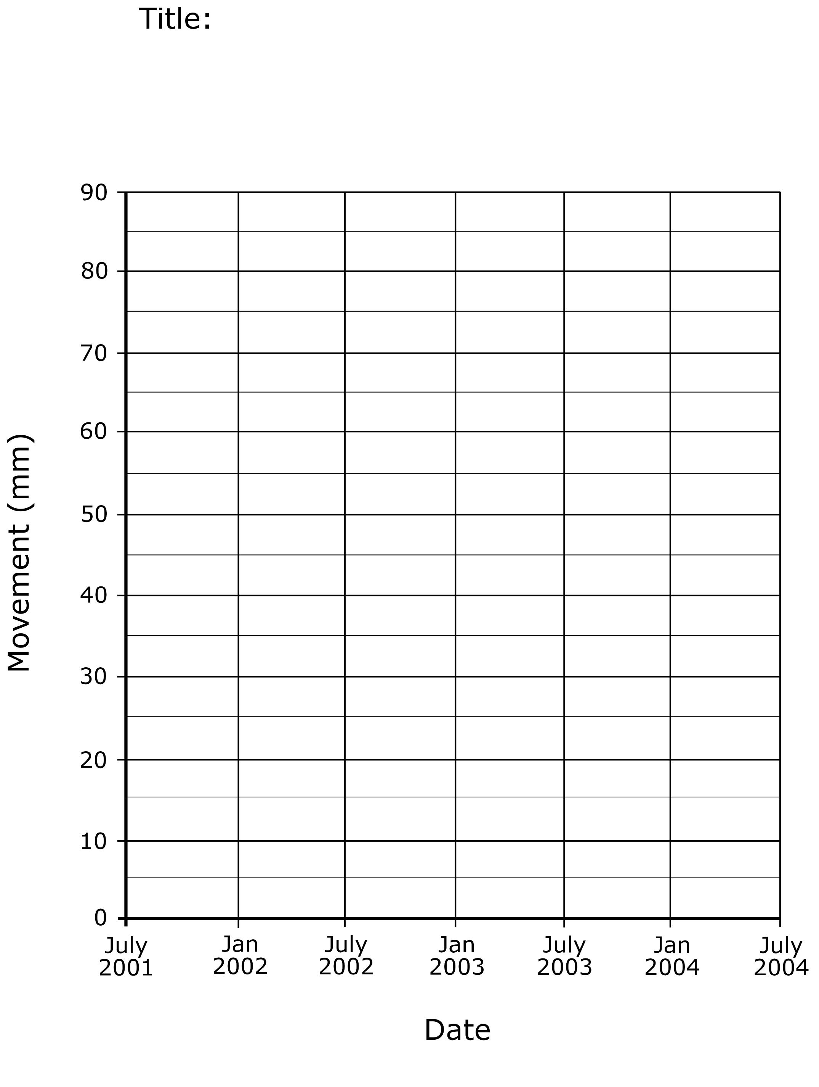

A slow slip near Kapiti – answers

The plotted graph should look something like this:

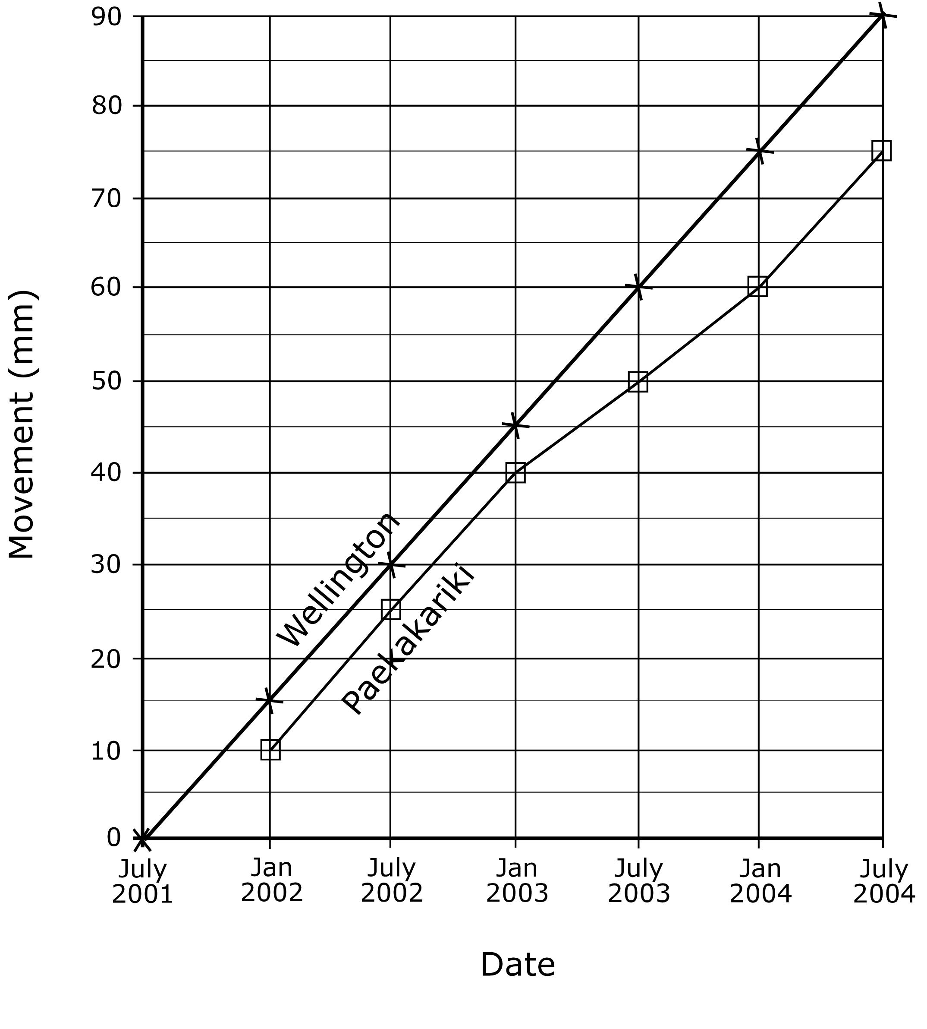

- Plot the Wellington data on the graph, and join the points with lines.

- How far does the land at Wellington move west each year? | 30 mm
- Does this rate change during the data collection period | No
- Now plot the Paekākāriki data on the same graph.

- What is the rate of movement per year between Jan 2002 and Jan 2003? | 25 mm
- Does this movement get faster or slower after Jan 2003? | Slower  – 20 mm a year
- When does it return to normal? | After Jan 2004

